ST CLARE’S R.C.P NEWSLETTER
Our School Mission Statement: Guided by Jesus Christ, our teacher, we journey together learning to dream, believe and achieve. Friday 9th October 2026

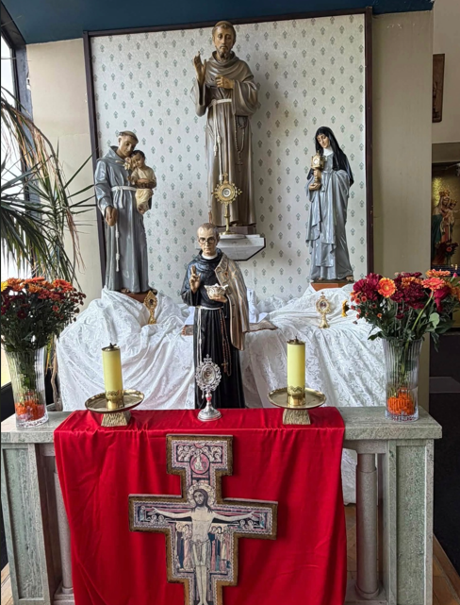
What a wonderful week we have had celebrating St Francis! Our celebrations began with the parish Mass on Sunday which Bishop John led with Father Jeremiah and Father Giles. The Mass was very well attended by the parish community – including the lovely children from our school who impressed Bishop John and the congregation with their beautiful singing. Thank you to everyone who brought their children along to the Mass. On Monday our Mini Clares led the children in prayer stations linked to St Francis. Children reflected on the beauty of the world and each day; how peace can be achieved in our lives; and thanked God for the special people in their lives. This was followed by the whole school Mass on Tuesday where Father Jeremiah encouraged us to be kind like St Francis and spoke of stories where kindness overcame misery and hurt. Our Mini Clares were also commissioned to their role at the end of the Mass. Some photographs of these events are available on our school website.
https://st-clares.manchester.sch.uk/religious-life-at-st-clare-s
There is also a new section here linked to ‘Living like Saints’ which you may wish to share with your children.

In Reception this week, the children have been creating their own avatars on Purple Mash using the paint tool on the Ipads! In maths, Year 1 have been looking at addition fact families and creating lots of number sentences. Year 2 have been describing their new villain Scissor Shark in English. Year 3 have been writing a short report about a volcanic eruption as if they witnessed it in their Geography lesson this week. After discussions, Year 4 have been writing a one sided argument, explaining why they believe all children should be entitled to a free school meal. For Space Week year 5 have spoken with

scientists that study space asking them a range of interesting and detailed questions. For Black History Month and Space Week, Year 6 have been researching the life and work of Valerie Thomas, an influential black scientist who invented the illusion transmitter - helping us to see things in 3D such as 3D movies! Year 6 have also had a lab workshop this week organised by Our Lady’s. Years 4 -6 attended workshops in school on Thursday linked to climate change. They have been busy!

Come and pray
Spending some quiet time with God is a great way to start each day. You are invited into our chapel each
Tuesday morning from 8.15am to start your day with individual prayer.
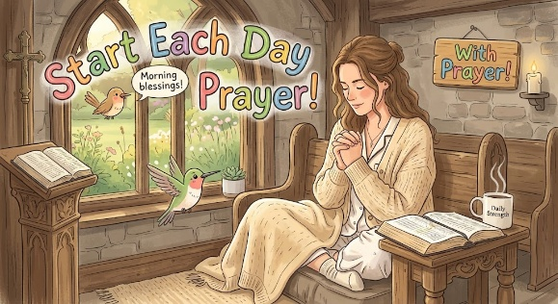

Pupil certificates
 | Pupil of the week | Achievement
N | Marcel for using his beautiful manners all week!
RDM | Daniel for always being ready to learn! | Ralph for excellent Fred talk in phonics this week!
RS | Maverick for always having beautiful manners. | Elon for super answers at carpet time!
Y1G -  Caritas | Nadia S for working hard to be a more independent learner. | Jomi for her fantastic maths work on addition fact families.
Y1M - Caritas | Luna for helping her friends in class | Daniel for writing super addition sentences
Y2C | Joel for always challenging himself in lessons | Layla for beautiful letter formation in her writing
Y2D | Hamdala for being ready to learn and working hard. | Victoria for writing a lovely description of Scissor shark.
Y3F | Ayden for really trying hard to concentrate on his work this week. | Mia for producing some wonderful homework about volcanoes.
Y3H - | Eliza for excellent listening and always trying her best. | Sara for a super improvement in her concentration.
Y4H | Rosie for consistent good behaviour and following school rules | Advika for always taking pride in her work and presenting work beautifully.
Y4O’H | Krystale for showing great confidence and skill in PE working on rolls and balances. | Kai for showing great rally coach skills, teaching his partner in maths this week.
Y5W | Curtis for having a great attitude towards school, always wanting to improve his work or understanding. | Grace for her fantastic knowledge and contributions in History.
Y5L | Maria for being a positive role model in the class. | Lucca for his improved attitude towards his learning.
Y6S | Michael for his brilliant efforts with all of his assessments this week. | Olivia K for a fantastic weather report video completed for her homework.
Y6GK | Poppy L for trying really hard with her assessments this week, having a great attitude and not giving up. | Elisa for a beautifully presented piece of work in geography comparing Blackley in 1900, 1950 and now.

Headteacher’s Awards
Rhiley in RS for consistently being an excellent role model to her peers.
Reggie in 2C for saying he wanted to get a gold card for his shoulder partner who had gone home ill.
Chidumebi in 3H for her beautiful work in RE about being stewards of creation.
Kody in 5W for a fantastic effort in his English writing this week.

Caritas Award 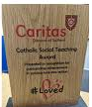
The Caritas Award is presented each week to a child in recognition of their outstanding achievement in putting love into action. This week the award goes to Isabelle L in Y4 for caring for a member of our class who has broken their arm, helping them with their things in the morning and ensuring that they have someone at break time.

Attendance
Overall whole school attendance this week 93.85%. There seems to be lots of illness amongst the children this week. The best classes for attendance this week is 6GK with 98.5%. Well done to them – they will get a longer break.
School doors open at 8.40am to give the children time to take off their coats and be ready at their desks for an 8.45am start. The doors close promptly at 8.45am.
Under the UN Convention on the Rights of the Child (UNCRC), Article 29, children have the right to an education. If you are experiencing any difficulties or require any additional support with attendance or punctuality, please contact our Attendance Officer, Mrs Burgess Hamlett.
There are strict procedures in place issued by the government for schools to follow in the event of poor absence which may not be due to genuine illness. Parents can be fined or face legal action. We do not want this to happen, so please work with us if you are struggling getting your child to school or you personally need any support. Contact Mrs Burgess Hamlett.

Own clothes Day
On Friday 16th October, children are able to wear their own clothes in return for a food item for the parish foodbank. We are living out our Catholic Mission of loving one another and serving others.
Any food donations are gratefully received, but we suggest:
Nursery and Reception children – cereal
Y1 – tinned vegetables
Y2 – pasta
Y3 – rice
Y4 – tinned meat
Y5 – tinned meat
Y6 – pasta or rice.

High School applications
Parents of children in Year 6 MUST apply for a high school place by 31st October. The web link is manchester.gov.uk/admissions 4
Support
As a school we are here for both your children and your family. If you are experiencing any difficulties or have any anxieties, please get in touch with Mrs Sylvester for a private conversation. Her email address is c.sylvester@st-clares.manchester.sch.uk or you can ring the school number or message via the school app. If we are unable to help you, we may be able to refer you to somebody who can.

Safeguarding
Safeguarding children is everyone’s responsibility. If you have any concerns regarding the safety of a child, please report it. You are able to refer concerns directly to children’s services or via school.

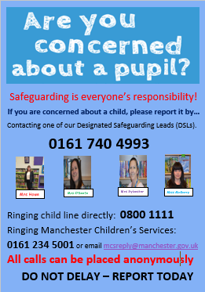

Mrs Howe

Upcoming dates
Sunday 11th October – Family Mass (Sacramental Programme) 10.30am
Friday 16th October – own clothes day in return for food items for the parish food bank.
Tuesday 20th October – Harvest Service in church 9.00am
Wednesday 21st October – parents evening

The weekly newsletter is also available on our school website Newsletters

