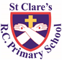
ST CLARE’S R.C.P NEWSLETTER
Guided by Jesus Christ, our teacher, we journey together learning to dream, believe and achieve.
Friday 1st October 2021

Dear Parents / Carers,
Assembly
“If your hand should cause you to sin, cut it off.” Mark 9: 38 – 43, 45, 47 – 48
In this week’s assembly, we learnt how the disciples jealously wanted to keep the power to heal to themselves. Through a film about one twin sabotaging the other’s gardening efforts, we explored Jesus’ response to our envious tendencies and challenged pupils to celebrate the abilities and character of others. Jesus asks us not to stand in the way of others’ attempts to do good.
Please keep both Father Darius and Father Jeremiah in your prayers this week as they have both lost close family members recently. May God bless and comfort them.
Pupil certificates
 | Pupil of the week | Achievement
RH | Pablo for wonderful role-play. He looked after the baby dolls by giving them food and drink and rocking them to sleep, before putting them carefully in the crib. | Pixie for an excellent piece of work where she was able to name the different parts of our bodies.
RC | Ellion for joining in with his friends in the small world area and using his imagination | Emiley for being a kind and caring friend all of the time.
Y1S | Alex D for improving his attitude to learning and contributing good ideas on the carpet. | Alex K for producing some super independent writing in the challenge areas practising his set 2 sounds!
Y1D | Isla for being a fantastic role model to her peers and always being ready to learn. | Ranveer for drawing and labelling a fantastic monster in Literacy this week.
Y2M | Lacey for always demonstrating good listening in class and being a fantastic example to others. | Nova for her absolutely beautiful handwriting
Y2L | Harry for always being helpful, without being asked. He is a lovely friend to others and should be proud of himself! | Zachery for a fantastic acrostic poem in RE. He blew our socks off and gave us goosebumps!
Y3M | Keir for settling into his new class really well. Well done for working so hard and making lots of new friends. | Laura for using manipulatives in maths really effectively to start to solve addition maths problems independently.
Y3G | Scarlette for always being polite and kind to others in the class. She helps those around her to try and do the right thing and is a pleasure to have in the classroom. Keep it up Scarlette, Well done! | Poppy H for writing a brilliant narrative about a volcano using lots of different language features and a range of fantastic punctuation. Well done Poppy! I really enjoyed reading your work.
Y4RW | Sheldan as I have been extremely impressed with his attitude towards school and his work this week. | Jaxon for fantastic work in maths rounding to 10,100 and 1000.
Y4S | Rowan for always working hard and trying his best. He also wrote a fantastic story at home which he read out to the class. Well done Rowan! | Holly for brilliant maths work, she’s been trying really hard and pushing herself on the challenges. Well done Holly!
Y5OH | Bella for having lovely manners and always being on task. She’s always ready first in class and puts 100% into everything she does. | Charlie for creating some amazing art work this week with drawing figures in different positions. Well done.
Y5OK | Bella for having lovely manners and making brilliant contributions to class discussions. She is always ready to learn and always works hard. | Riley for working really hard this week in maths on negative numbers and Roman numerals, producing some brilliant work!
Y5H | Jake for making an excellent start to his time at the school and producing great work. | Joel for making an excellent start at the school and for writing an excellent newspaper report even though he only had 1 lesson on the topic.
Y6F | Lily for being such a lovely child and friend to everyone in the class | Riley for trying his best in his work this week especially in maths
Y6H | Mariatu for having lovely manners and always respecting everyone around her. | Jacob J for some incredibly descriptive writing about light.
Y6S | Isabelle for working hard in her maths this week, resulting in some fabulous work being produced. | Ikenna for his amazing effort in computing this week, he took it upon himself to go above and beyond our LO using scratch and impressed me with his computing knowledge.
Headteacher’s Awards:
Elizabeth in 1S for keeping the pulse so well in music.
James in 2M for great verbal reasoning in maths.
Roman in 2m for being caring friend.
Samuel in 3G for being one of the youngest competitors at the cross country events and competing so well.
Oliver in 5O for fantastic use of similes in his writing.

Attendance
Whole school attendance this week is 94%. This is below the 97% we aim to achieve. The class with the best attendance this week is 6F with 99% - a big well done to all the children!
Please remember that school doors open at 8.50am to enable children to come in and be ready for a prompt start at 9.00am. Thank you to all parents who bring their children to school on time each day. If you are experiencing difficulties getting your child to school on time, please contact our Attendance Officer, Mrs Burgess Hamlett, for support and advice.
Welcome
We welcome some new additions to our St Clare’s family:
We welcome Michelle Flood to our Governing Body as our second parent governor.
I am pleased to tell that you Miss Nicholas has given birth to a beautiful baby boy called Percy.
We look forward to welcoming the parents of children in 6S into school on Monday at 9.10am for their class assembly.
Football
This week, a group of ten Year 6 boys competed in a 7-a-side competition at the Clough run by Manchester United. They boys were brilliant and reached the finals. Sadly, they were beaten by a strong Ringway team in the final, but played well throughout the tournament and represented our school with pride. Well done boys! Thank you to Mr Lockwood and Mrs Heaps for accompanying the children and Ms Drury for organising it.
MacMillan Coffee Morning
We now have our final total raised at the MacMillan Coffee Morning last week. We raised a staggering £693.20! Thank you so much to all of you who baked or bought cakes for us to sell; who sent money in for the children to buy cakes; who came and supported the event; and who donated money for wearing own clothes. It was lovely to welcome you back into school.
Covid 19
Although many Covid restrictions have been lifted in school, we are still following the Covid guidelines set by the government. If your child develops a high temperature, a new, continuous cough or their sense of smell or taste changes, they need to take a PCR test. Your child only has to be displaying one of the three symptoms. They should not be sent into school until they have a negative PCR test or they have completed their isolation period. Children will still be sent home from school if they are displaying any of these symptoms.
We will send you a ‘Warn and Inform’ letter should someone in your child’s class test positive for Covid. If somebody in your family tests positive for Covid, we will encourage all family members to take a PCR test. Track and trace will notify any close contacts who may need to isolate. We want to continue to keep our school community as safe as possible. Thank you for your cooperation during these times.
Support
As a school we are here to support your child academically, spiritually and emotionally. If you need any support, please contact Mrs Sylvester. Similarly, if as an adult you need any help please do not hesitate to get in touch. If we are not able to help you, we may be able to signpost you to somebody who can.
Manchester Youth Zone
This charity runs a range of activities after school to support children between the ages of 8 and 11. It is totally free and the children are fed whilst they are there. It looks good fun. Please see their website for further details https://www.manchesteryz.org/
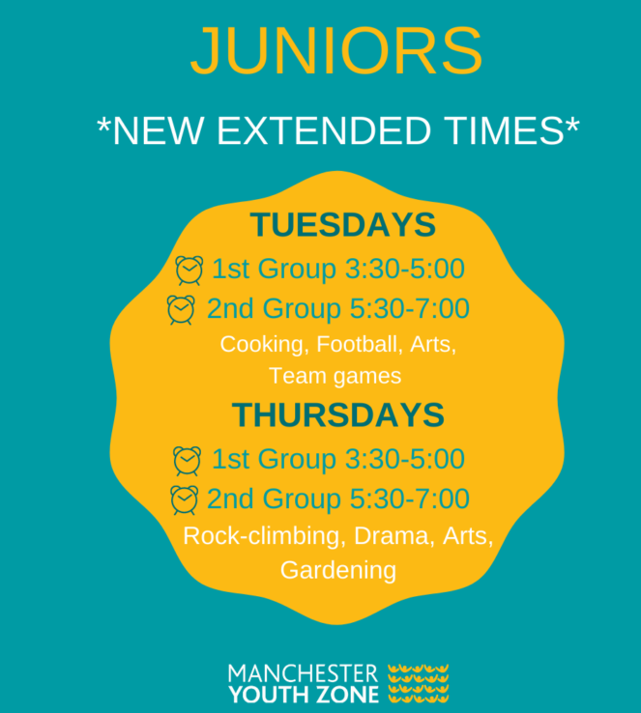
Dates for your diary:
Monday 4th October – 6S class assembly 9.10am.
Tuesday 5th October – whole school Mass to celebrate the feast of St Francis 9.15am.
Thursday 7th October – Y3 visit the Jewish museum
Thursday 7th October - Y2 parents information session 3.15pm
Wednesday 13th October – Parents Evening
Sunday 17th October – Family Mass 10.30am
Friday 22nd October – Finish for half term 3.15pm

I hope that you all have a relaxing weekend,
Mrs Howe

