ST CLARE’S R.C.P NEWSLETTER
Our School Mission Statement: Guided by Jesus Christ, our teacher, we journey together learning to dream, believe and achieve. Friday 16th October 2026

This week the children all attended workshops relating to Black History Month. The theme was African Reborn with pupils being given a chance to explore identity, heritage and belonging together. Year 3 have had a ballet lesson from the Royal Ballet School which was a new experience for them. Thank you to all the parents who attended to Read Write Inc session and stay and play on Thursday. Thank you to everyone for your incredible generosity in donating food for our parish foodbank.
This week Reception have been learning all about people who help us and who we can ring in different emergencies. In Year 1 the children learnt what human need to survive. In their English lessons, Year 2 have been writing WANTED posters about the evil villain Dr Sock. Year 3 have been identifying different types of soils in science. Year 4 have been considering the virtues of love, faith and hope in RE and carrying out discussions in class on which is the most important and why. Year 5 have been writing about the features of a diary entry, preparing to write an entry based on the topic of their class read - Who let the gods out? Year 6 have been pitching their product designs of a navigation tool in Design and Technology in the style of Dragons Den.

Assembly
This week 2C did their class assembly which focused on Our Lady and the Holy Rosary. Thank you to everyone who was able to join this celebration which the children led confidently.
4H will be leading the key stage 2 assembly on Monday. You are very welcome to join us.

Come and pray
Spending some quiet time with God is a great way to start each day. You are invited into our chapel each
Tuesday morning from 8.15am to start your day with individual prayer.
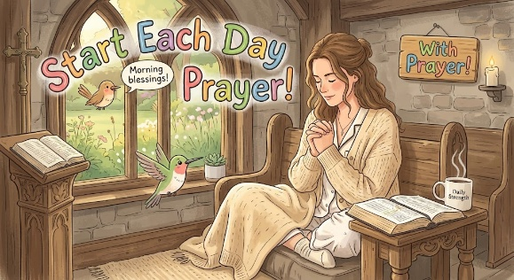

Pupil certificates

 | Pupil of the week | Achievement
N | Cassidy for being such a loving and caring little girl | Hoorane for having an improved attitude to learning
RDM | Olivia for being a superstar all week (and being so brave!) | Rocky for trying so hard with his phonics this week.
RS | Lilly-May for always being a kind and thoughtful friend. | Noah for writing cvc words independently!
Y1G -  Caritas | Ryan for his amazing counting to 10 using his clear voice. | Pearl for her amazing sounding out when writing sentences.
Y1M - Caritas | Jesse for a positive change in attitude towards his work | Kerry for writing two fantastic captions independently
Y2C | Thea for always having a super attitude to her learning | Theodore for super 2A sentences in English
Y2D | Aria-Rose for working hard all week and trying her best. | Gia for always contributing to lessons and remembering our sticky knowledge.
Y3F | Trinity for completing some fantastic geography work on why people might live near volcanoes. | Rory for always reading at home, and wanting to do well on his quizzes.
Y3H - | Yamie for a wonderful piece of work about The Fairtrade Foundation. | Olivia W for always reading lots at home.
Y4H | Hugo for some great behaviour and making good choices. | Grace for creating a fantastic plan of an Anglo Saxon settlement in History.
Y4O’H | Tomasz for always following our school rules and being an example to all. | Eliana for writing a fantastic independent write on children receiving a 2 week holiday during the October half term.
Y5W | Marvellous for always having a fantastic attitude towards her learning and work. | Jacob K for his great answers during our science lesson this week
Y5L | Jaxley for showing kindness towards his peers this week in PE. | Louie for producing a fantastic 5L pledge on how we can stand up against racism in PHSE.
Y6S | Amber for her resilience in maths this week with our work around BIDMAS | Heidi for a brilliant product pitch in Design and Technology in the style of Dragons Den.
Y6GK | Tyler for sharing some wonderful knowledge in our science lesson on light phenomena and being such an enthusiastic learner! | Nylah for writing an excellent resolution to her Light Jar narrative and always wanted to improve her work.

Headteacher’s Awards
Devonte in N for always being such an enthusiastic learner.
Tare in 2D for being a kind friend and coaching others with their work.
Phoenix in 4O for trying her hardest in every subject!
Rory in 6S for his fantastic writing of a resolution and ending to the Light Jar text that they have been reading in their English lessons.

Caritas Award 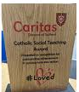
The Caritas Award is presented each week to a child in recognition of their outstanding achievement in putting love into action. This week the award goes to Timi in Year 1 for always being a kind and caring friend.

Attendance
Overall whole school attendance this week is very low with 90.87%. There seems to be lots of illness amongst the children this week. The best class for attendance this week is 5W with 97% – they will get a longer break.
School doors open at 8.40am to give the children time to take off their coats and be ready at their desks for an 8.45am start. The doors close promptly at 8.45am.
Under the UN Convention on the Rights of the Child (UNCRC), Article 29, children have the right to an education. If you are experiencing any difficulties or require any additional support with attendance or punctuality, please contact our Attendance Officer, Mrs Burgess Hamlett.
There are strict procedures in place issued by the government for schools to follow in the event of poor absence which may not be due to genuine illness. Parents can be fined or face legal action. We do not want this to happen, so please work with us if you are struggling getting your child to school or you personally need any support. Contact Mrs Burgess Hamlett.

High School applications
Parents of children in Year 6 MUST apply for a high school place by 31st October. The web link is manchester.gov.uk/admissions 4
Support
As a school we are here for both your children and your family. If you are experiencing any difficulties or have any anxieties, please get in touch with Mrs Sylvester for a private conversation. Her email address is c.sylvester@st-clares.manchester.sch.uk or you can ring the school number or message via the school app. If we are unable to help you, we may be able to refer you to somebody who can.

Safeguarding
Safeguarding children is everyone’s responsibility. If you have any concerns regarding the safety of a child, please report it. You are able to refer concerns directly to children’s services or via school.

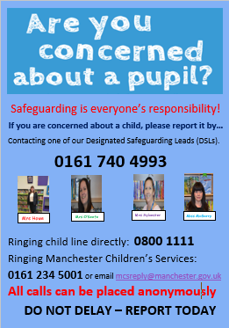

Half term
Just a reminder that we finish for half term next Friday 23rd October at 3.15pm. Our Lady’s are closed for two weeks, but we are not.
Mrs Howe

Upcoming dates
Tuesday 20th October – Harvest Service in church 9.00am
Wednesday 21st October – parents evening
Friday 23rd October – finish for half term.

The weekly newsletter is also available on our school website Newsletters

