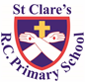

ST CLARE’S R.C.P NEWSLETTER

Our School Mission Statement: Guided by Jesus Christ, our teacher, we journey together learning to dream, believe and achieve. Friday 10th October 2025

Friday 24th November 2023

On Monday, we celebrated a whole school Mass led by Father Giles to celebrate the lives St Francis and St Clare. As always, it was a joyful, reverent Mass.

We have also been celebrating Black History Month in school. Our younger children were entertained through the story of Handa’s surprise and learnt about life in Kenya. Meanwhile, our Key Stage 2 pupils were introduced to hidden figures within Black history including the first black Roman emperor.

Parents were invited into school yesterday for a phonics workshop and a stay and play with their children in Reception. Thank you for your attendance.

In Nursery, the children have been learning the story of creation and talking about all the wonderful things God has given us. As part of their work on the senses, Year 1 have been smelling different foods. In English, Year 2 have been creating a wanted poster for Scissor Shark. Year 3 have enjoyed making fossils out of clay. In music, Year 4 have been learning the classic Abba hit – Mamma Mia. They sounded great! As part of their science topic, Year 5 have been investigating which materials are soluble or not. In maths, Year 6 have been learning about the order of mathematical operations.

**Come and pray**

Our chapel / KS2 prayer garden is open each Tuesday morning before school for staff, pupils and parents to come and pray privately. Starting the day with God is a beautiful way to begin the morning. You are very welcome to pop in from 8.15am each Tuesday.

**The Holy Rosary**

October is a month dedicated to Our Lady and the Rosary. To honour Our Lady, two parishioners have been coming into school each week to share a decade of the Rosary with different year groups. Our Mini Clares have also led each class in the saying of this very powerful prayer.

**Sacramental Programme 2025/26**

This weekend all pupils involved in the Sacramental Programme this year are invited to the 10.30am Mass in church on Sunday.

**Anybody who has not yet signed up for the programme and wishes to will be able to do so after the Mass.**

Any key stage 2 children or members of the choir are invited along to help boost the singing. They can come and sit in the choir seats.

**Harvest**

We will be hosting our Harvest service in church on Tuesday 21st October. Next Friday -17th October- will be an own’s clothes day in return for items of food for our parish foodbank. Below are the suggested items for each year group to try and ensure that we get a range of different foods. If you wish to send a different food item to the suggestion on the list, that would be fine:

Nursery and Year 5 – tinned potatoes

Reception and Year 6 – tinned vegetables

Year 1 – rice

Year 2 – pasta

Year 3 – tinned beans

Year 4 – tins of soup

Thank you for your support with this!

**Pupil certificates**

|  |  |  |
| --- | --- | --- |
|  | Pupil of the week | Achievement |
| N | Victoria for being an amazing role model to all of her peers! | Dax for choosing to do the right thing all week! We are so proud of you Dax! |
| RDM | Nadia K for always trying so hard and setting a great example. | Jesse for brilliant number work. |
| RS | Ruby for having a great week trying school dinners! | Kerry for having a full week on green! |
| Y1G | Tare for being a super helpful member of our class. | Milton for completing work on time to the same high standards. |
| Y1S | Anastazja for always doing the right thing and being kind, helpful and thoughtful with everything she does. | K’cey for brilliant work with addition fact families in maths. |
| Y2C | Freya for always being ready to learn | Ziyan for showcasing his amazing maths understanding |
| Y2D | Anaya for being caring, kind and hardworking and always having a big smile on her face. | Olivia S for writing a lovely character description about Scissor Shark. |
| Y3F | Poppy for really trying her best in all work, keep it up! | Advika for producing fantastic geography work about the advantages and disadvantages of living near a volcano. |
| Y3H | Anuli for an excellent explanation of how fossils are formed. | Ethel for writing  a magnificent explanation text about rocks. |
| Y4H | Saara for having fantastic, persuasive ideas in English! | Elijah for working hard to calculate subtractions with exchanges! |
| Y4O | Emiley for being an amazing member of our classroom, she’s helpful, well-mannered and so caring. | Keriane for her wonderful explanations regarding the main points of our persuasive text. |
| Y5K | Elijah for always being ready to learn, trying his best and being a wonderful member of our class! | Joleen for creating some amazing PPT presentations on our history topic of Ancient Greece! |
| Y5L | Olivia W for supporting her peers during a science investigation | Logan for applying his subtraction and addition knowledge brilliantly to solve word problems in Maths |
| Y6S | Phaedra for being a positive role model in 6S and putting 110% effort into all that she does. | Jacob for an incredible short write this week, he blew me away with the language features he had included! |
| Y6W | Tolani for her fantastic attitude towards her work this week especially in her writing assessment. | Lilly for a fantastic piece of work in science for space week. |

**Headteacher Awards**

Nancy in 1S for a creating a great space scene.

Norah in 2C for amazing tidying up in class.

Poppy in 3F for great dancing in breakfast club.

Amelia in 5L for being a good leader in forest school.

Dolcie in 6W for being a mature, caring friend.

**Caritas Award** 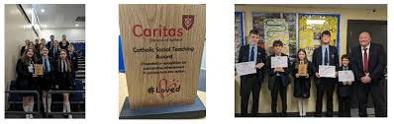

The Caritas Award is presented each week to a child in recognition of their outstanding achievement in putting love into action. This week the award goes to Cerah in RS for being a kind and thoughtful friend by sharing her fruit at snacktime with another pupil.

**Rights Respecting School – Silver Award**

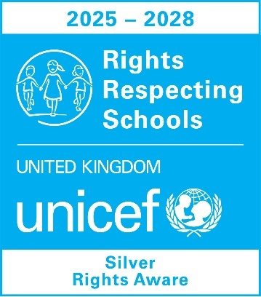

This week we were assessed tosee if we were meeting the requirements needed to be award the Silver Mark for Rights Respecting Schools. I am thrilled to inform you that we passed with flying colours. The assessor was impressed with the provision provided for our children and was amazed at how well our pupils knew their rights and how they could be used. A report will be available in the next week which I will share with you. We are super proud of our pupils and this award is further proof of what an amazing school St Clare’s is.

Special thanks to Mrs Harrison and the steering group for leading on the award and the work completed in school. We are now going for gold!

**Attendance**

Overall whole school attendance this week was 95.9% Lates after 9am are improving, but we still have 48 pupils late 62 times before 9.00am. Some of you are literally a minute late, but it is still late. Please try and leave the house a couple of minutes earlier.

School doors open at 8.40am to give the children time to take off their coats and be ready at their desks for an 8.45am start. The doors close promptly at **8.45am.**

Under the **UN Convention on the Rights of the Child (UNCRC),** Article 29, children have the right to an education. If you are experiencing any difficulties or require any additional support with attendance or punctuality, please contact our Attendance Officer, Mrs Burgess Hamlett.

The best class this week for attendance is 1S with 100%. They will have an own clothes day next Friday and a treat. Well done to them!

**Parents Evening**

Please make sure that you go onto the app to book your appointment with your child’s class teacher for 22nd October.

**Year 6 high school places**

You are now able to apply for your child’s high school place for next September 2026. **Applications must be made prior to October 31st 2025 for a September 2026 start.**

If you live in Manchester, you can apply online via <https://www.manchester.gov.uk/info/500322/secondary_school_admissions/7516/apply_for_a_year_7_secondary_place_for_september_2020>

If your address comes under Rochdale, the link is <https://www.rochdale.gov.uk/school-admissions-appeals/apply-secondary-school-place>

If you need any support with filling in the application, please ask.

As a Catholic school, we hope that you will continue to choose to educate your child in a Catholic high school.

**Support**

As a school we are here for both your children and your family. If you are experiencing any difficulties or have any anxieties, please get in touch with Mrs Sylvester for a private conversation. Her email address is [c.sylvester@st-clares.manchester.sch.uk](mailto:c.sylvester@st-clares.manchester.sch.uk) or you can ring the school number or message via the school app. If we are unable to help you, we may be able to refer you to somebody who can.

**Safeguarding**

Safeguarding children is everyone’s responsibility. If you have any concerns regarding the safety of a child, please report it. You are able to refer concerns directly to children’s services. The contact details for them is particularly important during the summer holidays when some children may be susceptible to more harm and neglect.

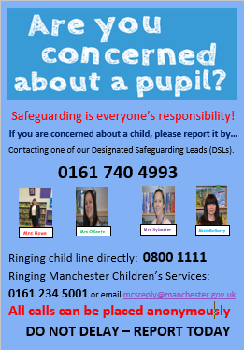

I hope that you all have a great weekend,

Mrs Howe

**Upcoming dates**

12th October – Family mass 10.30am

21st October – Harvest Service in church 9am

22nd October – parents evening

24th October – finish for half term 3.15pm

***The weekly newsletter is also available on our school website***[*Newsletters*](https://st-clares.manchester.sch.uk/parents/newsletters/newsletters-2024-2025)

**A Prayer for Peace**

