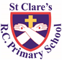
ST CLARE’S R.C.P NEWSLETTER
Guided by Jesus Christ, our teacher, we journey together learning to dream, believe and achieve.
Friday 20th October 2023

We finish today for half-term after a busy 7 weeks. Please remember that our website and class pages give you a lot of information about what your child will be learning each half term. There are also useful links to other websites to support your child’s learning. Under the Catholic Life and Mission you will find the many things we have done so far this year to enhance our faith life in school. We have been busy!
On an autumnal walk, Nursery gathered leaves which they have used to make hedgehogs. Reception pupils have been learning about people who help us and how they do so. Year 1 have been on a walk around school to spot signs of autumn as part of their science work. Year 2 made shields in DT and parents were welcomed into class at the end of the day to celebrate their work. Year 3 have been identifying different types of soil from descriptions of them. As part of their history topic, Year 4 have been learning about Sutton Hoo whilst Year 5 have been learning about the legacies left from Ancient Greece. In DT, Year 6 have made paper mache light bulbs.
Harvest Festival Service
Thank you to everyone who attended our Harvest Service this week and thank you for your food donations. We have donated them to the parish food bank. We thanked God for the food and drink we have access to and prayed that food is shared equally between all of God’s people.
Morning Prayers
Our school chapel will be open every Tuesday morning from 8.30 -9.00am for parents (and children) to come into school for some private prayer, some time alone with God or quiet reflection.

Caritas Award
Indiya in RS for being very kind and helpful, and helping someone form the letter s. She was even holding their hand and guiding them down the snake.
Pupil certificates
20/10/23 | Pupil of the week | Achievement
N | Gia for showing lots of enthusiasm and always being eager to learn | Michelle for being a good girl during her first visit to church!
RDM | Diana for fantastic listening during carpet sessions | Hassan for amazing phonic work
RS | Bonnie for always brightening up our classroom with her positive energy and kind heart! | Indiya for learning to write all the letters in her name in the correct order!
Y1D | Cora Rae for always being a positive role model in our class. | Maggie for writing some lovely sentences with super spelling!
Y1G | Phoenix for following our class rules. | Pharrell for amazing descriptive sentences about Bog Baby this week.
Y2C | Saara for being a kind and helpful member of our class | Mia for super maths all week
Y2O | Louie for a fantastic attitude towards all his learning this week. | Ophelia for creating a wonderful Superhero shield in DT!
Y3F | Frankie for being an excellent pupil this half term. Always putting a smile on my face | Phoebe for doing some excellent RE work on being able to keep a promise
Y3H | Ella, for fantastic column addition with an exchange. | George, for being a kind and compassionate friend.
Y4H | Lacey for always behaving beautifully and being respectful. | Annie for some beautiful writing and making a super effort!
Y4S | Harry for being a fantastic friend and always helping others in class. | Jack for a brilliant improvement in his times tables.
Y5G | Khadijah for her calm and peaceful presence in the classroom and setting a great example of how to behave beautifully. | Aliyah for an impressive piece of narrative writing titled The Forgotten Promise.
Y5W | Poppy H for always having a fantastic attitude towards her learning, giving 100% in every lesson. | Jacob for fantastic work on cubed and squared numbers.
Y6K | Rosalie for some wonderfully mature responses during our recent NSPCC based work. | James, for a huge improvement in the overall quality and presentation of his written work in all subjects.
Y6S | John Joe for engaging well with the NSPCC workshop visitors, and asking lots of very helpful questions. | Oliver M for his amazing independent writing this week!

Headteachers awards:
Bereket in Nursery for sharing and being kind.
Yarislav in 1G for great maths work on addition to 10.
Emiley in 2O for being focused and hardworking in class.
Logan in 3H for reading and quizzing so frequently.
Joachim in 4S for always working hard and giving his all.
Ramani in 5G for a beautiful acrostic poem and Harvest prayer.
Abigail in 6K for always being kind and considerate to others.
Attendance
Attendance this week has fallen to 93.7%. We need to work on attendance improving again after the holiday. We had 59 pupils late this week who missed over 13 hours of valuable learning time – that is nearly 3 days of learning time. The best class this week was 4S with 98.6% Well done to them – they will have a longer playtime as a reward.
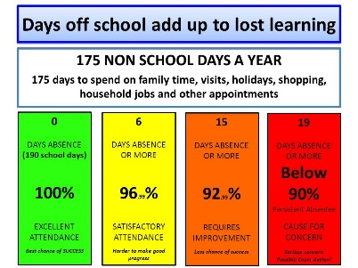
Parents Evening
Thank you to everyone who attended our parents evening this week. It is really important to meet your child’s class teacher to get an update on how they have settled into their new class and discuss any matters that may have arisen.
Thank you to all the parents the DT celebration in Year 2O this week too.
Our Lady’s High School
OLHS have recently had their RE inspection and are pleased to announce that they were graded outstanding. What a great achievement! It is wonderful recognition for the work the school do and will help support parents in deciding which high school they might like to send their children to.
Support
We know that families may experience difficult times and difficult situations throughout a year, especially with the cost of living increase. We are here to support you in any way we can - should you need it. If you are experiencing any financial or other worries, please get in touch. If we are unable to help you, we may know of a group who can help. Please contact Mrs Sylvester at school for a discrete conversation if you require some support.
Upcoming dates:
22nd October - Family Mass / Sacramental Programme children
1st November – All Saints Day Mass 9.30am
6th November – Class photographs
7th November – SEND parents coffee morning
8th November – Nursery dough disco stay and play
9th November – Maths fun day
11th November – Sacramental Programme Day at church
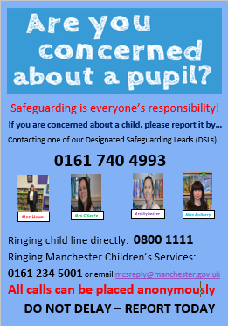

Enjoy the holiday and keep safe. We look forward to seeing you on Monday 30th October. Doors open at 8.50am.
God bless,
Mrs Howe

