ST CLARE’S R.C.P NEWSLETTER
Our School Mission Statement: Guided by Jesus Christ, our teacher, we journey together learning to dream, believe and achieve. Friday 23rd October 2026

Happy half term everyone!
First of all, thank you all for your incredible generosity in donating food for the parish foodbank as part of our harvest celebration. Our harvest service was held in church on Friday and was led beautifully by the children. Thank you to everyone who was able to join us.
This week Nursery have been learning about number 1. Reception have been subitising objects, sounds and actions this week in Maths. In their DT lesson, Year 1 made smoothies whilst Year 2 made moving monsters.
Year 3 have been writing a letter based on their class book, ‘Lubna and Pebble’. Year 4 have been working hard on area in maths, and enjoying finishing off their Anglo Saxon topic in History. Year 5 this week visited OLHS where we had the opportunity to join in with an Ancient Greek drama lesson and experience some high school D.T lessons. Year 6 have been using an 8 figure grid reference in geography to locate landmarks in Manchester. They were able to apply the vocabulary of Eastings and Northings to their grid references.

Assembly
This week 4H did their class assembly which focused on Our Lady and the Holy Rosary. Thank you to everyone who was able to join this celebration which the children led confidently.

Come and pray
Spending some quiet time with God is a great way to start each day. You are invited into our chapel each
Tuesday morning from 8.15am to start your day with individual prayer.
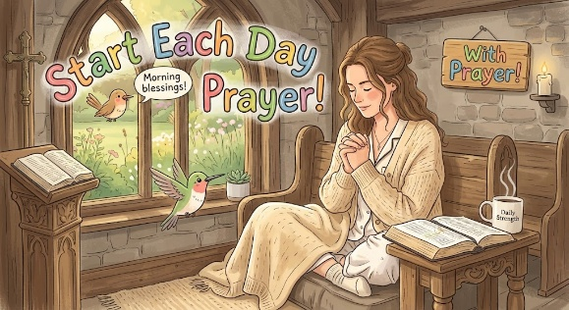

Pupil certificates
 | Pupil of the week | Achievement
N | Nancy for impressive mathematical language | Lidia K for writing her name in the glitter so well!
RDM | Louie for always benign ready to learn! | Selina for a super effort in phonics lessons this week!
RS | Chinira for using her words more when asking for help. | Shai for fantastic tricky word spelling this week!
Y1G - | Jomi for her dancing and singing during the harvest service on Tuesday. | Golibenachi for working hard on improving his handwriting.
Y1M - | Ruby for always being an enthusiastic learner | Isla for a big improvement in her handwriting.
Y2C | Amina for always being a super role model to the rest of her class | Lula for super letter formation
Y2D | Ralphi for settling into our class wonderfully and trying hard all week. | Oscar for your super DT work making a moving monster
Y3F | Iris for always being ready to learn and being a great example | Olivia J for producing some wonderful homework on our Volcano topic
Y3H - | Eryn for always being a sensible, hardworking and caring member of the class. | Frankie for an excellent improvement in his handwriting.
Y4H | Ellis for always behaving beautifully and making good choices. | Lennox for consistently good maths work- well done!
Y4O’H | Esther for fantastic reading during our Harvest service. | Frank for creating a fantastic poster based on the virtues of love, hope and faith in RE.
Y5W | Olivia for challenging herself by reading longer and more difficult books. | Jennifer for the fantastic effort she has put into her writing this week.
Y5L | Bryn for her fantastic attitude towards her reading. | Emily for producing some brilliant creative writing on Elliot’s feelings in her diary entry.
Y6S | Olivia K for always trying her best in all that she does. | Lilith for practicing her spellings weekly and achieving 10/10 every single week!
Y6GK | Azra for always doing her best in lessons and showing great resilience - she always has a beautiful smile on her face. | Nayane for going the extra mile by planning ideas for her narrative at home and including so many year 6 features in her writing!

Headteacher’s Awards
Kymora in RDM for being so kind and caring to everyone!
Mayah in 1G for her brilliant knowledge of fruits and vegetables and where they grow.
Paige in 3F for writing a fantastic letter based on our class book.
Anna and Maria in 5L for their fantastic teamwork, working together to make pizza in the home economics lesson at OLHS.

Caritas Award 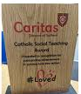
The Caritas Award is presented each week to a child in recognition of their outstanding achievement in putting love into action. This week the award goes to Oliver D in Year 6 for always having something positive to say about others and consistently put their needs before his own. His thoughtfulness and kindness are a shining example to everyone!

Parents Evening
Thank you for attending parents evening. It is a great opportunity for you to meet your child’s class teacher and see how they are doing in relation to their learning and social skills.

Attendance
Overall whole school attendance this week is low with 91.83% . The best class for attendance this week is 3F with 97% – they will get a longer break.
School doors open at 8.40am to give the children time to take off their coats and be ready at their desks for an 8.45am start. The doors close promptly at 8.45am.
Under the UN Convention on the Rights of the Child (UNCRC), Article 29, children have the right to an education. If you are experiencing any difficulties or require any additional support with attendance or punctuality, please contact our Attendance Officer, Mrs Burgess Hamlett.
There are strict procedures in place issued by the government for schools to follow in the event of poor absence which may not be due to genuine illness. Parents can be fined or face legal action. We do not want this to happen, so please work with us if you are struggling getting your child to school or you personally need any support. Contact Mrs Burgess Hamlett.

High School applications
Parents of children in Year 6 MUST apply for a high school place by 31st October. The web link is manchester.gov.uk/admissions 4
Support
As a school we are here for both your children and your family. If you are experiencing any difficulties or have any anxieties, please get in touch with Mrs Sylvester for a private conversation. Her email address is c.sylvester@st-clares.manchester.sch.uk or you can ring the school number or message via the school app. If we are unable to help you, we may be able to refer you to somebody who can.

Safeguarding
Safeguarding children is everyone’s responsibility. If you have any concerns regarding the safety of a child, please report it. You are able to refer concerns directly to children’s services or via school.

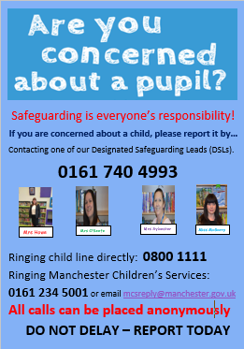

Half term
We finish today for one week. School re-opens on Monday 2nd November.
Enjoy the break!

Mrs Howe

Upcoming dates
Monday 2nd November – school opens
Sunday 8th November – family Mass 10.30am
Monday 9th November – EYFS nursery rhyme week
Friday 13th November – flu vaccination catch-up
Monday 16th November – photographs in school
26th -30th November – Y3 bikeability

The weekly newsletter is also available on our school website Newsletters

