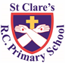

ST CLARE’S R.C.P NEWSLETTER

Our School Mission Statement: Guided by Jesus Christ, our teacher, we journey together learning to dream, believe and achieve. Friday 18th October 2024

Friday 24th November 2023

Thank you to everyone who joined us for our harvest service on Tuesday which the children led so beautifully. Thank you for your very kind generosity in sending in food for the parish foodbank – they are very grateful.

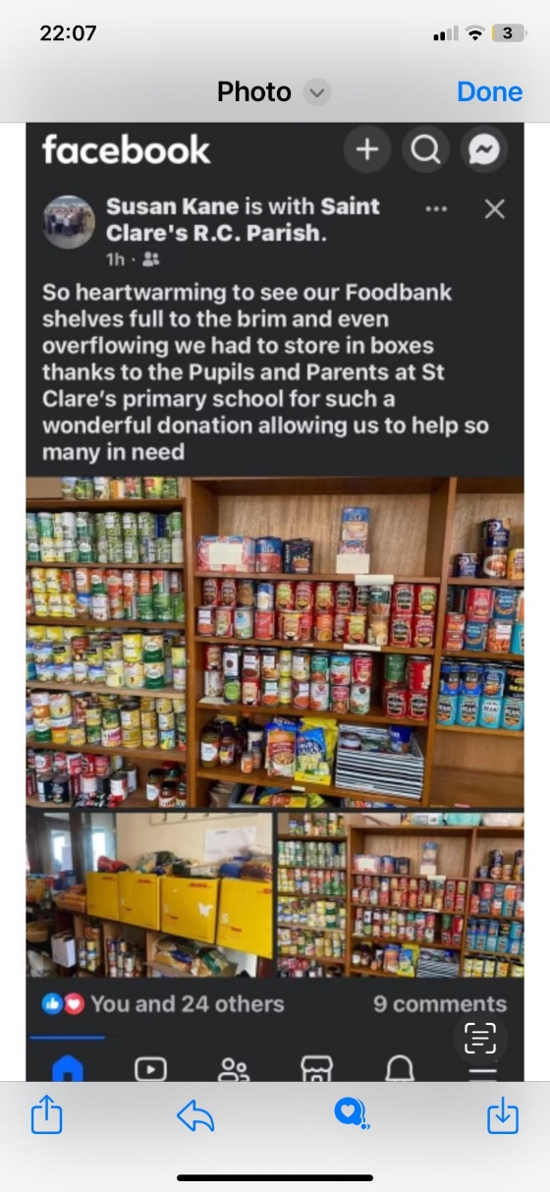

Thank you for your attendance at parents evening this week. 88% of our parents attended the meeting. I hope that you found meeting your child’s class teacher beneficial and enjoyed sharing your child’s work. We do have amazing children here at St Clare’s.

Thank you to everyone who attended the SEND coffee morning today. I hoped that you enjoyed meeting informally with other parents for a chat.

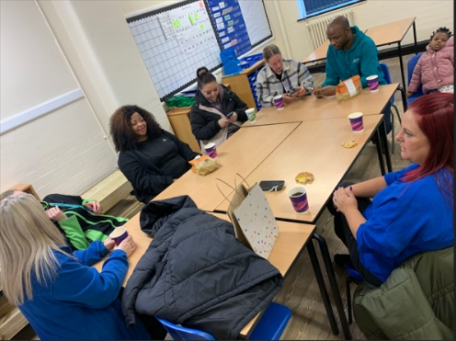

The next SEND coffee morning is scheduled for Tuesday 4th February 8:40am-9:30am

This week in Nursery, the children have been using potatoes to make their own Supertato super heroes. In Reception, pupils have been learning about blackbirds and they went outdoors to make nests. In DT, Year 1 made fruit smoothies. In Year 2, as part of their DT topic, the children have made moving monsters. In dance, Year 3 have learnt a routine to ‘Cotton Eyed Joe.’ In Year 4, pupils have made a slingshot car and it has moved using kinetic energy. Linked to Ancient Greece, Year 5 have designed, made and decorated Greek vases using clay. In geography, the children have been locating sites in Manchester city centre using 6 figure grid references.

**Chapel / prayer garden**

Our chapel / KS2 prayer garden is open each Tuesday morning before school for staff, pupils and parents to come and pray privately. Starting the day with God is beautiful. You are very welcome to pop in from 8.15am each Tuesday.

**Pupil certificates**

|  |  |  |
| --- | --- | --- |
|  | Pupil of the week | Achievement |
| N | Bobby for trying really hard to be a good talk partner and following our discussion rules | Timi for always being very engaged during our carpet times. |
| RDM | Freya for always being ready to learn | Lacey for beautiful letter formation in phonics |
| RS | Joelvy for always being ready to learn! | Joel for super progress in phonics! |
| Y1G | Isaac for becoming more independent in his learning. | Olivia S for a well presented postcard. |
| Y1S | Oskar B for being really helpful and looking out for others. | Bonnie for writing a brilliant postcard. |
| Y2C | Hajra for an amazing first few weeks at St Clares | Isabelle O for beautiful letter formation in her writing |
| Y2D | Lexi for always making good choices and being ready to learn. | Hugo for your fantastic work during our Design and Technology lessons making a moving monster. |
| Y3F | Macie-Mae for always trying her best in everything she does. Keep it up! | Carter H for being an amazing work partner, he helps his partner and is always on task during discussions |
| Y3H | Anna for a great improvement in her handwriting AND a fantastic knowledge of the Sacrament of Baptism. | Akongwi for impressive dribbling and ball control skills in hockey. |
| Y4H | Rory for always behaving beautifully and treating others with respect. | Logan for a brilliant non-chronological report on the digestive system. |
| Y4O | Henry for being a good and considerate friend! | Elisa for always putting 100% effort into every lesson! |
| Y5G | Archie for always having a positive attitude towards his friends and his work! | Excel for making great progress in all of her subjects by working hard and having an excellent attitude to learning. |
| Y5K | Shae for always trying her hardest and for constantly wanting to improve and get better! | Malik for some wonderful Greek myth writing over the last few weeks! |
| Y6S | Aliyah for always having a positive attitude towards everything that she does. | Sam for the fantastic effort he puts into his spelling test every single week! |
| Y6W | Jessica for having a great attitude during our visit to OLHS, joining in with all the drama performances | Ava for her fantastic work in her maths work all week, especially in her arithmetic work and work on long division. |

**Headteacher awards**

**Tinsley** in Nursery for being a great role model and following school rules.

**Reube**n in RS for always being helpful and looking after his friends.

**Arwyn** in 1S always doing the right thing.

**Jennifer** in 3F for noticing someone was on their own and inviting them to play with her.

**Khadijah** always being so engrossed in her work and putting in maximum effort.

**Caritas Award**

The Caritas is awarded each week in recognition of someone in school who has shown kindness to others by putting love into action. This week the award goes to Oscar in Year 3 who volunteers his time each week to help his Grandma clean the church.

**Attendance**

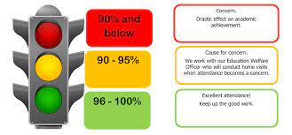

Whole school attendance this week is 94.75%. The best class this week is 6W for the second week running with 98%.

This week we had 81 recorded lates for 67 pupils which is down by 35 this week, so thank you for this improvement.

**Potty / Toilet training**

As half term is upon is it is the ideal time for you to try and potty train your child. Experts state that potty training can begin at 18 months. Research shows it is better for your child’s bladder and bowel health to stop using nappies between 18 and 30 months. Do not wait until you think your child is ready – they may never show those signs. Please access the following website for some good advice on how to potty train your child. <https://eric.org.uk/potty-training/>

**Unintentional injury prevention**

There is a host of information on our school website with guidance and advice on how to avoid injuries and help keep children safe. To access it, please follow the link

<https://st-clares.manchester.sch.uk/parents/unintentioonal-injury-prevention>

There is a section relating to firework safety which may be useful over the coming weeks.

**Uniform Policy**

We are very proud of how you send your children into school each day – in the correct uniform and looking very smart. Uniform helps to give children a feeling of belonging to the school community and ensures that there is no competition between children regarding the clothes that they wear for school each day. Our uniform policy is on the school website. Section 4.1 states:

* Parents are asked to send their children into school clean and tidy and dressed appropriately for the weather conditions of the day.
* Pupils are not permitted to wear jewellery in school. This includes ear-rings.
* Pupils are not allowed to wear false nails or nail varnish.
* Pupils are not permitted to wear make up or stick on tattoos.
* Hair styles must be sensible with no extreme styling.
* If pupils are wearing hair extensions as part of their culture, they must be of a neutral colour e.g brown or black.

<https://st-clares.manchester.sch.uk/parents/uniform-information>

**Abusive relationships apps**

**Bright Sky** is a free to download mobile app providing support and information for anyone who may be in an abusive relationship or those concerned about someone they know. The app is also available to use in Polish, Punjabi and Urdu. For more information see <https://www.england.nhs.uk/supporting-our-nhs-people/support-now/wellbeing-apps/bright-sky/>

**Hollie Guard** is a smartphone app that provides individuals with enhanced protection. It is a personal alarm, deterrent, evidence catcher and more. For more details see <https://hollieguard.com/>

**Support**

As a school we are here for both your children and your family. If you are experiencing any difficulties or have any anxieties, please get in touch with Mrs Sylvester for a private conversation. Her email address is [c.sylvester@st-clares.manchester.sch.uk](mailto:c.sylvester@st-clares.manchester.sch.uk) or you can ring the school number or message via the school app. If we are unable to help you, we may be able to refer you to somebody who can.

**Safeguarding**

We are off school next week, so please remember that safeguarding children is everyone’s responsibility. If you have any concerns regarding the safety of a child, please report it. You are able to refer concerns directly to Manchester Children’s Services on 0161 234 5001. It is better to be safe than sorry.

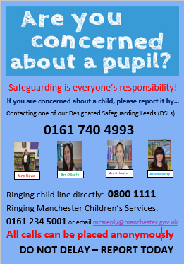

I hope that you have a great half term holiday.

School re-opens on Monday 4th November.

Mrs Howe

**Upcoming dates:**

Sunday 10th November – Family Mass in church 10.30am

18th November – school individual photographs