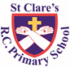
ST CLARE’S R.C.P NEWSLETTER
Our School Mission Statement: Guided by Jesus Christ, our teacher, we journey together learning to dream, believe and achieve. Friday 17th October 2025
Friday 24th November 2023

Happy Diwali to any of our families who have been celebrating this week. It is hard to believe that we have already completed 8 weeks back at school and finish today for half term.
We enjoyed a whole school Harvest Service on Tuesday. Many thanks for your food donations which have been given to the parish to support families in the local community. Once again, you have been extremely generous.
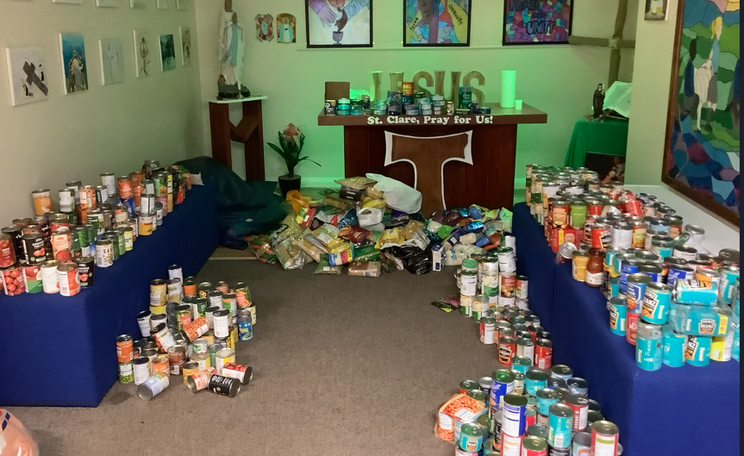
We also held parents evening on Wednesday evening. Many thanks to everyone who attended. It is vital that home and school work together to support our children. It must be such a pleasure to be told how wonderful your child is, as we have a school full of amazing children. Attendance was great with 88% of parents attending, so thank you!
Thank you to everyone who came to the Rosary led by our Mini Clares on Thursday. Praying together with your children is such a lovely experience.
This week our Year 5 and Year 6 pupils took part in a Dream Big football competition. They reached the semi-final stages. We are very proud of the team. Thank you to Mr Sabatel for taking the children.
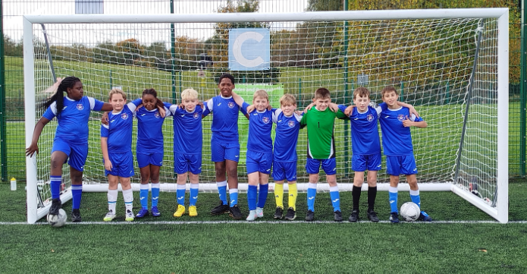
Our Nursery children have been learning about Diwali and have made diya lamps. Continuing the theme of harvest, our Reception children were sorting harvest

foods according to whether they were fruit, vegetables or meat. In art, Year 1 are looking at the work of Romero Britto and copying his style of pop art. In maths, Year2 have been learning how to subtract across a ten. Year 3 have been performing dance routines taught by our dance coach in PE. Year 4 have been looking at the clothes of Anglo Saxons and using the patterns to create belts – the results are amazing. In Spanish, Year 5 have been learning the months of the year and numbers to 31, so that they can say their birthday. Our Year 6 pupils spent the day at Our Lady’s this week where they made electrical circuits and addressed cyber bullying through drama activities.

Come and pray
Our chapel / KS2 prayer garden is open each Tuesday morning before school for staff, pupils and parents to come and pray privately. Starting the day with God is a beautiful way to begin the morning. You are very welcome to pop in from 8.15am each Tuesday.

Pupil certificates
 | Pupil of the week | Achievement
N | Lucas for a wonderful first full week in school! | Frankie for amazing recall of the celebration ‘Diwali’.
RDM | Mayah for working hard in all areas this week | Samuel for wonderful writing about harvest.
RS | Elana for using initial sounds when writing about people who help us! | Azlan for becoming more confident with his communication skills!
Y1G | Gia for being a helpful and responsible member of our classroom. | Jessen for blowing us away with his maths work this week!
Y1S | Aiden for always trying his best and showing fantastic enthusiasm in everything that he does. | Danica for amazing maths work this week.
Y2C | Alba Duncan for always trying her hardest with her work and following instructions | Mickey for making an amazing moving monster in DT
Y2D | Olivia S for always being ready to learn and for working hard in every lesson. | Amy for being resilient and making a super moving monster during our DT day.
Y3F | Fabian for having a great week and being ready to learn! | Olivia May for writing a fantastic setting description using the five senses.
Y3H | Joshua for beautiful singing in Mass. | Talia for excellent rhythm in our dance lesson.
Y4H | Harlen for being a great team player, who is always smiling! | Carter H for a fabulous improvement in handwriting!
Y4O | Bryn for being so focused all week and producing some amazing work! | Anthony for creating a wonderful slingshot car in DT
Y5K | Nayane for being an amazing member of our class who is always ready to learn and a great role model. | Oliver, for designing and making an absolutely amazing Ancient Greek vase!
Y5L | Lilith for always being respectful and kind to everyone in the school. | Evie for producing a fantastic free verse figurative language poem.
Y6S | Ryan for being a great role model for 6S, always following the school rules. | Isla for a great product pitch in a Dragon’s Den style lesson for our Design and Technology unit.
Y6W | Shae for always being a great help around the class. | Liza for showing a fantastic improvement in her arithmetic knowledge.

Headteacher Awards
Jesse in RDM for great contribution to our work on Harvest.
Olivia W in 2D for making a fabulous moving monster in DT.
Olivia C in 4H for making a brilliant Anglo Saxon belt.
Abdul in 6S for teaching everyone how to use microbits.

Caritas Award 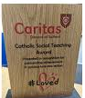
The Caritas Award is presented each week to a child in recognition of their outstanding achievement in putting love into action. This week the award goes to Emilie in RDM for looking after a friend when they were upset.

Attendance
Overall whole school attendance this week was 92.9% . 34 pupils have been late 42 times and 10 pupils have arrived after 9 o’clock 23 times. There does seem to be a pattern of lateness for certain families. If you are experiencing any difficulties or require any additional support with attendance or punctuality, please contact our Attendance Officer, Mrs Burgess Hamlett.

The best classes this week for attendance is 4H with 99% They will have a longer break. Well done to them!

School doors open at 8.40am to give the children time to take off their coats and be ready at their desks for an 8.45am start. The doors close promptly at 8.45am.
Under the UN Convention on the Rights of the Child (UNCRC), Article 29, children have the right to an education.

Year 6 high school places
You are now able to apply for your child’s high school place for next September 2026. Applications must be made prior to October 31st 2025 for a September 2026 start.
If you live in Manchester, you can apply online via https://www.manchester.gov.uk/info/500322/secondary_school_admissions/7516/apply_for_a_year_7_secondary_place_for_september_2020
If your address comes under Rochdale, the link is https://www.rochdale.gov.uk/school-admissions-appeals/apply-secondary-school-place
If you need any support with filling in the application, please ask.
As a Catholic school, we hope that you will continue to choose to educate your child in a Catholic high school.

Support
As a school we are here for both your children and your family. If you are experiencing any difficulties or have any anxieties, please get in touch with Mrs Sylvester for a private conversation. Her email address is c.sylvester@st-clares.manchester.sch.uk or you can ring the school number or message via the school app. If we are unable to help you, we may be able to refer you to somebody who can.

Safeguarding
Safeguarding children is everyone’s responsibility. If you have any concerns regarding the safety of a child, please report it. You are able to refer concerns directly to children’s services. The contact details for them is particularly important during the summer holidays when some children may be susceptible to more harm and neglect.

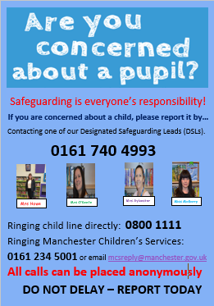

I hope that you all have an amazing half term break. School re-opens on Monday 3rd November.
God bless,
Mrs Howe

Upcoming dates
9th November – Family Mass 10.30am in church
10th November – Year 6 Crucial Crew
11th November – R-Y6 flu immunisations
17th November – individual photographs in school

The weekly newsletter is also available on our school website Newsletters

A Prayer for Peace
