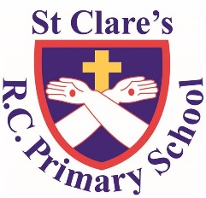
Religious Education Curriculum Overview 2023

 | Autumn |  |  | Spring |  |  | Summer
 | Domestic church / family | Baptism / Confirmation / belonging | Advent / Christmas / loving | Local church / community | Reconciliation / inter-relating | Lent / Easter / giving | Pentecost / serving | Eucharist / relating | Universal church / world
EYFS | Myself | Welcome | Birthday | Celebrating | Friends | Growing | Good News | Gathering | Our world
Year 1 | Families | Belonging | Waiting | Special people | Being sorry | Change | Holidays and holydays | Meals | Neighbours
Year 2 | Beginnings | Signs and symbols | Preparations | Books | Rules | Opportunities | Spread the word | Thanksgiving | Treasures
Year 3 | Homes | Promises | Visitors | Journeys | Choices | Giving all | Energy | Listening and sharing | Special places
Year 4 | People | Called | Gift | Community | Building bridges | Self discipline | New life | Giving and receiving | God’s people
Year 5 | Ourselves | Life choices | Hope | Mission | Freedom and responsibility | Sacrifice | Transformation | Memorial sacrifice | Stewardship
Year 6 | Loving | Vocation and commitment | Expectations | Sources | Healing | Death and new life | Witnesses | Unity | Common good

In addition to the Come and See programme of study, we have two inter-faith weeks. During these weeks we focus on Judaism and Islam.

