SEND Information Report 2022-2023
1.1 The kinds of SEN that are provided for:
St. Clare’s currently provides additional and/or different provision for a range of needs, including:
- Communication and interaction, for example, autistic spectrum disorder, Asperger’s Syndrome, speech and language difficulties
- Cognition and learning, for example, dyslexia, dyspraxia
- Social, emotional and mental health difficulties, for example, attention deficit hyperactivity disorder (ADHD)
- Sensory and/or physical needs, for example, visual impairments, hearing impairments, processing difficulties, epilepsy
- Moderate and severe learning difficulties
1.2 Identifying pupils with SEN and assessing their needs
Identification, Assessment and Provision
In order to help children with special educational needs, St. Clare’s will adopt a graduated response, which is led and co-ordinated by the SENDCO working with and supporting individual practitioners in the setting as outlined in “The Code of Practice (2014)” https://www.gov.uk/government/publications/send-code-of-practice-0-to-25

This may see us using specialist expertise if as a school we feel that our interventions are still not having an impact on the individual. The school will record the steps taken to meet the needs of individual children through the use of an IEP (Individual Education Plan) and review sheet/provision map and the SENDCO will have responsibility for ensuring that records are kept and available when needed. If we refer a child for statutory assessment/Education Health and Care Plan, we will provide the LEA with a record of our work with the child to date.

When any concern is initially noticed, it is the responsibility of the class teacher to take steps to address the issue. Parents may be consulted and a specific intervention put in place and monitored for a short period of time. If no/limited progress is noted after this time the child may be added to the school SEND list with parental permission. The class teacher, after discussion with the SENDCO, will then provide additional support for the pupil which could be in the form of:
- Additional adult support.
- Resources to support their learning but maintain independence and support their resilience.
- Be given opportunities to work as part of a group.
- Adaptations to how work is presented or given.
- Interventions that are additional to those provided as part of the school’s differentiated curriculum.
- An Individual Education Plan (IEPs) which will be worked on regularly throughout the week. These targets will be monitored by the class teacher and teaching assistants in collaboration. The TA will regularly review and celebrate these with the young person following each session. The Class teacher will review these formally with the parents and new targets will be set three times a year.

We will assess each pupil’s current skills and levels of attainment on entry, which will build on previous settings and Key Stages, where appropriate. Class teachers will make regular assessments of progress for all pupils and identify those whose progress:
- Is significantly slower than that of their peers starting from the same baseline.
- Fails to match or better the child’s previous rate of progress.
- Fails to close the attainment gap between the child and their peers
- Is slower than expected and as a result the attainment gap is widening.

Slow progress and low attainment will not automatically mean a pupil is recorded as having SEND.
When deciding whether special educational provision is required, we will start with the desired outcomes, including the expected progress and attainment, and the views and the wishes of the pupil and their parents. We will use this to determine the support that is needed and whether we can provide it by adapting our core offer, or whether something different or additional is needed.

At St. Clare’s we screen pupil for possible SEND at various points in their school journey. The screening procedures we use and when are:
Reception – On entry; all pupils are screened for possible S&L difficulties using WELCOMM
Year 3 – In December all pupils are screened for dyslexia and any pupil new to the school.

1.3 Consulting and involving pupils and parents
We will have an early discussion with the pupil and their parents when identifying whether they need special educational provision. These conversations will make sure that:
- Everyone develops a good understanding of the pupil’s areas of strength and difficulty
- We take into account the parents’ concerns
- Everyone understands the agreed outcomes sought for the child
- Everyone is clear on what the next steps are

Notes of these early discussions will be added to the pupil’s internal CPOM record.
We will formally notify parents by letter when it is decided that a pupil will receive SEN support and parents will be asked to sign and return this, agreeing to SEND support.
1.4 Assessing and reviewing pupils' progress towards outcomes
We will follow the graduated approach and the four-part cycle of assess, plan, do, review.
The class teacher will assess pupil’s needs. This will draw on:
- The teacher’s assessment and experience of the pupil
- Their previous progress and attainment or behaviour
- Other teachers’ assessments, where relevant
- The individual’s development in comparison to their peers and national data
- The views and experience of parents
- The pupil’s own views
- Advice from external support services, if relevant

All teachers and support staff who work with the pupil will be made aware of their needs, the outcomes sought, the support provided, and any teaching strategies or approaches that are required. We will regularly review the effectiveness of the support and interventions and their impact on the pupil’s progress.
Where the pupils have more complex or significant SEND a formal assess, plan, do, review document will be completed by the class teacher in consultation with the SENDco and shared with parents.
1.5 Supporting pupils moving between phases and preparing for adulthood
We will share information with the school, college, or other setting the pupil is moving to. We will agree with parents and pupils which information will be shared as part of this.
We support transition in the following ways:
- Personalised Social Stories
- Additional visits to the pupils next phase in education
- Meeting with new schools where appropriate to share information
- Transferring all information held to new school
1.6 Our approach to teaching pupils with SEN
Teachers are responsible and accountable for the progress and development of all the pupils in their class.
High-quality teaching is our first step in responding to pupils who have SEN. SEND pupils will be supported with their learning in the following ways:
- Activities may be differentiated for individual pupils.
- Additional scaffolding for SEND pupils may be given e.g. writing frames
- Resources to support their learning be given e.g. wordbanks, concrete math’s equipment, visual resources,
- Pre teaching new learning and vocabulary.
- Individualised resources e.g laptop, writing slope
1.7 Adaptations to the curriculum and learning environment
We make the following adaptations to ensure all pupils’ needs are met:
- Differentiating our curriculum to ensure all pupils are able to access it, for example, by grouping, 1:1 work, teaching style, content of the lesson, etc.
- Adapting our resources and staffing
- Using recommended aids, such as laptops, coloured overlays, visual timetables, larger font, etc.
- Differentiating our teaching, for example, giving longer processing times, pre-teaching of key vocabulary, reading instructions aloud, etc.
- Personalising the curriculum that is taught.

Below is a list of all the resources and interventions St. Clare’s currently provide to support pupils in school.
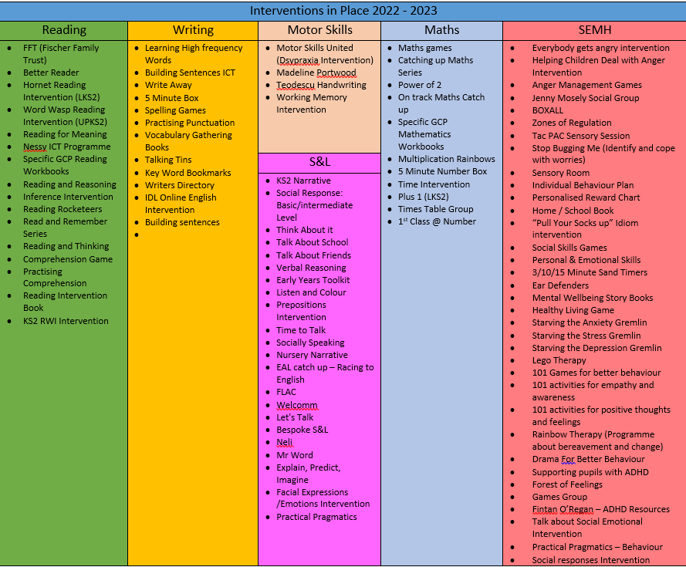
1.8 Additional support for learning
St. Clare’s R.C. Primary School currently employs 38 teaching assistants. We have teaching assistants specifically trained to deliver interventions such as:
- FFT
- Better Reader
- Numbers Count
- RWI
- Forest School
- NELI
- WELCOMM
- SALT
- ELKLAN
- 1st Class@Number
Teaching assistants will support pupils on a 1:1 basis when they are in receipt of an EHCP and they have complex SEND. The amount of 1:1 support they are given will differ depending on the pupils needs and the amount of top up funding is received. Where a pupil has complex SEND the school will use their budget to top up the difference.
Teaching assistants will support pupils in small groups during Literacy and Numeracy as well as deliver identified and bespoke interventions for identified pupils.

Teaching assistants will also deliver additional booster sessions before and after school for identified pupils whose attainment or progress is below the school’s expectations. These are changed after each assessment point.
1.9 Expertise and training of staff
St. Clare’s SENDCO has 21 years’ experience as a SENDco. She has worked as a class teacher in EYFS, KS1 and KS2 prior to her appointment at St. Clare’s.
J. O’Keefe is non-class based and so is able to manage her time effectively to manage SEN provision.
We have a team of 38 teaching assistants which include 3 higher level teaching assistants (HLTAs).
Each year the SENDco looks at relevant training and some TAs receive training based on the needs of the school. All training is reported in the governors reports which is also shared on the school website.
2.0 Securing equipment and facilities
Some SEND resources are stored in a cupboard in the KS2 building on the main link corridor. SEND resources are also in every class to support pupils with their learning.
SEND iPads and laptops are secured in class safely and are the responsibility of either the pupil’s 1:1 or the class teacher if the pupil does not have a 1:1.
2.1 Evaluating the effectiveness of SEN provision
We evaluate the effectiveness of provision for pupils with SEN by:
- Reviewing pupils’ individual progress towards their goals each term
- Regularly reviewing the impact of interventions
- Using pupil questionnaires
- Monitoring by the SENDCO and/or SLT
- Using provision maps to measure progress
- Holding annual reviews for pupils with EHC plans
- Producing reports to the governing body standards committee three times yearly
2.2 Enabling pupils with SEND to engage in activities available to those in the school who do not have SEND
All of our extra-curricular activities and school visits are available to all our pupils regardless of their SEND; including our breakfast club provision and after-school clubs.
All SEND pupils are encouraged to go on our residential trip to Condover in Year 6.
All SEND pupils are encouraged to take part in all activities available to them e.g. sports day / school plays / special workshops / forest school.
No pupil is ever excluded from taking part in these activities because of their SEN or disability.
Arrangements for the admission of SEND and disabled pupils is in line with our agreed admissions policy.
To support pupils with disabilities we have an accessibility policy which covers:
  - Improving the physical environment to enable disabled pupils to take better advantage of the education, benefits, facilities and services you provide
  - Improving the availability of accessible information to disabled pupils
2.3 Support for improving emotional and social development
We provide support for pupils to improve their emotional and social development in the following ways:
- Pupils with SEND are encouraged to represent the school
- We have a zero tolerance approach to bullying.
St. Clare’s have a number of interventions that support SEND pupils with social, emotional needs. These are listed above:

2.4 Working with other agencies
At St. Clare’s we work with the following agencies to provide support for pupils with SEND:
- Educational Psychologist
- Speech and Language Therapist
- Occupational Therapist
- Early Help
- CAMHs
- Youth Zone – Manchester
- Play therapy
- Health
- Children’s Services
- Outreach
- RHOSEY

2.5 Complaints about SEN provision
Complaints about SEN provision in our school should be made to the class teacher in the first instance and then if the complainant is not satisfied this is then escalated to the SENDCO and / or Head teacher. If a satisfactory resolution is not found they will then be referred to the school’s complaints policy.
The parents of pupils with disabilities have the right to make disability discrimination claims to the first-tier SEND tribunal if they believe that our school has discriminated against their children. They can make a claim about alleged discrimination regarding:
- Exclusions
- Provision of education and associated services
- Making reasonable adjustments, including the provision of auxiliary aids and services
2.6 Contact details of support services for parents of pupils with SEN
Support services available in Manchester to support parent with SEND are:

Information Advice and Support Service: https://secure.manchester.gov.uk/info/500132/special_educational_needs/628/information_advice_and_support_ias_manchester

Manchester Directory of Support:
https://hsm.manchester.gov.uk/kb5/manchester/directory/localoffer.page?localofferchannel=0

2.7 The local authority local offer
St. Clare’s Local Offer is published here: https://www.st-clares.manchester.sch.uk/parents/sen
Our local authority’s local offer is published here: https://hsm.manchester.gov.uk/kb5/manchester/directory/localoffer.page?localofferchannel=0

2.8 Links with other policies and documents
This Information Report links to the following documents
- Accessibility plan
- Behaviour policy
- Equality information and objectives
- Supporting pupils with medical conditions policy
- Teaching and Learning Policy
2.9 Contact details for SENDco
Mrs. Joanne O’Keefe
Email: j.okeefe@st-clares.manchester.sch.uk

Telephone: 0161 740 4993

This SEND information report will be reviewed by Mrs Joanne O’Keefe each year and be shared with the full governing body. The SEND information report will then be published on the school SEND page on the website:
https://www.st-clares.manchester.sch.uk/parents/sen

