SENDco: Mrs Joanne O’Keefe
SEND Governor: Sue Kane
Appointments can be made via the school office: 0161 740 4993
In September 2022:
21.1% of pupils at St. Clare’s are listed as SEND. This compares to a national average of 14.6% and a Manchester average of 15.5%
4.1% of pupils have an EHCP. This compares to a national average of 2.1% and a Manchester average of 2.2%

The aims of this policy are:
• To create an environment that meets the special educational needs of each child in order that they can achieve their learning potential and engage in activities alongside pupils who do not have SEN
• To request, monitor and respond to parents/carers and pupils’ views in order to evidence high levels of confidence and partnership
• To ensure support for pupils with medical conditions full inclusion in all school activities by ensuring consultation with health and social care professionals
• Through reasonable adjustments to enable all children to have full access to all elements of the school curriculum
• To work in cooperation and productive partnerships with the Local Education Authority and other outside agencies, to ensure there is a multi-professional approach to meeting the needs of all vulnerable learners

It is the belief that all children have an equal right to a full and rounded education which will enable them to achieve their full potential. We use our best endeavours to secure special educational provision for pupils for whom this is required, that is ‘additional to and different from’ that provided within the differentiated curriculum to better respond to the four areas of need identified in the SEND Code of Practice.

Legislation and Guidance:
This policy and information report is based on the statutory Special Educational Needs and Disability (SEND) Code of Practice and the following legislation:
- Part 3 of the Children and Families Act 2014, which sets out schools’ responsibilities for pupils with SEN and disabilities
- The Special Educational Needs and Disability Regulations 2014, which set out schools’ responsibilities for education, health and care (EHC) plans, SEN co-ordinators (SENCOs) and the SEN information report
What is a special educational need?
A pupil has SEN if they have a learning difficulty or disability that calls for special educational provision to be made for them.
They have a learning difficulty or disability if they have:
- A significantly greater difficulty in learning than the majority of the others of the same age, or
- A disability which prevents or hinders them from making use of facilities of a kind generally provided for others of the same age in mainstream schools.

PART 1: Introduction
SEND falls into one of the following categories:
• Communication and interaction (SCLN)
• Cognition and learning (MLD)
• Social, mental and emotional health (SEMH)
• Sensory/physical (PD)

Philosophy
All members of staff, in conjunction with the authorities, (Governing Body and LA) have a responsibility to ensure that every student has an equal opportunity to attain their maximum potential in all aspects of the curriculum. Students are entitled to a broad and balanced curriculum, including the National Curriculum (incorporating personalised provision), and their relative progress will be recorded, valued and reviewed.

Definition of Special Educational Needs and Disability (SEND):
Students have special educational needs if they have a difficulty accessing the curriculum, temporary or more long-term, which calls for special educational provision to be made for them. Students have difficulty accessing the curriculum if they: Have significant difficulties in learning in comparison with the majority of children of the same age. Have a disability, which prevents or hinders them from making use of educational facilities of a kind generally provided for children of the same age. Students who experience difficulty in accessing the curriculum may also have a particular gift or talent. This is addressed through the Gifted and Talented Provision, in addition to provisions made for their specific need. Special Educational Provision may be triggered when students fail to achieve adequate progress, despite having had access to a differentiated programme. Parents and staff will be informed that the child has special educational needs and appropriate provision identified to meet the student’s individual need(s) will be made.

Throughout this policy, parents should be taken to include all those with parental responsibility, including corporate parents and carers. Lack of adequate progress may be indicated by:
- Little or no progress despite the use of targeted teaching approaches and a differentiated curriculum.
- Working at levels significantly below age expectations, particularly in Literacy or Numeracy.
- Presenting persistent emotional and / or behavioural difficulties, which have not been managed by appropriate strategies, usually employed.
- Sensory or physical impairments that result in little progress despite the provision of appropriate aids or equipment.
- Poor communication or interaction, requiring specific interactions and adaptations to access learning.

Responsibilities:
Responsibility for the teaching of pupils with special educational needs remains the responsibility of the class teacher as set out in the teacher standards.
The SENDCO for St. Clare’s is: Mrs. Joanne O’Keefe
Email: j.okeefe@st-clares.manchester.sch.uk

Telephone: 0161 740 4993

Governors:
- A named governor to have responsibility for the implementation of the SEN policy.
- To be fully involved in developing and monitoring the SEN policy.
- To have up to date knowledge about the school’s SEN provision, including funding.
- To know how equipment and personnel resources are deployed.
- To ensure that SEN provision is an integral part of the School Improvement Plan.
- To ensure that financial resources are available to carry out the SEN policy.
- To ensure the quality of SEN provision is continually monitored.
- To ensure the SEN policy is subject to a regular cycle of monitoring, evaluation and review.
- To liaise with the Head teacher and SENDco.
Headteacher:
- Work with the SENDCO and SEN governor to determine the strategic development of the SEN policy and provision within the school.
- Have overall responsibility for the provision and progress of learners with SEN and/or a disability.

SENDco:
- Work with the head teacher and SEN governor to determine the strategic development of the SEN policy and provision in the school.
- Have day-to-day responsibility for the operation of this SEN policy and the co-ordination of specific provision made to support individual pupils with SEN, including those who have EHC plans.
- Provide professional guidance to colleagues and work with staff, parents, and other agencies to ensure that pupils with SEN receive appropriate support and high-quality teaching.
- Advise on the graduated approach to providing SEN support.
- Advise on the deployment of the school’s delegated budget and other resources to meet pupils’ needs effectively.
- Be the point of contact for external agencies, especially the local authority (LA) and its support services.
- Liaise with potential next providers of education to ensure that the school meets its responsibilities under the Equality Act 2010 with regard to reasonable adjustments and access arrangements.
- Ensure the school keeps the records of all pupils with SEN up to date.
- Update the website to ensure there is accurate and relevant information to support parents of pupils with SEND https://www.st-clares.manchester.sch.uk/parents/sen

Class Teacher:
- Teachers will deliver high-quality teaching as our first step in responding to pupils who have SEND.
- Teacher will ensure SEND pupils within their class are supported to access the curriculum in the following ways:
- Activities may be differentiated for individual pupils.
- Additional scaffolding for SEND pupils may be given e.g. writing frames.
- Resources are used to support their learning and independence e.g. word banks, concrete math’s equipment, visual resources.
- Pupils given opportunities to pre teach new learning and vocabulary.
- Pupils may be given bespoke resources to support their learning and independence e.g. laptop, iPad, specialist equipment.
- Teachers are responsible for the progress and development of every pupil in their class.
- Teachers are responsible for working closely with any teaching assistants or specialist staff to plan and assess the impact of support and interventions, and how they can be linked to classroom teaching.
- Teachers have a responsibility to work with the SENDCO to review each pupil’s progress and development, and decide on any changes to provision.
- Teachers have a responsibility to ensure they follow this SEND policy.
- Teachers have a responsibility to ensure they know which pupils in their class are on the SEN List and who receive external agency support.
- Teachers have a responsibility to maintain an SEN file for their class reflecting this information for each individual child and copies of all relevant IEPs.
- Teachers are responsible for writing individual IEPs for pupils who require SEN support and those with an EHCP.
- Teachers have a responsibility to ensure that these IEPs are reviewed with the parents (and child if appropriate) at least three times a year.
- Teachers have a responsibility to provide a detailed record of the Individual Education Plan targets and the strategies adopted and their relative success for each child with special needs.
- Teachers have a responsibility to attend appropriate INSET and courses.

Teaching Assistants: Under the guidance of the class teacher to:
- Carry out activities and learning programmes planned by the class teacher and the SENDCo.
- To keep records of this work as requested.
- To support children in class or by withdrawing individuals and small groups.
- To attend INSET and courses where appropriate.
- To be fully aware of the school’s SEN policy.

PART 2: Identification, Assessment and Provision
In order to help children with special educational needs, St. Clare’s will adopt a graduated response, which is led and co-ordinated by the SENDCO working with and supporting individual practitioners in the setting as outlined in “The Code of Practice (2014)” https://www.gov.uk/government/publications/send-code-of-practice-0-to-25

This may see us using specialist expertise if as a school we feel that our interventions are still not having an impact on the individual. The school will record the steps taken to meet the needs of individual children through the use of an IEP (Individual Education Plan) and review sheet/provision map and the SENDCO will have responsibility for ensuring that records are kept and available when needed. If we refer a child for statutory assessment/Education Health and Care Plan, we will provide the LEA with a record of our work with the child to date.

When any concern is initially noticed, it is the responsibility of the class teacher to take steps to address the issue. Parents may be consulted and specific intervention put in place and monitored for a period of up to 6 weeks. If no progress is noted after this time the child may be added to the school SEN list with parental permission. The class teacher after discussion with the SENDCO will then provide additional interventions that are additional to those provided as part of the school’s differentiated curriculum and the child will be given individual learning targets (IEPs) which will be worked on regularly throughout the week. These targets will be monitored by the class teacher and teaching assistants in collaboration. The TA will review these with the young person and the Class teacher will review these formally with the parents and new targets will be set.

We will assess each pupil’s current skills and levels of attainment on entry, which will build on previous settings and Key Stages, where appropriate. Class teachers will make regular assessments of progress for all pupils and identify those whose progress:
- Is significantly slower than that of their peers starting from the same baseline
- Fails to match or better the child’s previous rate of progress
- Fails to close the attainment gap between the child and their peers
- Widens the attainment gap

Slow progress and low attainment will not automatically mean a pupil is recorded as having SEN.
When deciding whether special educational provision is required, we will start with the desired outcomes, including the expected progress and attainment, and the views and the wishes of the pupil and their parents. We will use this to determine the support that is needed and whether we can provide it by adapting our core offer, or whether something different or additional is needed.

Screening procedures are used…
Reception – On entry; all pupils are screen for possible S&L difficulties using WELCOMM
Year 3 – In December all pupils are screened for dyslexia and any pupil new to the school.

Observation
Teacher and TAs consult with the SENDco and Inclusion Lead if they notice students who may need specialist help during the school year. These concerns are logged on CPOMs for the SENDco or Inclusion Lead to respond.

A student’s parent may express concern. Once information is gathered the process is the same as for staff referrals. All parental referrals are acted upon.

Curriculum Support [Provision] is achieved by:
- Identifying and assessing individual student's needs.
- Reporting of students' needs to all members of school staff.
- Providing an appropriate curriculum, taking into account;
  - National Curriculum
  - Continuity and progression
  - Delivering an appropriate curriculum, taking into account;
  - Suitable teaching materials
  - Effective, differentiated teaching strategies
  - A supportive learning environment
  - Encouraging a positive self-image.
- Providing learning support through;
  - Curriculum development
  - Support teaching
  - Bespoke training
  - Interventions to support pupils with SEND. https://www.st-clares.manchester.sch.uk/parents/sen
- Using outside agencies where necessary and appropriate.
- Monitoring individual progress and making revisions where necessary.
- Ensuring that parents / carers understand the process and involving them in the support of their child’s learning.
- Encouraging students with SEND to actively participate in all decision making processes and contributing to the assessment of their needs, meetings and transition process.
- Teaching Assistants and teachers collaborate effectively.
- Making regular reports to governors regarding SEND issues to raise awareness and to aid implementation of processes and procedures.
- Provide training where necessary to improve the knowledge and skills of teachers/TAs to support learners with SEND.

Progress
Pupil progress of all pupils is closely tracked throughout the year; interventions are pupils who fall behind or fail to make progress. When St. Clare’s identify a child as having SEN, parents will be informed and a graduated approach with four stages of action: assess, plan, do and review will be used. We will work in partnership with parents to establish the support the child needs.

Assessment
In identifying a child as needing SEN support, the practitioner, SENDCO and the child’s parents, will have carried out an analysis of the child’s needs. This initial assessment should be reviewed regularly to ensure that support is matched to need. Where there is little or

no improvement in the child’s progress, more specialist assessment may be called for from specialist teachers or from health, social services or other agencies beyond the setting. Where professionals are not already working with the setting, the SENCO should contact them, with the parents’ agreement.

Plan
Where it is decided to provide SEN support, and having formally notified the parents; the practitioner and the SENDCO should agree, in consultation with the parent, the outcomes they are seeking; the interventions and support to be put in place; the expected impact on progress, development or behaviour; and a clear date for review. Plans should take into

Account the views of the child where possible. The support and intervention provided should be selected to meet the outcomes identified for the child, based on reliable evidence of effectiveness, and provided by practitioners with relevant skills and knowledge. Any related staff development needs should be identified and addressed.

Parents should be involved in planning support and, where appropriate, in reinforcing the provision or contributing to progress at home.

Review
The effectiveness of the support and its impact on the child’s progress should be reviewed in line with the agreed date. The impact and quality of the support should be evaluated by the practitioner and the SENDCO working with the child’s parents and taking into account the child’s views. They should agree any changes to the outcomes and support for the child in light of the child’s progress and development. Parents should have clear information about the impact of the support provided and be involved in planning next steps.

This cycle of action should be revisited in increasing detail and with increasing frequency, to identify the best way of securing good progress. At each stage parents should be engaged with the setting, contributing their insights to assessment and planning. Intended outcomes should be shared with parents and reviewed with them, along with action taken by the setting, at agreed times.

Where a child has an EHC plan, the local authority must review that plan as a minimum every twelve months. As part of the review, the local authority can ask settings, and require maintained nursery schools, to convene and hold the annual review meeting on its behalf. Further information about EHC plan reviews and the role of early year’s settings is accessible on the website under our Local Offer.

In identifying a child as needing SEN support, the early years’ practitioner, working with the setting SENCO and the child’s parents, will have carried out an analysis of the child’s needs. This initial assessment should be reviewed regularly to ensure that support is matched to need. Where there is little or no improvement in the child’s progress, more specialist assessment may be called for from specialist teachers or from health, social services or other agencies beyond the setting. Where professionals are not already working with the setting, the SENCO should contact them, with the parents’ agreement.

Monitoring Children’s Progress
The school’s system for observing and assessing the progress of individual children will provide information about areas where a child is not progressing satisfactorily. Under these circumstances, teachers may need to consult the SENDCO to consider what else might be done. This review might lead to the conclusion that the pupil requires help over and above that which is normally available within the class. The key test of the need for action is that, current rates of progress are inadequate. Adequate progress can be identified as that which:
- Prevents the attainment gap between the child and his peers from widening.
- Closes the attainment gap between the child and his peers.
- Betters the child’s previous rate of progress.
- Ensures access to the full curriculum.
- Demonstrates an improvement in self-help, social or personal skills.
- Demonstrates improvements in the child’s behaviour.
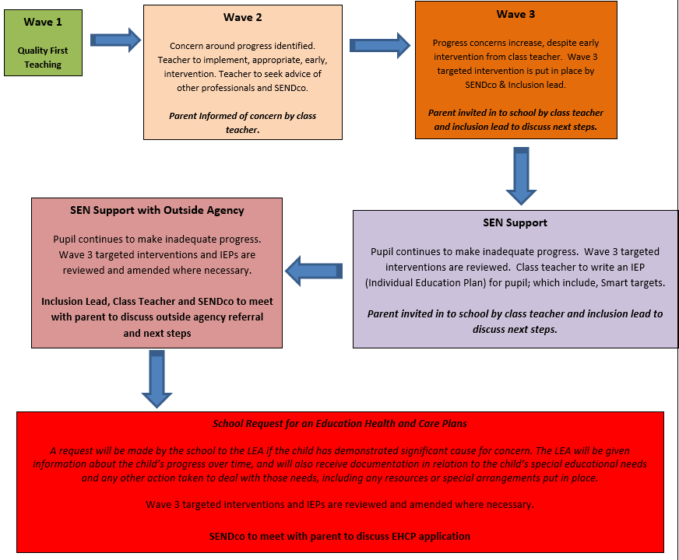

Agreed by the Governors of St. Clare’s RC Primary School on

Date: ……………………………………….

Declaration of receipt

I confirm that I have read the SEN policy and understand that failure to comply with the policy may lead to disciplinary action being taken.

Name: (please print): …………………………………………………

Signature: ……………………………………… Date: …………………………

