SEN Information:

Year | SEND Support | EHCP | Total
2020 | 74 | 17 | 91
2021 | 69 | 15 | 83
2022 | 81 | 17 | 98
2023 | 67 | 22 | 89

2022– 2023 SEN School Profile

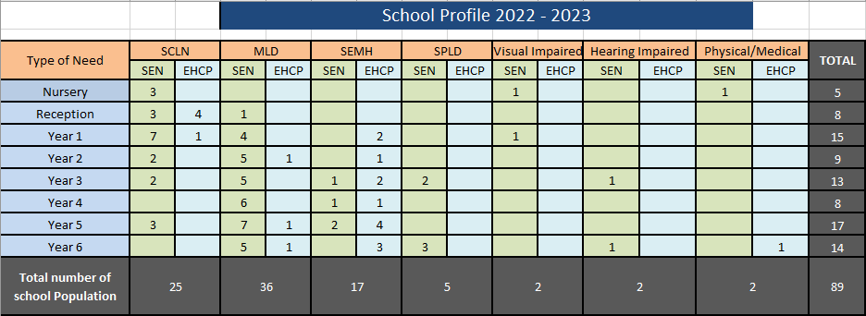

2022 – 2023 SEND Contextual Information:
In 2023 there were 89 pupils on the SEND list (at the time of writing this report). We continue to take in much more complex SEND pupils, who are requiring a much higher level of co-ordination and management. Out of the 89 pupils currently on the SEND list, over 56 of these pupils have outside agency involvement. Comparing our SEND data to Manchester and National data, St. Clare’s have a higher percentage of pupils with EHCP’s and accessing SEND support.
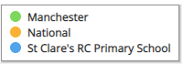

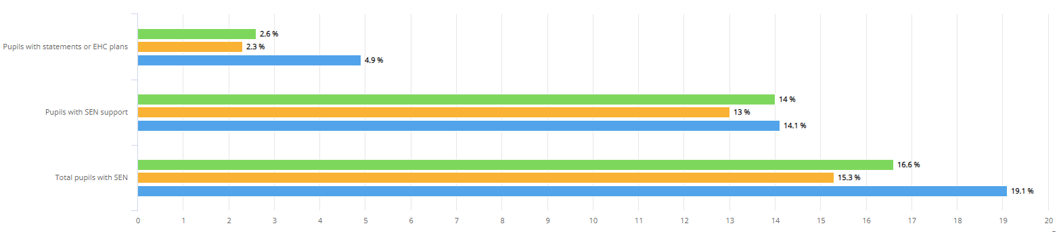

Identification of pupils with SEN:
SEN children are identified as having a defined difficulty over and above those generally experienced by the majority of his/her peer group. Teaching staff are responsible for identifying students with Special Educational Needs. Class teachers have the overall responsibility of ensuring that the curriculum will be, differentiated and delivered, in an inclusive way to meet the needs of each child within their class.

To support swift identification and the effective leadership of SEND within St. Clare’s the following strategies are used:
- SENDco is non-class based so SEND can be given the time and leadership required to fulfil the role effectively.
- SEND needs are quickly identified.
- Parents and outside agencies have quick access to the SENDco and provision is put into place to meet the needs of pupils quickly and efficiently.
- Provision for our most vulnerable pupils is regularly monitored for impact.
- Home visits are carried out to all new starters to Nursery or Reception. SALT TA accompanies EYFS staff to identify SEND quickly.
- Whole school data is analysed following each assessment point and new provision put in place to support SEND pupil to make at least expected progress.
- SEND forms part of all pupil progress meetings.
- The SEND list is a working document and updated regularly, based on agreed thresholds.
- Early identification and planned interventions ensure each child progresses in line with their academic ability to ensure no child goes undetected.
- Head teacher meets all new starters so any SEND is quickly identified. As a result, bespoke provision is immediately put into place.
- Open-door policy for SEND for parents to meet and discuss concerns they may have.
- Interventions are evidence-based and regularly reviewed so that the impact is maximised. SENDco regularly researches new interventions/resources; trials these regularly with smaller numbers of pupils before rolling these out to wider groups of SEND pupils.
- All pupils with an EHCP have a transfer review at the end of year 5 to ensure transition to secondary is smooth.
- All pupils who have had EP involvement are reviewed prior to transition to KS3 to ensure they are well supported going onto their next stage of education.
- Interventions are bespoke to the pupil’s needs.
- Class teachers ensure lessons are differentiated, matched to pupils needs and concrete resources used to support pupil learning.
- First-wave quality teaching is regularly monitored so that learning for SEND pupils is maximised.
- A central online tracking system allows interventions to be quickly grouped, analysed and costed. Provision Maps are then easily accessible. The system also allows individual pupil passports to be completed for our most complex SEND pupils.

Staffing Arrangements:
2022-23:
During this academic year we employed 16 Key Worker Teaching Assistants which were linked to 25 pupils across the school with an EHCP or element 2 funding via Rodney House. For most key workers, as part of their role, they work in small groups on interventions, which include their identified pupil. We currently have six pupils with exceptionally complex needs with four of whom requiring a completely different curriculum, based on their individual needs from the rest of their class.

Due to the levels of need and failure to recruit, despite trying on three occasions we had to employ three key workers from an agency to support our pupils with complex needs within the school.

Education Health Care Plans (High Needs):
During 2022-2023, I made five applications for statutory assessment. This remains significantly higher than previous. The evidence and educational evidence required to submit an application is lengthy and can takes weeks to put together before being ready to submit. During recent SEND updates through the SEND network meetings the Local Authority are looking into making the application process more streamline and easier to complete. All five of the applications I have submitted were agreed.

Seven pupils with an EHCP leave St. Clare’s in July. Five of these pupils are year 6 pupils moving onto secondary provision and transition for these pupils has already begun and I am already liaising with their chosen secondary school. All annual reviews are scheduled to take place in July with the SENDco from each school attending, which will support a smooth transition for our most vulnerable SEND pupils. Three of the EHCP pupils are transferring to Our Ladies and I met the SENDco around their transition on the 14th June. One year 6 pupil will be transferring to a specialist Catholic High school in Trafford. This is the first pupil to successfully obtain a place here during my time at St. Clare’s.

The Two remaining pupils moving to specialist are from reception and year one. Both pupils have continued to struggle with the mainstream environment despite school’s best efforts.

I am currently aware of two complex pupils who will be joining St. Clare’s in September. Both will be starting Reception. I have started liaising with parents and their current setting to support their transition. Both of these pupils have an EHCP in place and recruitment to support these pupils will be necessary before we finish for summer.

Educational Psychology Input:
Nine pupils have received educational psychologist (EP) assessment/input this year. Three of these were new assessments to support school in planning for their progress. Six pupils have had updated EP advice, five of these are form year 5 to support transition to secondary school. One pupil from Year Three also had updated EP advice in conjunction with their EHCP to support planning for them over Key Stage Two.

Speech and Language (SALT) Input:
Fourteen pupils have received Speech & Language (SALT) assessments/input over the year. Two pupils are currently receiving Developmental Language Disorder (DLD) input. This is intensive SALT input which requires a specially trained therapist to come into school to deliver alongside our SALT TA, Mrs Johnson. Mrs Johnson then completes the set work daily with the pupil. The impact of this work is regularly reviewed and adapted with the therapist. This intensive package of support costs the school around £3000 per annum as well as the additional cost of Mrs Johnson working with the pupil for an hour each day on the programme. The DLD programme is usually an eighteen month to two years’ programme.

High Needs Additional Funding

Intervention cost Breakdown:

SEND Stage | No. of Pupils | Cost Per Pupil | Total Cost
EHCP | 22 | 11,138.48 | 245,046.58
SEND Support | 71 | 872.01 | 61,912.52
 | 93 | 12,010.49 | 306,959.10

Training: 2022-2023:
- Positive Handling Training
- ASD Training
Resources April 2021- March 2022:
- SEMH Books for Children to support anxiety, behaviour, worries, ASD diagnosis
- SEMH Games to support positive choices, behaviour and improving resilience
- Sand Timers
- Chew Toys
- EP time to complete full cognitive assessments
- EP time to review pupils with previous EP input and write up to date reports
- SLI – DLD intense SALT input
- Sensory Resources
- Reading for Meaning Resources
- SALT Resources
- Lego Therapy Resources
- Provision Map online licence
- Speech Link License
- ICT resources to support Language and Literacy
- IDL Computerised Programme license
- EYFS resources to support SEND
- Fine motor resources
- Wedge cushions
Resource Name |  |  |  | Area of Need | Age | Resource Name | Area of Need | Age | Resource Name | Area of Need | Age
FFT (Fischer Family Trust) |  |  |  | Reading | KS1 | Maths games | Maths | KS2 | Everybody gets angry intervention | SEMH | KS2
Better Reader |  |  |  | Reading | KS2 | Catching up Maths Series | Maths | UKS2 | Helping Children Deal with Anger Intervention | SEMH | KS2
Hornet Reading Intervention |  |  |  | Reading | LKS2 | Power of 2 | Maths | KS2 | Anger Management Games | SEMH | KS1  KS2
Word Wasp Reading Intervention |  |  |  | Reading | UKS2 | On track Maths Catch up | Maths | KS2 | Jenny Mosely Social Group | SEMH | All
Reading For Meaning |  |  |  | Reading | KS2 | Specific GCP Mathematics Workbooks | Maths | KS2 | BOXALL | SEMH | All
Nessy ICT Programme |  |  |  | Literacy | KS2 | Multiplication Rainbows | Maths | KS2 | Tac PAC Sensory Session | SEMH | EYFS
Specific GCP Reading Workbooks |  |  |  | Reading | KS1 KS2 | 5 Minute Box | Maths | KS1 KS2 | Stop Bugging Me (Identify and cope with worries) | SEMH | All
Reading and Reasoning |  |  |  | Reading | KS1 KS2 | Time Intervention | Maths | KS2 | Sensory Room | SEMH | All
Inference Intervention |  |  |  | Reading | KS1 KS2 | Plus 1 | Maths | KS2 | Individual Behaviour Plan | SEMH | KS1 KS2
Reading Rocketeers |  |  |  | Reading | KS1 KS2 | KS2 Narrative | S&L | KS2 | Personalised Reward Chart | SEMH | All
Read and Remember Series |  |  |  | Reading | KS2 | Social Response: Basic/intermediate Level | S&L | ALL | Home / School Book | SEMH | KS2
Reading and Thinking |  |  |  | Reading | KS2 | Think About it | S&L | KS2 | “Pull Your Socks up” Idiom intervention | SEMH | KS2
Comprehension Game |  |  |  | Reading | KS2 | Talk About School | S&L | All | Social Skills Games | SEMH | KS2
Practising Comprehension |  |  |  | Reading | KS2 | Talk About Friends | S&L | All | Personal & Emotional Skills | SEMH | KS2
Reading Intervention Book |  |  |  | Reading | KS2 | Verbal Reasoning | S&L | All | 10 Minute / 15 Minute Sand Timers | SEMH | KS1  KS2
Learning High frequency Words |  |  |  | Writing | All | Early Years Toolkit | S&L | EYFS / EAL | Ear Defenders | SEMH | All
Building Sentences ICT |  |  |  | Writing | KS1 KS2 | Listen and Colour | S&L | EYFS Yr1 EAL | Mental Wellbeing Story Books | SEMH | All
Write Away |  |  |  | Writing | KS2 | Prepositions Intervention | S&L | All | Healthy Living Game | SEMH | KS2
5 Minute Box |  |  |  | Literacy | KS1 KS2 | Time to Talk | S&L | KS1 | Starving the Anxiety Gremlin | SEMH | KS1 KS2
Spelling Games |  |  |  | Writing | KS2 | Socially Speaking | S&L | KS2 | Starving the Stress Gremlin | SEMH | KS1 KS2
Practising Punctuation |  |  |  | Writing | KS2 | Nursery Narrative | S&L | EYFS | Starving the Depression Gremlin | SEMH | UKS2
Vocabulary Gathering Books |  |  |  | Writing | KS1 KS2 | EAL catch up – Racing to English | S&L | KS2 | Lego Therapy | SEMH | All
Talking Tins |  |  |  | Writing | KS1 LKS2 | Welcomm | S&L | EYFS | 101 Games for better behaviour | SEMH | KS1 KS2
Key Word Bookmarks |  |  |  | Writing | KS2 | Let's Talk | S&L | KS2 | 101 activities for empathy and awareness | Emotional Literacy | KS2
Writers Directory |  |  |  | Writing | KS2 | Teodescu Handwriting | Handwriting | All | 101 activities for positive thoughts and feelings | Emotional Literacy | KS2
Motor Skills United |  |  |  | Motor Skills | All | Working Memory Intervention | SPLD | All | Rainbow Therapy (Programme about bereavement and change) | SEMH | All
Madeline Portwood |  |  |  | Motor Skills / Dyspraxia | ALL | Forest Group | SEMH | All | Drama For Better Behaviour | SEMH | KS1  KS2
IDL – computer based Intervention |  |  |  | Literacy /  Numeracy |  | Talkabout Children developing social skills | S&L |  | Forest of Feelings – Emotions Intervention | SEMH | KS2
Fine motor skills owl |  |  |  | Dyspraxia | KS1 | Talkabout Children developing self-awareness and self esteem | S&L |  | KS1 Worry & Anxiety 1:1 books | SEMH | KS1
 |  |  |  |  |  | Talkabout Children Social Communication skills | S&L |  | The Worry Workbook | SEMH | KS2
 |  |  |  |  |  |  |  |  | Don’t Worry Be Happy | SEMH | KS2
 |  |  |  |  |  |  |  |  | Happy Confident Me Life Skills Journal | SEMH | UKS2
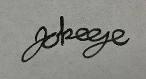
Signed:

Date: June 2023

