SEN List as of January 2025:

SEN | Number of Children
SEN Support | 59
EHCPs | 15
Total | 74

Current Interventions/SEND Resources:
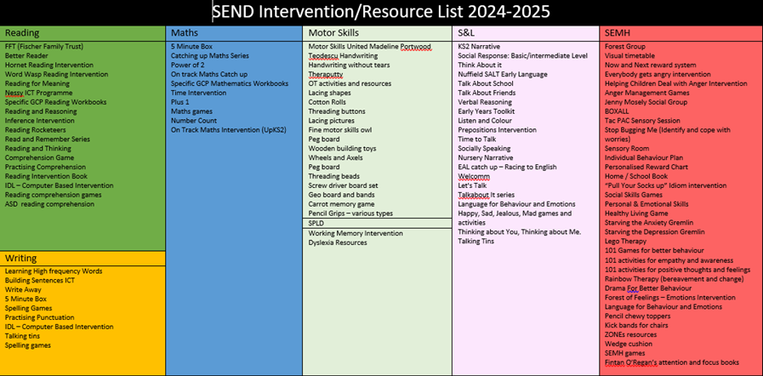
TA Deployment:
Autumn Training:
Welcomm Training
SALT Training
ElKlan Training
CHAMP Training
We have two HLTAs within school. During autumn, one HLTA worked for 3 days across Year 2 with identified pupils and pupils who were not on track to meet ARE (Age Related Expectations). 1 day was spent over 2 afternoons in Year 6 focusing on specific pupils to raise attainment and accelerate progress. Pupils in receipt of pupil premium funding were targeted in the first instance. A second HLTA worked across Year 1 for 4 days a week with a focus on Phonics and improving outcomes.

One TA, who specialises in speech & language has worked with pupils across the whole school around S&L (Speech & Language) as well as intervention to improve attention, listening and social skills. In the autumn term P. Johnson worked with 55 pupils across the school.

All other TAs are deployed directly by the class teacher with whom they work with as well as being given direct interventions from myself. These are based on their most recent assessment point, their SEND needs or interventions specifically designed to support pupils, SALT, social, emotional or Mental Health needs.

Outside Agency Involvement – Autumn term:
During the autumn term we had one pupil accessed for an intense SALT package (DLD – Developmental Language Disorder). A TA is deployed in school to work on their specific programme daily, under weekly guidance from the SALT team. A further pupil has been identified by the SALT team and is now awaiting a slot for the DLD to begin.

EHCP (Educational Health Care Plan) Pupils:
Over the autumn term I held five annual reviews for pupils with an EHCP.

In September, three pupils in Nursery were identified as needing a statutory assessment for an EHCP due to complex social communication and language difficulties. Element 2 funding was requested for all three pupils and this was granted at £300 a month per pupil. With this money an additional TA has been employed for the Nursery setting to support these pupils.

During the autumn term I made four applications for statutory assessment and all four have been successful. All four pupils will receive additional funding through an EHCP once these have been issued.

A review will be completed in March for the third Nursery pupil with a view of requesting statutory assessment for this pupil.

The demand for specialist places remains high across the city. We currently have a year 1 pupil who has been waiting for a place at a specialist setting since Nursery. We have yet to be informed whether this pupil will move to specialist for September 25.

During the spring term, a further three applications for statutory assessment will be made – one Year 3 pupil, one Nursery pupil and one Reception pupil.

During the spring term, nine pupils will be seen by an educational psychologist (EP). Five pupils are being seen by the school’s EP; three pupils will be seen by a one education EP to support statutory assessment. Finally, an EP is meeting with myself, class teacher and parents to support the writing of the EHCP for one pupil.

SEN Progress Autumn Term :
School Expectation is: 1-point Autumn, 2-points Spring, 3-Points Summer
% Progress | Mathematics | Reading | Writing
1 [4 children] | 50% 2/4 | 50% 2/4 | 50% 2/4
2 [8 children] | 100% 8/8 | 100% 8/8 | 88% 7/8
3 [17 children] | 82% 14/17 | 82% 14/17 | 76% 13/17
4 [11 children] | 45% 5/11 | 82% 9/11 | 64% 7/11
5 [11 children] | 73% 8/11 | 82% 9/11 | 73% 8/11
6 [8 children] | 100% 8/8 | 88% 7/8 | 88% 7/8
Overall Pts Progress | Mathematics | Reading | Writing
1 [4 children] | 0.5 | 0.5 | 0.5
2 [8 children] | 1.4 | 1.8 | 1.0
3 [17 children] | 0.9 | 0.7 | 0.8
4 [11 children] | 0.0 | 0.6 | 0.8
5 [11 children] | 0.6 | 1.2 | 1.6
6 [8 children] | 1.6 | 1.8 | 2.0
Data Analysis:
Overall, progress of pupils with SEND over the autumn is fairly positive. In Year 1, progress for SEND pupils was below the expectation however this was due to two exceptionally complex EHCP pupils. One of whom is waiting for specialist as outlined above.

In year 4 several pupils did not make their expected progress (particularly in Maths) this will be discussed with the class teachers in pupil progress meetings to see what further support these pupils may need over the spring term so the attainment gap does not widen any further.

All SEND pupils, who have not made at least expected progress over the autumn, have been identified and additional support through interventions and boosters put in place for them over the spring term.

SEND Attendance:
Attendance | National Data | LA Data | School 2023/24
Whole School | 94.1% | 94.19% | 95.26%
SEN Support | 92.2% | 92.52% | 93.63%
Difference | -1.9% | -1.67% | -1.63%
EHCP | 90.1 | 89.74 | 94.7
Difference | -4% | -4.45% | -4.1%

In 2023/24 our SEND attendance data was above National and Local Authority figures. The current picture looks similar and it is likely that SEND attendance will again be above National data.

Signed: 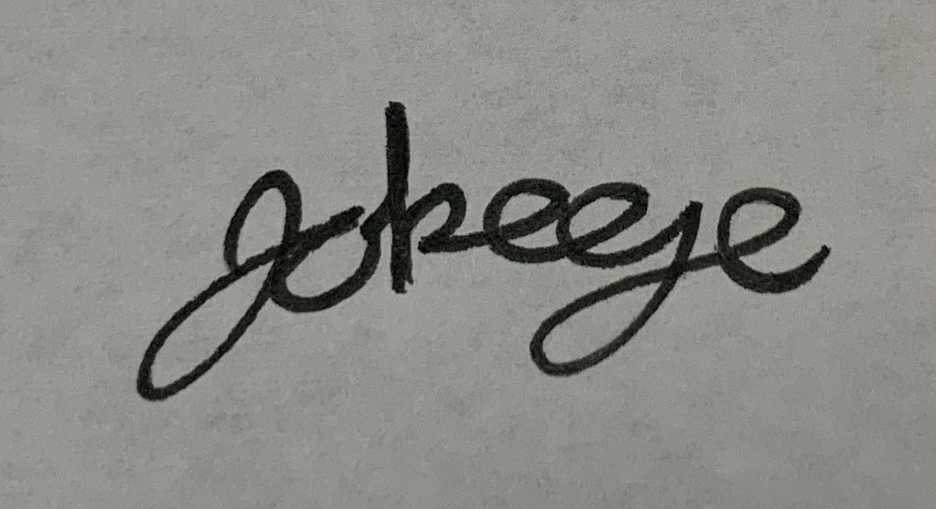 Date: 7th January 2024

