SEN List as of September 2025:

SEN | Number of Children | % of school | % of National
SEN Support | 51 | 11.9% | 14.2%
EHCP | 20 | 4.7% | 5.3%
Total | 71 | 16.6% | 19.5%

SEND School Profile of Need 2025-2026
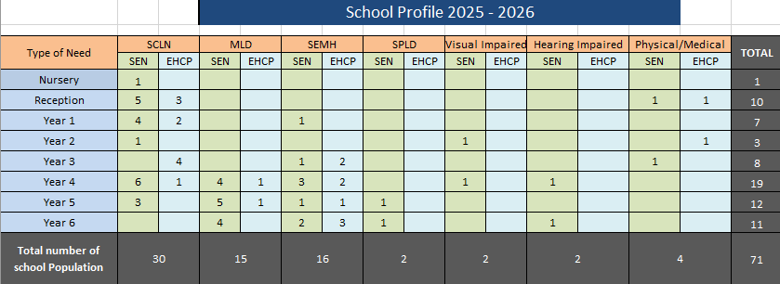
At St. Clare’s, our main type of need is speech, language and communication needs (SLCN) followed by Social Emotional and Mental health Needs (SEMH). Our most common type of need for those with an EHC plan is SEMH and SCLN (90%)

SEND Data: 2024-2025:
Year Group | SEND Progress  3 points is expected progress
Year Group | Reading | Writing | Maths
1 | 2.5 | 1.8 | 2.3
2 | 3.5 | 2.8 | 3.0
3 | 2.3 | 1.8 | 2.6
4 | 2.6 | 3.2 | 2.6
5 | 2.3 | 1.7 | 1.7
6 | 3.2 | 4.7 | 3.1
Progress of SEND Pupils in the Academic Year 2024-25
The overall progress of pupils with Special Educational Needs and Disabilities (SEND) during the 2024-25 academic year was varied. Multiple factors contribute to the challenges some SEND pupils face in achieving their expected progress within a school year.
In Year 1, we have a significant number of pupils with complex SEND needs. One pupil had been awaiting specialist assessment for several years and was transferred to specialist provision in September 2025. Another pupil has complex medical needs that affect their capacity to make academic progress; however, parental preference is for this pupil to remain at St. Clare’s. In Year 5, it was identified that previous assessments had been inaccurately administered, resulting in inflated attainment data.
For all SEND pupils who did not meet their expected progress targets, additional targeted interventions have been implemented for the autumn term. Their progress will be closely monitored and tracked throughout the academic year to ensure timely support and adjustment of strategies.
The systematic use of tracking data and detailed analysis of pupil progress remains critical in identifying pupils who are falling behind or at risk of doing so. Targeted interventions are promptly deployed to address emerging needs, ensuring that appropriate support packages are swiftly put in place. Despite this, the cornerstone of improving pupil attainment remains high-quality, first-wave teaching. Supporting every teacher to deliver outstanding teaching is paramount to securing the best outcomes for all pupils, with particular attention to our most disadvantaged learners.
Meeting the diverse needs of pupils with SEND is a collaborative process involving the pupil, their parents, and school staff. We maintain close partnerships with families to plan tailored support and conduct regular reviews of progress.
Pupil progress is analysed following each assessment point and is rigorously monitored by senior leaders. SEND provision and pupil outcomes are consistently featured in pupil progress meetings to ensure ongoing evaluation and responsive action.
Throughout the school day, many SEND pupils receive bespoke support tailored to their individual needs. This support is delivered either on a one-to-one basis or in small groups, ensuring targeted and effective intervention.
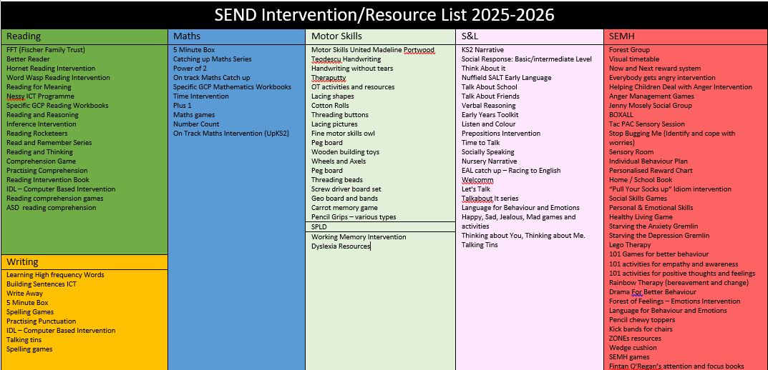

EHCP Pupils:
As of September 2025, St. Clare’s has twenty pupils with an Education, Health and Care Plan (EHCP) currently on roll, with a further three pupils awaiting their EHCPs to be finalised.
During the 2024-25 academic year, five EHCP applications were submitted, all of which were successful. Over the same period, two pupils with EHCPs left St. Clare’s: one Year 6 pupil transitioned to Our Lady’s High School for secondary education, and a Year 1 pupil moved to a specialist primary school, Camberwell.
Currently, three pupils with complex SEND needs are on roll. Two of these pupils are awaiting transfer to specialist provision, while one pupil remains at St. Clare’s by parental preference. To support pupils with significant Speech, Language, and Communication Needs (SLCN) and other complex needs, we have established the Willow Room in Key Stage 2. This dedicated internal SEND classroom offers a personalised curriculum and intensive support for pupils who find it challenging to thrive in mainstream classrooms. Entry and exit criteria for the Willow Room are strictly applied to ensure appropriate placement and to facilitate reintegration into mainstream classes when pupils meet the exit criteria. Daily inclusion opportunities are carefully planned to promote integration and social development.
In 2024-25, nine Educational Psychology assessments were conducted. Seven of these were reviews for pupils with existing EHCPs to ensure ongoing needs were met and to support transitions to secondary education. Two assessments were for newly identified pupils and contributed to successful EHCP applications.
Looking ahead, the school improvement plan for the coming year includes a targeted focus on enhancing SEND provision, particularly for pupils with complex needs.

Signed:  Date: October 2025

