SEN Register:

Number of children on SEN list as of June 2020

2019 – 2020 SEN School Profile



**Identification of pupils with SEN:**

SEN children are identified as having a defined difficulty over and above those generally experienced by the majority of his/her peer group. Teaching staff are responsible for identifying students with Special Educational Needs. Class teachers have the overall responsibility of ensuring that the curriculum will be, differentiated and delivered, in an inclusive way to meet the needs of each child within their class.

**To support swift identification of SEND within St. Clare’s the following strategies are used:**

* Home visits are carried out to all new starters to Nursery or Reception. SALT TA accompanies EYFS staff to identify SEND quickly.
* Whole school data is analysed at the end of each term and the SEN register is updated regularly, based on agreed thresholds between the Head-Teacher and SENDco.
* Early identification and planned interventions are essential in ensuring each child progresses in line with their academic ability to ensure no child goes undetected.
* Head teacher meets all new starters so any SEND is quickly identified. As a result, bespoke provision is immediately put into place.
* Open-door policy for SEND for parents to meet and discuss concerns they may have.

**Meeting the needs of pupils’ with SEN:**

* All pupils with an EHCP have a transfer review at the end of year 5 to ensure transition to secondary is smooth.
* Interventions are bespoke to the pupil’s needs.
* Interventions are evidence-based and regularly reviewed so that the impact is maximised.
* Class teachers ensure lessons are differentiated and matched to pupils needs.
* First-wave quality teaching is regularly monitored so that learning for SEND pupils is maximised.
* A central online tracking system allows interventions to be quickly grouped, analysed and costed. Provision Maps are then easily accessible. The system also allows individual pupil passports to be completed for our most complex SEND pupils.
* Termly SEND clinics allow parents to raise and discuss concerns they have about their child.

**Staffing Arrangements 2019-2020:**

We currently have ten Key Workers (TAs) linked with pupils across the school with EHCP’s. For most key workers, as part of their role, - they work in small groups on interventions, which include their identified pupil. We currently have four pupils with exceptionally complex needs. All four of these pupils need a completely different curriculum, based on their individual needs. One of these pupils has complex social, emotional difficulties and is on a completely different curriculum with the main focus being around improving his concentration, ability to follow instructions and learning to play alongside others. Three of these pupils is in KS1 and one pupil is in KS2.

Due to the increase in pupils with EHCPs we will need to recruit additional staff once school returns to some normality. This was on the agenda prior to the COVID-19 pandemic but we were unable to complete this.

**Education Health Care Plans (High Needs):**

During 2019-2020, I made three applications for statutory assessment. All three were agreed. During this academic year we have had two new starters to St. Clare’s from other settings. This takes the total number of EHCPs to seventeen – the most EHCPs in St. Clare’s history. Two pupils with an EHCP will leave St. Clare’s in July, reducing that number to fifteen.

Three pupils have received educational psychologist (EP) assessment/input this year. Another three were due to have assessments in April but this was cancelled due to the pandemic and the closure of school. These will be now be assessed when it is safe to do so.

Four pupils have received Speech & Language (SALT) assessments/input over the year.

**High Needs Additional Funding Amount Per Pupil Spend – Intervention:**

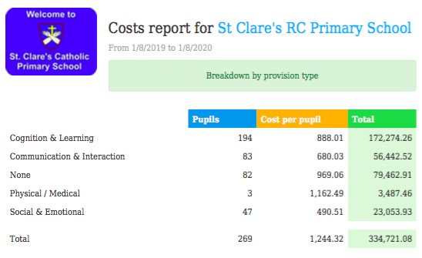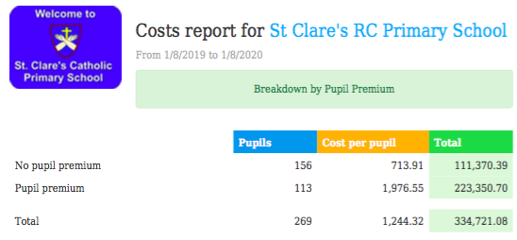

n 2019-2020, 269 pupils have benefitted from at least one intervention over the course of the year. The highest cost related to cognition and learning.

**Training: 2019-2020:**

* SALT Training
* Positive Handling Training
* Lego Therapy Training
* ASD Training
* TACPAC training
* De-escalation Training
* Teaching Numicon with SEND pupils.

**Resources April 2019- March 2020:**

* EP time to complete full cognitive assessments
* EP time to review pupils with previous EP input and write up to date reports
* Plus 1
* Power of 2
* SLI – intense SALT input
* Sensory Resources
* Word wasp
* Hornet
* SALT Resources
* Lego Therapy Resources
* Cooking Resources
* Provision Map online licence
* Speech Link License
* Social, Emotional Resources to support Anger, worries, Resilience, Emotional Literacy
* Cognitive resources to support Maths and Literacy
* Nessy Licence to support the teaching of reading and spelling for five pupils.

|  |  |  |  |  |  |  |  |  |
| --- | --- | --- | --- | --- | --- | --- | --- | --- |
| **Intervention Name** | **Area of Need** | **Age** | **Intervention Name** | **Area of Need** | **Age** | **Intervention Name** | **Area of Need** | **Age** |
| Maths Tuition | Cognition | KS1 / KS2 | Time to Talk | Communication | KS1 | BOXALL | SEMH | KS1 / KS2 |
| Reading Tuition | Cognition | KS1 / KS2 | Socially Speaking | Communication | KS2 | Lego Therapy | SEMH | ALL |
| RWI Tuition | Cognition | KS1 | Nursery Narrative | Communication | EYFS | Rainbow Therapy (Programme about bereavement and change) | SEMH | ALL |
| SPAG Tutition | Cognition | KS2 | SALT Individual Input | Communication | ALL | Jenny Mosely Social Group | SEMH | ALL |  |  |  |
| Better Reader | Cognition | KS2 | EAL catch up | communication | KS2 | Cooking | SEMH | KS2 |  |  |  |
| IEP | Cognition | All | Language Link SALT | Communication | EYFS | Tac PAC Sensory Session | SEMH | EYFS |  |  |  |
| Writing Intervention | Cognition | KS1 / KS2 | Let's Talk | communication | KS2 | Stop Bugging Me (Identify and cope with worries) | SEMH | ALL |  |  |  |
| Hornet Reading Intervention | cognition | LKS2 | SALT Vocab Group | communication | KS2 | Sensory Room | SEMH | ALL |  |  |  |
| Word Wasp Reading Intervention | cognition | UKS2 | Language Disorder Intensive | Communication | ALL | Individual Behaviour Plan | SEMH | KS1 / KS2 |  |  |  |
| Reading For Meaning | cognition | KS2 | KS2 Narrative | Communication | KS2 | Personalised Reward Chart | SEMH | ALL |  |  |  |
| Plus 1 | cognition | KS2 | Social Response: Basic/intermediate Level | Communication | ALL | Home / School Book | SEMH | KS2 |  |  |  |
| Power of 2 | cognition | KS2 | Think About it | Communication | KS2 | ASD Intervention | SEMH | KS2 |  |  |  |
| Inference Intervention | Cognition | KS2 | Talk About School | Communication | All |  | | |  |  |  |
| Daily Read | Cognition | EYFS/KS1/KS2 | Talk About Friends | Communication | All | Motor Skills United | Motor Skills | ALL |  |  |  |
| FFT (Fischer Family Trust) | Cognition | KS1 | Verbal Reasoning | Communication | All | Madeline Portwood | Motor Skills / Dyspraxia | ALL |  |  |  |
| Phonics Intervention | Cognition | EYFS / KS1 |  |  |  | Teodescu Handwriting | Motor Skills | ALL |  |  |  |
| Working Memory Intervention | Cognition | All |  |  |  |  |  |  |  |  |  |
| Nessy | Cognition | KS2 |  |  |  |  |  |  |  |  |  |
| Specific Reading Workbook | Cognition | KS2 |  |  |  |  |  |  |  |  |  |
| Specific Mathematics Workbook | Cognition | KS2 |  |  |  |  |  |  |  |  |  |

Signed: J. O’Keefe Date: June 2020