SEN Register:

Number of children on SEN list as of June 2021

2020 – 2021 SEN School Profile



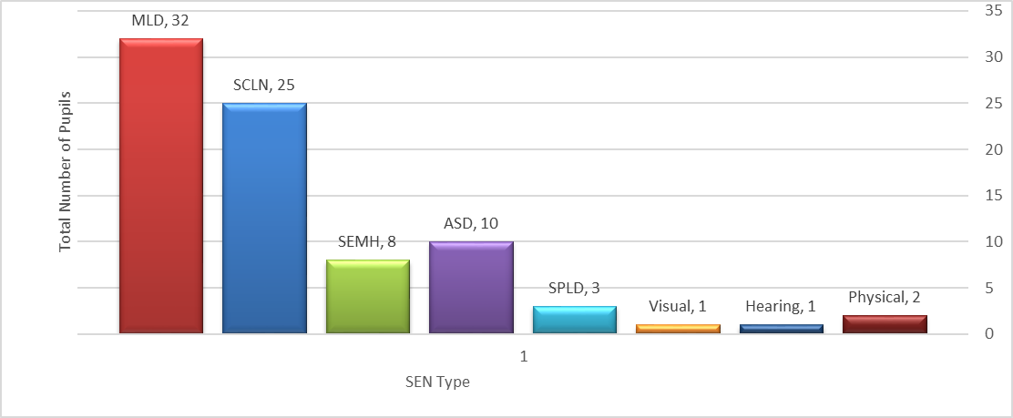

**Identification of pupils with SEN:**

SEN children are identified as having a defined difficulty over and above those generally experienced by the majority of his/her peer group. Teaching staff are responsible for identifying students with Special Educational Needs. Class teachers have the overall responsibility of ensuring that the curriculum will be, differentiated and delivered, in an inclusive way to meet the needs of each child within their class.

**To support swift identification of SEND within St. Clare’s the following strategies are used:**

* Home visits are carried out to all new starters to Nursery or Reception. SALT TA accompanies EYFS staff to identify SEND quickly.
* Whole school data is analysed at the end of each term and the SEN register is updated regularly, based on agreed thresholds between the Head-Teacher and SENDco.
* Early identification and planned interventions are essential in ensuring each child progresses in line with their academic ability to ensure no child goes undetected.
* Head teacher meets all new starters so any SEND is quickly identified. As a result, bespoke provision is immediately put into place.
* Open-door policy for SEND for parents to meet and discuss concerns they may have.

**Meeting the needs of pupils with SEN:**

* All pupils with an EHCP have a transfer review at the end of year 5 to ensure transition to secondary is smooth.
* All pupils who have had EP involvement are reviewed prior to transition to KS3 to ensure they are well supported going onto their next stage of education.
* Interventions are bespoke to the pupil’s needs.
* Interventions are evidence-based and regularly reviewed so that the impact is maximised.
* Class teachers ensure lessons are differentiated and matched to pupils needs.
* First-wave quality teaching is regularly monitored so that learning for SEND pupils is maximised.
* A central online tracking system allows interventions to be quickly grouped, analysed and costed. Provision Maps are then easily accessible. The system also allows individual pupil passports to be completed for our most complex SEND pupils.
* Termly SEND clinics allow parents to raise and discuss concerns they have about their child.

**Staffing Arrangements 2020-2021:**

We currently have 13 Key Workers (TAs) linked with pupils across the school with EHCP’s. For most key workers, as part of their role, - they work in small groups on interventions, which include their identified pupil. We currently have five pupils with exceptionally complex needs. All five of these pupils need a completely different curriculum, based on their individual needs. One of these pupils has complex social, emotional difficulties and is on a completely different curriculum with the main focus being around improving his concentration, ability to follow instructions and learning to play alongside others. Four of these pupils are in KS1 and one pupil is in KS2.

Specialist provision has been secured for two of these pupils. The year two pupil transferred to specialist in May and the other pupil (year one) is due to start specialist in September following ongoing discusses with parents. An annual review of his EHCP was conducted in April saying we were unable to meet his complex needs.

One Nursery pupil has been offered a place at specialist in September and mum has accepted this so he will also move in September.

**Education Health Care Plans (High Needs):**

During 2020-2021, I made five applications for statutory assessment. Four have been agreed and I await a decision on the fifth. One successful application was an emergency following a significant medical deterioration of a year 6 pupil. This pupil was recently admitted to hospital where he remains.

Two pupils with an EHCP leave St. Clare’s in July. In September there will be thirteen pupils with an EHCP.

**Educational Psychology Input:**

Ten pupils have received educational psychologist (EP) assessment/input this year. This is high due to four assessments being cancelled the previous year because of the Pandemic. Six of these were due to be seen in January & February, but were cancelled due to the school closure in January. All pupils who were on the list were seen during May and June.

**Speech and Language (SALT) Input:**

Eleven pupils have received Speech & Language (SALT) assessments/input over the year. One pupil received Developmental Language Disorder (DLD) input and after significant progress this will end in June. A new pupil will receive DLD input from June.

**High Needs Additional Funding Amount Per Pupil Spend – Intervention:**

During 2020-2021, 365 pupils have benefitted from at least one intervention over the course of the year. The highest intervention cost related to cognition and learning.



**Training: 2020-2021:**

* SALT Training - Nuffield Early Language
* Positive Handling Training
* ASD Training
* Youth Mental Health First Aider
* First Class at Number
* Better Reader
* Forest School Training

**Resources April 2020- March 2021:**

* EP time to complete full cognitive assessments
* EP time to review pupils with previous EP input and write up to date reports
* Plus 1 / Power of 2
* SLI – DLD intense SALT input
* Sensory Resources
* Word Wasp / Hornet
* Reading for Meaning Resources
* SALT Resources
* Lego Therapy Resources
* Cooking Resources
* Provision Map online licence
* Speech Link License
* SEMH Resources
* Cognitive resources to support Maths and Literacy
* 5 Minute Box – Literacy and Number
* Nessy Licence to support the teaching of reading and spelling for ten pupils.
* ICT resources to support Language and Literacy
* Fidget toys to support SEMH
* EYFS resources to support SEND
* Forest of Feelings Resources for SEMH Intervention

|  |  |  |  |  |  |  |  |  |
| --- | --- | --- | --- | --- | --- | --- | --- | --- |
| **Intervention List – 2020-2021** | | | | | | | | |
| **Resource Name** | **Area of Need** | **Age** | **Resource Name** | **Area of Need** | **Age** | **Resource Name** | **Area of Need** | **Age** |
| FFT (Fischer Family Trust) | Reading | KS1 | 5 Minute Box | Maths | KS1 KS2 | Everybody gets angry intervention | SEMH | KS2 |
| Better Reader | Reading | KS2 | Catching up Maths Series | Maths | UKS2 | Helping Children Deal with Anger Intervention | SEMH | KS2 |
| Hornet Reading Intervention | Reading | LKS2 | Power of 2 | Maths | KS2 | Anger Management Games | SEMH | KS1  KS2 |
| Word Wasp Reading Intervention | Reading | UKS2 | On track Maths Catch up | Maths | KS2 | Jenny Mosely Social Group | SEMH | ALL |  |  |  |
| Reading For Meaning | Reading | KS2 | Specific GCP Mathematics Workbooks | Maths | KS2 | BOXALL | SEMH | ALL |  |  |  |
| Nessy ICT Programme | Spelling | KS2 | Time Intervention | Maths | KS2 | Tac PAC Sensory Session | SEMH | EYFS |  |  |  |
| Specific GCP Reading Workbooks | Reading | KS1 KS2 | Plus 1 | Maths | KS2 | Stop Bugging Me (Identify and cope with worries) | SEMH | ALL |  |  |  |
| Reading and Reasoning | Reading | KS1 KS2 | KS2 Narrative | S&L | KS2 | Sensory Room | SEMH | ALL |  |  |  |
| Inference Intervention | Reading | KS1 KS2 | Social Response: Basic/intermediate Level | S&L | ALL | Individual Behaviour Plan | SEMH | KS1 KS2 |  |  |  |
| Reading Rocketeers | Reading | KS1 KS2 | Think About it | S&L | KS2 | Personalised Reward Chart | SEMH | ALL |  |  |  |
| Read and Remember Series | Reading | KS2 | Nuffield SALT Early Language | S&L | EYFS | Home / School Book | SEMH | KS2 |  |  |  |
| Reading and Thinking | Reading | KS2 | Talk About School | S&L | All | “Pull Your Socks up” Idiom intervention | SEMH | KS2 |  |  |  |
| Comprehension Game | Reading | KS2 | Talk About Friends | S&L | All | Social Skills Games | SEMH | KS2 |  |  |  |
| Practising Comprehension | Reading | KS2 | Verbal Reasoning | S&L | All | Personal & Emotional Skills | SEMH | KS2 |  |  |  |
| Reading Intervention Book | Reading | KS2 | Early Years Toolkit | S&L | EYFS / EAL | Healthy Living Game | SEMH | KS2 |  |  |  |
| Learning High frequency Words | Writing | All | Listen and Colour | S&L | EYFS Yr1 EAL | Starving the Anxiety Gremlin | SEMH | KS1 KS2 |  |  |  |
| Building Sentences ICT | Writing | KS1 KS2 | Prepositions Intervention | S&L | All | Starving the Stress Gremlin | SEMH | KS1 KS2 |  |  |  |
| Write Away | Writing | KS2 | Time to Talk | S&L | KS1 | Starving the Depression Gremlin | SEMH | UKS2 |  |  |  |
| 5 Minute Box | Literacy | KS1 KS2 | Socially Speaking | S&L | KS2 | Lego Therapy | SEMH | ALL |  |  |  |
| Spelling Games | Writing | KS2 | Nursery Narrative | S&L | EYFS | 101 Games for better behaviour | SEMH | KS1 KS2 |  |  |  |
| Practising Punctuation | Writing | KS2 | EAL catch up – Racing to English | S&L | KS2 | 101 activities for empathy and awareness | Emotional Literacy | KS2 |  |  |  |
| Motor Skills United | Motor Skills | All | Welcomm | S&L | EYFS | 101 activities for positive thoughts and feelings | Emotional Literacy | KS2 |  |  |  |
| Madeline Portwood | Motor Skills / Dyspraxia | ALL | Let's Talk | S&L | KS2 | Rainbow Therapy (bereavement and change) | SEMH | ALL |  |  |  |
|  |  |  | Teodescu Handwriting | Handwriting | ALL | Drama For Better Behaviour | SEMH | KS1  KS2 |  |  |  |
|  |  |  | Working Memory Intervention | SPLD | All | Forest of Feelings – Emotions Intervention | SEMH | KS2 |  |  |  |
|  |  |  | Forest Group | SEMH | All |  |  |  |  |  |  |

Signed: 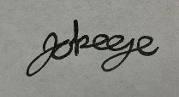 Date: June 2021