SEN Information:

Year | SEND Support | EHCP | Total
2019 | 57 | 13 | 70
2020 | 74 | 17 | 91
2021 | 69 | 15 | 83
2022 | 81 | 17 | 98

2021 – 2022 SEN School Profile
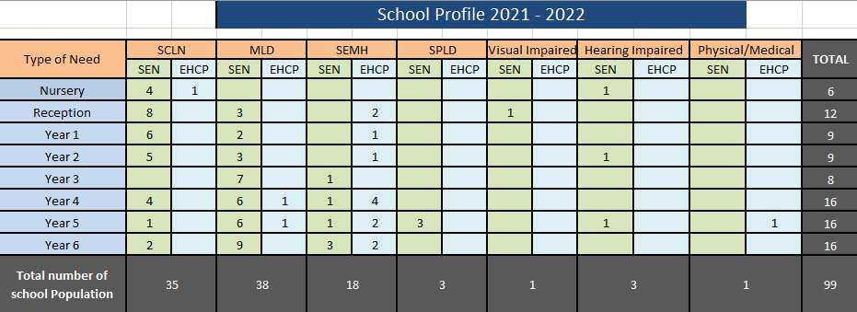

2021 – 2022 SEND Contextual Information:
Over the last 3 years, the trend of SEND has been on an upward trajectory. In 2019 there were 70 pupils on the SEND list. This is comparable to 98 at the time of writing this report. We are getting much more complex SEND pupils, who are requiring a much higher level of co-ordination and management. Out of the 98 pupils currently on the SEND list, over 60 of these pupils have outside agency involvement. Comparing our SEND data to Manchester and National data, St. Clare’s have a higher percentage of pupils with EHCP’s and accessing SEND support.
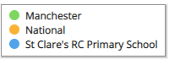

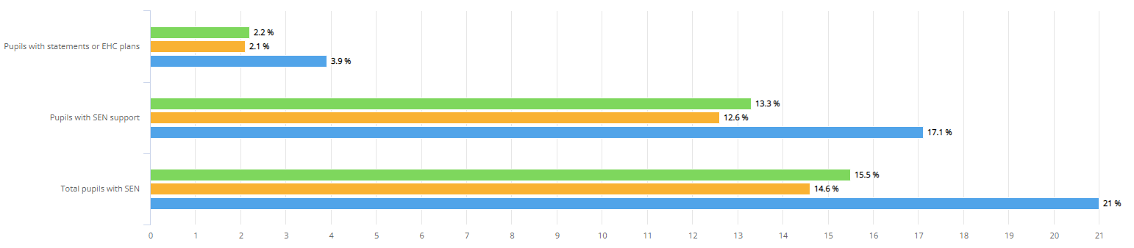

Identification of pupils with SEN:
SEN children are identified as having a defined difficulty over and above those generally experienced by the majority of his/her peer group. Teaching staff are responsible for identifying students with Special Educational Needs. Class teachers have the overall responsibility of ensuring that the curriculum will be, differentiated and delivered, in an inclusive way to meet the needs of each child within their class.

To support swift identification and the effective leadership of SEND within St. Clare’s the following strategies are used:
- SENDco is non-class based so SEND can be given the time and leadership required to fulfil the role effectively.
- SEND needs are quickly identified.
- Parents and outside agencies have quick access to the SENDco and provision is put into place to meet the needs of pupils quickly and efficiently.
- Provision for our most vulnerable pupils is regularly monitored for impact.
- Home visits are carried out to all new starters to Nursery or Reception. SALT TA accompanies EYFS staff to identify SEND quickly.
- Whole school data is analysed following each assessment point and new provision put in place to support SEND pupil to make at least expected progress.
- SEND forms part of all pupil progress meetings.
- The SEND list is a working document and updated regularly, based on agreed thresholds.
- Early identification and planned interventions ensure each child progresses in line with their academic ability to ensure no child goes undetected.
- Head teacher meets all new starters so any SEND is quickly identified. As a result, bespoke provision is immediately put into place.
- Open-door policy for SEND for parents to meet and discuss concerns they may have.
- Interventions are evidence-based and regularly reviewed so that the impact is maximised. SENDco regularly researches new interventions/resources; trials these regularly with smaller numbers of pupils before rolling these out to wider groups of SEND pupils.
- All pupils with an EHCP have a transfer review at the end of year 5 to ensure transition to secondary is smooth.
- All pupils who have had EP involvement are reviewed prior to transition to KS3 to ensure they are well supported going onto their next stage of education.
- Interventions are bespoke to the pupil’s needs.
- Class teachers ensure lessons are differentiated, matched to pupils needs and concrete resources used to support pupil learning.
- First-wave quality teaching is regularly monitored so that learning for SEND pupils is maximised.
- A central online tracking system allows interventions to be quickly grouped, analysed and costed. Provision Maps are then easily accessible. The system also allows individual pupil passports to be completed for our most complex SEND pupils.

Staffing Arrangements:
2021-22:
During this academic year we employed 13 Key Workers (TAs) linked with pupils across the school with EHCP’s. For most key workers, as part of their role, - they work in small groups on interventions, which include their identified pupil. We currently have nine pupils with exceptionally complex needs. Seven of these pupils require a completely different curriculum, based on their individual needs from the rest of their class.

Due to the levels of new EHCPs we had to employ two key workers from an agency to support the EHCPs within the school.

2022-23:
We have tried to recruit new SEND staff to support our increased EHCPs and have been successful in recruiting one. At the time of writing this report we were back out to advert to try and recruit further staff to support our most vulnerable pupils during the next academic year. We currently have more EHCP pupils than staff to support them. We are hopeful that a second advert will attract further applications, which will lead to successful recruitment.

Education Health Care Plans (High Needs):
During 2021-2022, I made nine applications for statutory assessment. This is significantly higher than previous years where I have applied for around 2-3 over the course of the year. The evidence and educational evidence required to submit an application is lengthy and can takes weeks to put together before being ready to submit. Eight of the applications I have submitted were agreed and I await a decision on the ninth. One successful application was an emergency following a significant deterioration of a year 6 pupil’s behaviour following her return to school after the COVID pandemic.

Three pupils with an EHCP leave St. Clare’s in July. Two of these pupils require specialist secondary provision and at the time of writing they still had not successfully been allocated a high school. This is, I am told, is due to large numbers of complex SEND pupils across the city needing specialist places which is much higher than previous years.

I am currently aware of three complex pupils who will be joining St. Clare’s in September. One in Nursery and two in Reception. I have begun liaising with their parent s and their current setting to support their transition and begin evidence gathering for possible EHCP applications.

Educational Psychology Input:
Seventeen pupils have received educational psychologist (EP) assessment/input this year. Eleven of these were new assessments to support the evidence gathering for the EHCP application. Six pupils have had updated EP advice which will support transition to secondary school.
Speech and Language (SALT) Input:
Six pupils have received Speech & Language (SALT) assessments/input over the year. One pupil is currently receiving Developmental Language Disorder (DLD) input. This is intensive SALT input which requires a specially trained therapist to come into school to deliver alongside our SALT TA, Mrs Johnson. Mrs Johnson then completes the set work daily with the pupil. The impact of this work is regularly reviewed and adapted with the therapist. This intensive package of support costs the school around £3000 per annum as well as the additional cost of Mrs Johnson working with the pupil for an hour each day on the programme. The DLD programme is usually an eighteen month to two years’ programme, however the pupil has made significant progress within the twelve months of starting and will therefore end in June.

High Needs Additional Funding

Intervention cost Breakdown:

Pupil Category | No. of pupils | Avg cost Per Pupil | Total Cost
SEND Support | 81 | £1079.41 | £93,198.40
EHCP | 17 | £8906.32 | £160,313.67
No SEND | 322 | £273.04 | £87,645.82
 |  | Total Cost | £341,157.89
Provision Type | No. of Pupils | Cost Per Pupil | Total Cost
Cognition & Learning | 375 | £669.51 | £251,063.93
SALT | 113 | £222.51 | £25,143.46
SEMH | 88 | £546.42 | £48,084.59

During 2021-2022, 423 pupils have benefitted from at least one additional provision alongside first-wave quality teaching over the course of the year. The highest intervention cost is related to cognition and learning.

Training: 2021-2022: | Resources April 2021- March 2022:
- SALT Training - Nuffield Early Language  - Positive Handling Training  - ASD Training  - Youth Mental Health First Aider  - First Class at Number  - Better Reader  - Forest School Training | - SEMH Books for Children to support anxiety, behaviour, worries, ASD diagnosis.  - SEMH Games to support positive choices, behaviour and improving resilience.  - Memory Games  - Talking Tins  - Literacy Resources to support writing  - Maths Games  - Reading Comprehension Cards  - Social Skills Games  - SPAG Games  - Sand Timers  - Chew Toys  - EP time to complete full cognitive assessments  - EP time to review pupils with previous EP input and write up to date reports  - Plus 1 / Power of 2  - SLI – DLD intense SALT input  - Sensory Resources  - Word Wasp / Hornet  - Reading for Meaning Resources  - SALT Resources  - Lego Therapy Resources  - Cooking Resources  - Provision Map online licence  - Speech Link License  - Cognitive resources to support Maths and Literacy  - 5 Minute Box – Literacy and Number  - Nessy Licence to support the teaching of reading and spelling for ten pupils.  - ICT resources to support Language and Literacy  - IDL Computerised Programme license  - EYFS resources to support SEND  - Forest of Feelings Resources for SEMH Intervention
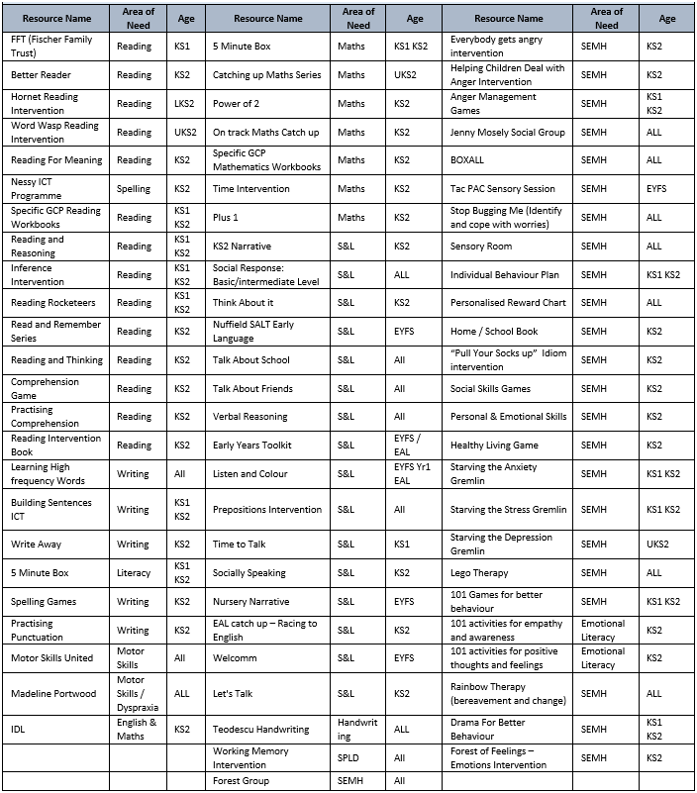

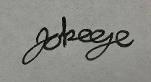
Signed: Date: June 2022

