**ICT**

We will be using Purple Mash to aid our learning this year. Our first topics will be;

Animated storybooks

**History**

We will be learning all about the history of our local area; Blackley, Manchester.

**PSHE**

We will be learning all about our world.

Science

This half term we will be learning all about plants. We look at seeds and what they need to grow, before planting our own seeds to grow a variety of plants!

We will also be looking at seasonal changes as we move through the year.

**Literacy**

**Our class text** is Jack and the Baked Beanstalk.

This half term, we are looking at Narratives, instructions and poetry. We will be learning what each of these are before investigating how we can write them ourselves.

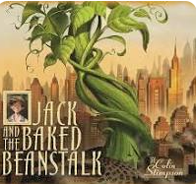

**Maths**

**This half term we will be focussing on:**

Numbers within 50

Length and height

Mass and Volume

**Music**

Round and Round.

Bossa Nova

Pulse, rhythm and pitch in different styles of music

**Art**

In our Art lessons this half term, we will be looking at the artist Georgia O’Keefe and her paintings. We will use water colours to create our own artwork.

**PE**

Dance with the dream big coach.

Ball skills – attacking and defending.

RE

Self-discipline

Caritas: Option for poor and Vulnerable

**Year 1 – Spring 2**

**Plants**