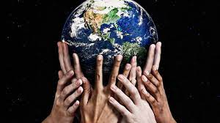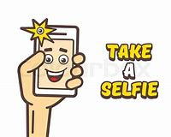**#Science Selfie Competition**

**Entries will be judged by our science ambassador’s the week beginning 13.12.2021**

**Email all entries to** [**k.salza@st-clares.manchester.sch.uk**](mailto:k.salza@st-clares.manchester.sch.uk) **or print them and hand them in to Mrs Salza.**

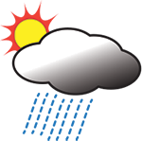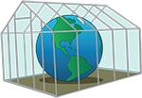

**Science is all around us; in everything that we do and everything that we see. In light of the current climate change action around the world we would like you to think of how you could protect our planet and be more environmentally friendly. Please take a selfie of you and your science.**

**There are prizes to be won for the best selfie!**

**See the page below for ideas and inspiration**

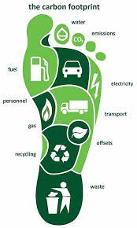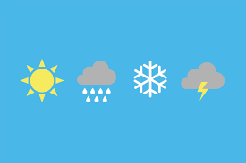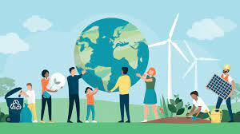**Ideas and Inspiration**

<https://climatekids.nasa.gov/menu/make/>

<https://www.weareteachers.com/climate-change-activities/>

* Compare the freezing point of fresh water with the freezing point of seawater or salt water, with varying amounts of salt.

Draw a picture of the Earth

Make an eco-brick from recycled materials

Create a toy using recycled materials

Research all about climate change

*Research the change in greenhouse gases and the effect it is having on our planet*

*Make an ecosystem dessert*

*Track your carbon footprint*

* Make a do it yourself rain gauge. Measure the rainfall over a week and compare it to last year’s data (world weather online)

*Make a cloud in a bottle*