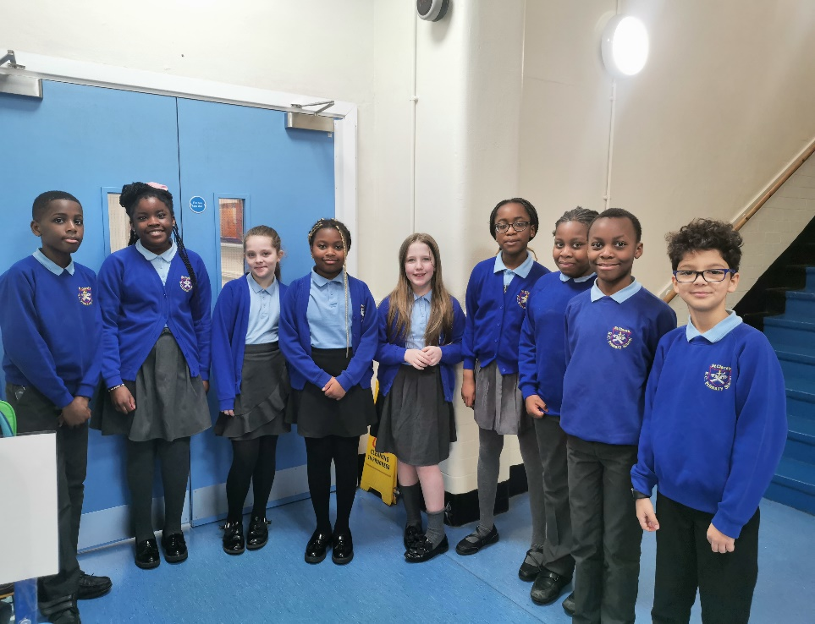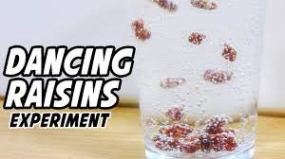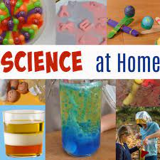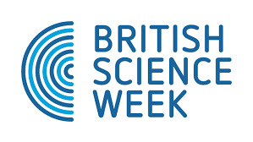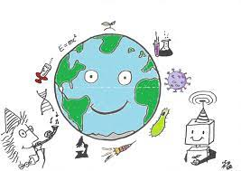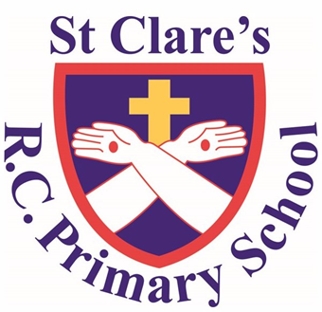

**Can you predict what will happen?**

#### **Meet Our New Science Ambassadors!**

After careful consideration, our previous science ambassadors have selected the **new members** of our science ambassadors team for St Clare’s. The applications received were all amazing, and we would like to say **thank you** to everyone who applied!

**Materials for Dancing Raisins Science Activity**

* raisins
* 2 clear glasses
* carbonated water and regular tap water

**Instructions:**

* Pour some carbonated water into a clear glass.
* Add some raisins and watch what happens.

St Clare’s Rc Primary School Science Newsletter

February 2023

**The date for British Science week is 10th March – 19th March.**

**We hope you are looking forward to all of the fun activities we have in store!**

**Science After School Club**

After the February half term holidays, the previous science ambassadors will be leading an after school science club. Initially, the new ambassadors will be invited; but throughout the year, other year groups will have the chance to come along too. All information will be shared on the school gatwey app.

Welcome to the first ever science newsletter from St Clare’s! In each newsletter, we will share important science news from throughout the school, share some examples of the children’s science, publish dates of science based events that may be of interest, and share some science activities for you to try at home too!