**Geography**

We will be learning all about hot and cold places in our world.

We will also look at weather.

We will also

**PSHE**

We will be learning all about our world.

**DT**

In design and technology this half term we will building our own windmills.

Science

This half term we will be continuing our learning all about different materials and their properties,

We will also be looking at seasonal changes as we move through the year.

**Literacy**

**Our class text** is Lost and Found by Oliver Jeffers.

In Literacy this half term, we are looking at setting descriptions and invitations, We will be learning what each of these are before investigating how we can write them ourselves.

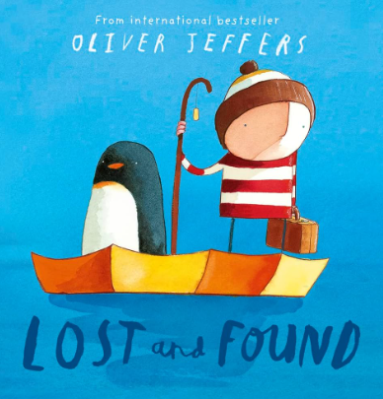

**Maths**

**This half term we will be focussing on:**

Number and place value.

Addition and Subtraction.

**Music**

In the groove

**ICT**

We will be using Purple Mash to aid our learning this year. Our first topics will be;

* Maze explorers

**PE**

Gymnastics

Ball skills – receiving.

RE

Caritas – Solidarity and the common good. The dignity of work.

Community – building bridges

**Year 1 – Spring 1**

**Hot and cold places**