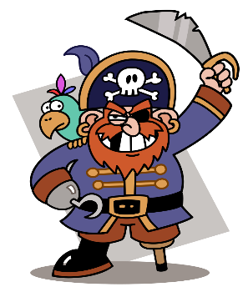

How can you help?

* Research famous pirates together e.g. Anne Bonney, Captain Blackbeard
* Make maps together.
* Talk about different places the pirates visited and how they lived.
* Practise counting from 1-100 and back from 20-0.
* Practise 1 more and 1 less than numbers up to 20
* Look for different 3D shapes and talk about what they look like.
* Practise reading and writing the 100 HFW that are in your child’s reading record.
* Play free educational games online (google phonicsplay and topmarks)
* Practise using scissors at home.
* Look on Pinterest for fine motor activities. These will help your child to hold and control their pencil e.g. using playdough, using tweezers
* Read with your child every night. Don’t forget the HFW in their envelope!

**Spring 1: Treasure Island**

We will be learning to:

**Mathematics (M)**

* Recognise coins and make different amounts
* Use the language of height and weight
* Order objects from shortest to longest and lightest to heaviest.
* Say the number that is 1 more and 1 less than
* Write number sentences (addition and subtraction)
* Know the number bonds to 10.
* Continue a repeating pattern
* Name 3D shapes and talk about their properties.

**Communication and language (C&L)**

* Use words such as “first”, “next”, “then” and “finally”, when retelling an event
* Compose our own questions using: who, what, why, when, where
* Answer questions and ask questions about pirates
* Retell a story

**Personal, social and emotional development (PSED)**

* Feel confident and proud of ourselves and others
* Say things that we are good at
* Try to solve conflicts ourselves before coming to an adult for help
* Speak to others about what we have learnt about pirates
* Keep our play going by responding to what others are saying or doing.

**Understanding the World (KUW)**

* Make our own maps, use beebots and use positional language
* Talk about floating and sinking
* Understand the importance of recycling
* About Chinese New Year

**Expressive Art and Design (EAD)**

* Make boats that float
* Sing pirate songs
* Mix colours
* Find ways to make our creations even better
* Use stories/ information that we have learnt, to build up a role play
* Make puppet and use them in our role-play

**Literacy (L)**

* Retell stories
* Continue a rhyming string
* Begin to write short sentences
* Use adjectives
* Use capital letters and full stops
* Leave finger spaces between words
* Read and write the 100 high frequency words (HFW)

Reminders:

* Please check bags for letters and homework.
* Homework will be sent home on a Friday. Please send it back by Wednesday.
* Please use the Tapestry app to show us all the fantastic work your child has been doing at home. You might even want to bring it in to show the class.
* Don’t forget to bring in your book bag every Friday so that we are able to isolate the books before giving them out on Mondays.

**Physical Development (PD)**

* Hold our pencil using a tripod grip
* Put on our coats by ourselves
* Form our letters correctly by always starting at the top