 | Personal, Social & Emotional  - Setting and working towards our own simple goals  - Resolving conflict ourselves  - Using a knife and fork to cut up our food  - Zipping up our own coats  - Recognising the feelings of characters in stories Saying what we are good at and what we need to practise  - Taking turns without an adult to support | 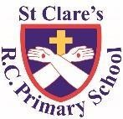  ST CLARE’S R.C PRIMARY SCHOOL  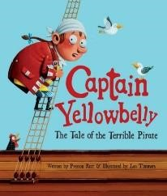  CURRICULUM OVERVIEW  Reception  Spring 1 2023-24  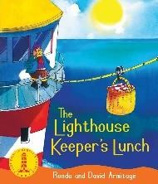  ‘Treasure Island’  Main texts:  Captain Yellowbelly The Tale of a Terrible Pirate  The Lighthouse Keepers Lunch  Linked texts:  Somebody Swallowed Stanley, The  Fort, The Troll, The Three Billy Goat’s Gruff |  | Communication and Language  - Listening and responding to stories  - Answering a range of questions, including  - ‘how’ and ‘why’ questions  - Reciting poems  - Retelling and creating our own stories  - Using connectives when speaking  - Using vocabulary linked to pirates, maps, floating and sinking  - Having longer conversations
 | Literacy  - Learning to recognise Set 1 single-letter sounds and  - Set 1 Special Friends  - Blending & reading CVC words containing Set 1 sounds  - Recognising rhyming words and continuing a rhyming string  - Learning to read the Red Words: I, the, to, no, of, go, my, he  - Talking about the blurb  - Asking questions about stories  - Repeating words and phrases from familiar stories  - Learning to form the letters m n h r b p c a o g d e s f l i t j y u correctly  - Listening to all of the sounds we can hear in a word and writing them down in the correct order  - Writing simple captions, using finger spaces | Physical Development  - Using scissors to cut straight and curved lines  - Using tweezers to pick up objects  - Using a knife and fork to cut up our own dinners  - Holding a pencil using a tripod grip  - Throwing balls/ beanbags at given targets  - Catching smaller balls/ beanbags from a longer distance |  | Maths  - Composing and subitising 0-5  - Comparing mass and capacity(heavier, lighter, fullest, emptiest)  - Comparing height and length (longer, shorter, longest shortest)  - Measuring height and length  - Composing and matching 6,7,8  - Learning the days of the week  - Learning the months of the year
•  •  •  •  •  •  • | Understanding of the World  Identifying features of a simple map e.g. river, mountain, road Drawing our own maps  Writing postcards from around the world  Looking at historical figures (Anne Bonny, Captain  Blackbeard)  Looking at floating and sinking  Learning how to recycle  Learning why it is important to recycle | Religious Education  - Learning what a celebration is and how people celebrate, drawing on our own experiences  - Decorating balloons depicting our own experiences of celebrations  - Discovering what a parish is and who makes up the parish of St Clare’s.  - Learning what and how the parish family celebrates  - Talking about how it feels to celebrate and the importance of gathering together  - Making candles as we learn the story of Jesus’s first visit to the temple  - Recognising church artefacts | • •  •  •  •  •  • | Expressive Arts and Design Making boats to see if they float  Drawing pictures with more detail  Drawing objects from memory  Enhancing small world play with simple resources e.g. blue cloth for a lake  Printing with sponges and fruit  Weaving to make an underwater scene Learning to play Nursery Rhymes on the glockenspiel

