St Clare’s Wellbeing Committee Newsletter

Spring 2023

Throughout Summer, we are going to continue to focus on communication.

Wellbeing committee members: Jade Coleman, Keira Guidan, Rebecca Sabor, Tina Heaps, Colette Howe, Michelle Flood

Throughout the Spring term we tried to improve everyone’s wellbeing by **focusing on ‘Communication’. interventions**.

In relation to health interventions:

Toiletries were purchased for the staff bathrooms.

Wellbeing suggestion box within both staff rooms.

Podcasts purchased to support staff.

Health work referrals were made when deemed necessary.

Weight loss intervention groups shared.

Wellbeing buddies to support our communication

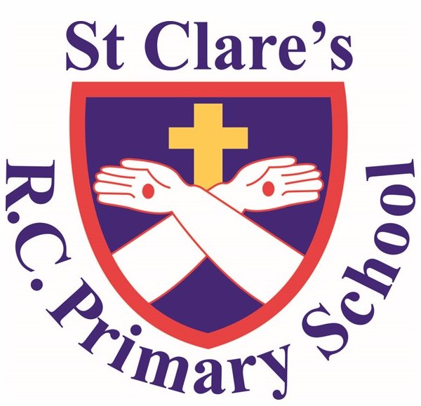

Autumn Newsletter 2022

To help with our mental health:

Staff are reminded of the Educational Assistance Programme support.

Podcasts were purchased and have been regularly sent via email to remind you of these.

Counselling sessions provided as and when necessary.

Staff get togethers arranged before parents evening.

Advice provided in staff rooms on ways to save money.

We listened to what you had to say, so in the staffroom:

We removed all the clutter. Ensured it was cleaned thoroughly. Created displays to promote financial support and ways to help save money.

We introduced book and recipe swaps. We introduced a wellbeing suggestion box. We bought new electrical equipment including microwaves and radios. We dedicated a room for staff release time, so the staff room did not have to be used. New crockery was purchased.

We still have a few more actions to complete in relation to the above three foci including appraisals for all staff, Calendar of events and organise a summer fun day.

**In addition to all of this, to help with our well-being we:**

Take PPA at home

Shared planning with parallel teacher

No expectation to respond to emails in the evening / weekend

No staff meeting when assessment week / parents evening

Pupil progress and performance management meetings held in school time

Own clothes days

Various subscriptions to online resources

Bought in planning schemes

Marking and Feedback policy reviewed

Twilights used in order to extend holidays

Lunch provided on INSET days

Support from SLT with any issues

Subject leadership release days

All staff given a well being day

Termly get together for staff

T/A working hours include time before or after school.

Teacher and t/a in all classes

PPA is given in one block and rarely changed.