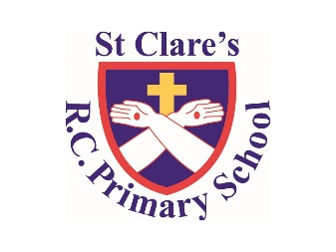

Numeracy

In numeracy, we will be learning about place value, looking at numbers to ten million. We will also be looking at the four operations.

Literacy

Our class text for this half term is *‘The Light Jar’* by Lisa Thompson. We will be using our learning from science to write a non-chronological report all about light. We will also be writing a narrative based on our class text.

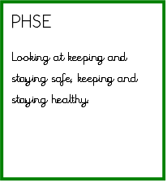

Geography

We will be looking at our local area. In particular the rivers in Manchester and how the temperature and climate differs during the year in Manchester.

Religious Education

During this half term, we will be looking at how I can love people I do not like. In addition, why do people give time and commitment for caring for others?

In addition, we will be looking Judaism during our multi-faith week.

PE

During PE lessons, we will be doing gymnastics indoor and invasion games outdoor.

Computing

In Computing, we will be looking at coding using Purple Mash and online safety.

Year Six-

Autumn One Overview

Science

Our science this half term is all about light and how we see things. We will be learning about how light travels, reflection, refraction and how shadows are formed