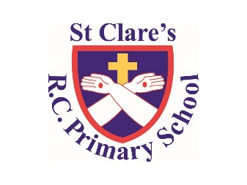

Numeracy

In numeracy, we will be learning about place value, looking at fractions and converting units

Literacy

Our class text for this half term is *‘Pig Heart Boy’* by Malore Blackman. We will be using our learning from science to write a balanced argument about Xenotransplantation. We will also be looking at formal letters and writing our own formal letter based on the book.

PSHE

We will be looking at being responsible, in particular the issues around stealing

Geography

We will be looking at the UK including co-ordinates.

Religious Education

During this half term, we will be looking at Christmas/Advent.

Children will have the opportunity to rehearse for all of our Christmas activities such as nativities, Christmas service and Christmas concert

PE

During PE lessons, we will be doing hockey

Computing

In Computing, we will be looking at online safety and spreadsheets

Year Six-

Autumn Two Overview

Science

Our science this half term is all about the heart.

We will be looking at our circulatory system and how they compare to other animals.