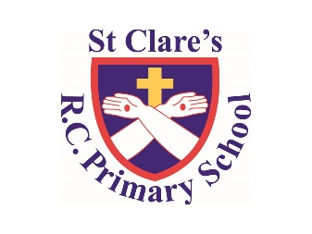

Literacy

Class text/reading: ‘Dear Mum I Miss You’ (Stewart Ross)

Writing: A letter from an evacuee, a war-time narrative, a non-chronological report

Grammar/Punctuation: Commas, subject and object, synonyms.

Numeracy

In numeracy, we will be learning about ratio, algebra and decimals.

PSHE

We will be looking at feelings and emotions concentrating on the emotion worry.

Plus computer safety and making friends online

Year Six-

Spring One Overview

Religious Education

This half term we will be looking at sources and looking at how we can find quotes from the bible.

Plus we will be looking at unity and how our community can unite for the better.

Science

Our focus is on electricity – we will be building series and parallel circuits.

History

Our Topic: ‘World War Two.’ Finding out all about evacuees, why they had to leave their homes and what their new temporary lives were like.

PE

During PE lessons, we will be focusing on strike and field and dance.

Computing

In Computing, we will be looking at blogging and text adventures.