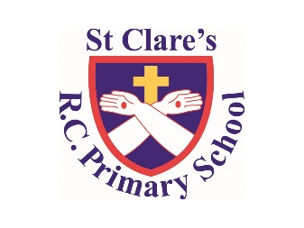

Numeracy

In numeracy, we will be learning about fractions, decimals and percentages, we will then move on to area.

Literacy

Class text - “Soccer Star”-*Mila Javaherbin*

Writing: Brochures (South America) and Narrative Poetry.

SPAG Focus – Paragraphs, Implied relative pronouns, Prefixes for verbs

Prepositions of time

Standard English

Science

Our focus is on evolution and inheritance, we will be exploring how animals and humans evolved over time and learn about inherited characteristic

Geography:

We will be learning all about South America and understand more about the physical and man-made feature as well as making comparisons to life in the UK.

PSHE

We will be looking at the topic called Our World, we will learn more about actions and their consequences.

Year Six-

Spring Two Overview

Religious Education

This half term we will be looking the topic of unity and understanding more about the Eucharist. We will then move on to the topic of Death and new life in line with the season of Lent.

PE

During PE lessons, we will be focusing on striking and fielding.

Computing

In Computing, we will be looking at networks.