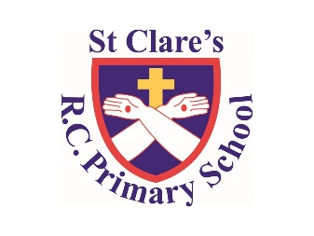

Numeracy

In numeracy, we will be learning about fractions, decimals percentages, area, perimeter and volume, plus statistics.

Literacy

Class Text/Reading: ‘Soccer Star’ by Mina Javaherbin

Writing: a persuasive letter, a holiday brochure, a holiday recount

GPS: apostrophes, adverbs, prefixes, ellipses

Religious Education

This half term we will be looking at death and new life linking it to lent and the Easter story.

We will be doing activities for Holy Week

PSHE

We will be looking at the working world and in-app purchases.

Plus British Values in a world without judgement.

Year Six-

Spring Two Overview

Science

Our focus is on Habitats

History

Our Topic: South America

Find out about the location and countries of South America.

PE

During PE lessons, we will be doing cheerleading.

Computing

In Computing, we will be looking at networks.