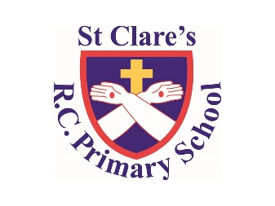

Numeracy

In numeracy, we will be revising everything we have learnt throughout the year.

Literacy

Class Text/Reading: ‘Soccer Star’ by Mina Javaherbin

Writing: a balanced argument about whether all sports teams in schools be mixed gender.

GPS: apostrophes, adverbs, prefixes, ellipses

Religious Education

This half term we will be looking at vocation and commitment. Plus our second topic will be on witness, which is one of our 5 W’s

PSHE

We will be looking at Relationships

Year Six-

Summer One Overview

Science

Our focus is on electricity

History

Our Topic: South America

Find out about the location and countries of South America.

PE

During PE lessons, we will be doing gymnastics

Computing

In Computing, we will be looking at quizzing