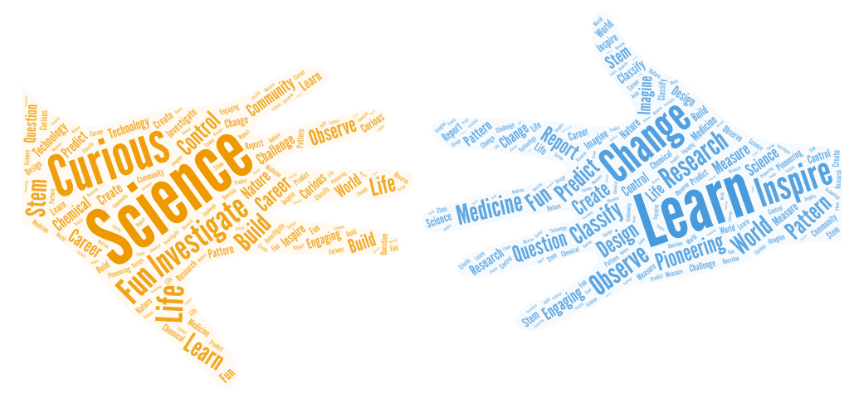[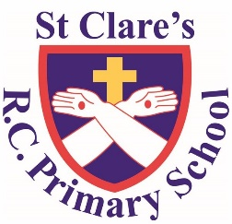](https://www.st-clares.manchester.sch.uk/)

Science

We know that effective science teaching and learning occurs when…

We asked the staff and pupils of St Clare’s School what they thought.

This is a collection of St Clare’s Science Principles:

1. Children’s curiosity is encouraged and valued; they are excited and enthusiastic when anticipating their science lessons.
2. Science is practical and hands on and children enjoy learning through exploration and questioning; they have the opportunity to use good quality resources, and to explore the outdoors within their lessons.
3. Progression of science skills and knowledge is evident and taught throughout
4. Teachers have a strong subject knowledge and can build upon children’s prior knowledge when planning lessons and assessing.
5. Lessons are child-led and focused on the curiosity and relevance of science in their own lives, they are encouraged to think and work like scientists.
6. All pupils are actively engaged in a science enquiry; using a variety of enquiry strategies, independently making decisions, answering their own questions.