SEND Information Report
Approved on:
July 2023
Next review:
June-July 2024
St Cuthbert’s Catholic Primary School, Hartlepool

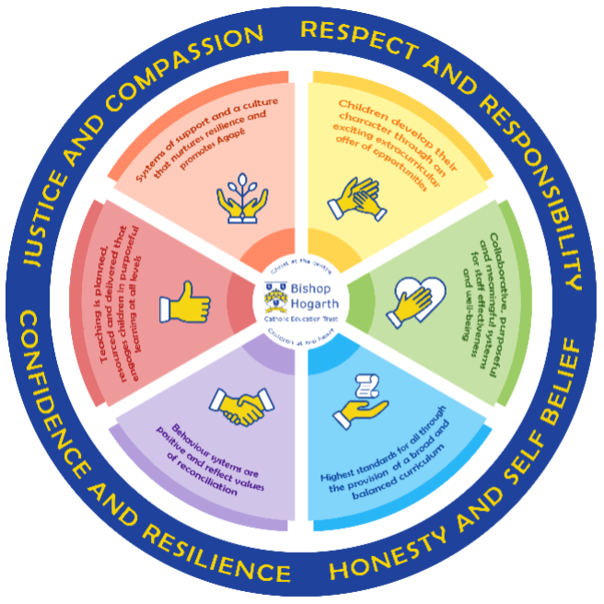
As part of the family of Bishop Hogarth Catholic Education Trust, our school has at its core, the virtues, and values of:
Respect for others and themselves, recognising that we are all created in the image of God and therefore must be compassionate towards others, especially the vulnerable. ​
Confidence in their own abilities, knowing that their talents are gifts from God and resilience to persevere when things become difficult. ​
Honesty in regard to the world around them and themselves and the ability to take responsibility for the times we may fall short of the mark. ​
Gratitude for all the amazing gifts from God and willingness to share their gifts both personal and material. ​

As an inclusive school, all teachers are teachers of pupils with Special Educational Needs & Disabilities. We deliver a curriculum and create an environment that meets the needs of every pupil within our school. We ensure that every pupil with Special Educational Needs and / or disabilities makes the best progress possible. We foster and promote effective working partnerships with parents / carers, pupils, and outside agencies. We consider the ‘whole’ child and strive to ensure that all our SEND pupils are prepared for adulthood.​

Our school’s approach to supporting pupils with SEND
St Cuthbert’s is an inclusive school that welcomes and celebrates diversity. All staff believe having high self-esteem is crucial to a child’s emotional wellbeing and academic progress. We have a caring, understanding team who look after all of our children. We strive to provide a nurturing and supportive learning environment in order for children to fulfil their potential.

Teachers are responsible for the progress of ALL pupils in their class. High quality teaching is personalised to meet every child’s need. This is the first step in supporting pupils who may have SEND (Special Educational Needs and Disabilities). All children are challenged to do their very best. This is usually enough for most pupils to make progress.

All children will be taught a broad and balanced curriculum; adapted to the needs of each individual. Where children require extra support, specialist resources or extension materials, these will be provided wherever possible.

All children are known well by their class teacher, who develops strong relationships with them. Good behaviour and work are rewarded.

Your child can express their views through school council representatives or directly to staff (Specifically the PSA) KS2 Buddies and the student council representatives encourage all pupils to have a voice in school.
We manage medical needs by working closely with parents and healthcare professionals and a child with medical needs will have an individualised health care plan in place in school.

We listen to and act on their advice, providing staff training when needed.

Our extracurricular clubs differ each term dependent on the interests of children.

There is also an SEND governor (Louise Robson) who has particular involvement with SEND policy and provision.

What support will there be for my child’s overall well-being? Support we can provide in school may include:
- Members of staff, including class teachers and SENCO readily available for those pupils who wish to discuss issues or concerns.
- Designated areas of school for children to ‘share’ worries with Tas or the PSA in Nurture room
- Weekly ‘Statement to live by’ liturgies and lessons which cover a variety of topics such as; I know what to do if I see someone being hurt, I can say one good thing about myself.
- A dedicated parental support and inclusion manager (Rebecca Garside)
- ‘Pupil voice’ – “Student Council.” • Behaviour programmes including rewards and sanctions.
- Social skills and friendship groups e.g. “Buddies and friendship clubs.”
- Mindfulness lessons – for all children during awareness week Great Dream work (www.actionforhappiness.org) – summer term focus on mental health Bereavement support -dealing with Loss (Rainbows programme)
- Intervention groups ran by Alliance / ELSA trained TAs for identified children which can include; F.R.I.E.N.D.S, There’s a volcano in my tummy or 1-1 specific intervention
- Medicines can be administered in school with signed parental permission. There are nominated first aiders in school with some members of staff holding paediatric first aid qualifications. If your child has significant medical needs you will need to speak to the SENDCo/ Head Teacher to discuss how we can best support you and your child. This might include drawing up a Health Care Plan.
The class teacher has responsibility for the overall well-being of every child in their class.
If you have any worries speak to the class teacher first. If further support is needed the class-teacher will speak to the SENCO. St. Cuthbert’s has a wealth of expertise and specialist services are always used when the need arises and the school feels it needs more support or advice to ensure a child fulfils their potential.
The following is a snapshot of our expertise, but is not an exhaustive list:
Expertise in School
- SENCO – Mrs Flounders and SENCO/Deputy Head– Emma Daly (NASENCO award)
- ELSA trained staff members (2) –supporting social and emotional learning
- ‘Know Your Mind’ Mindfulness - Mrs Mudd
- Bereavement support - dealing with loss (Rainbows programme) Mrs Cullen and Mrs Currell
- Talk Boost and Early Talk Boost, Blast speech programme, Lexia intervention, Inference Trained Staff, Squiggle while you wiggle – Nursery motor skills programme, Dough disco – fine motor skills programme
- Team Teach Trained Staff
- Qualified First Aid Staff
- Staff who are able to administer insulin and measure glucose levels (Training provided by Diabetes Nurses from Hartlepool Hospital)
At St. Cuthbert's we involve other bodies; including health and social care, local authority support services, charitable and voluntary sector organisations in meeting the children’s SEND and supporting their families.
Expertise/Specialist Services accessed by St Cuthbert’s:
- Educational Psychologist
- Occupational Therapists
- Speech and Language Therapists
- Early Help – Referrals made by school and other specialists
- Alliance Psychological Services
- CAMHs – Child and Adolescent Mental Health Service
- Neurodiversity pathway for assessment of ASD/ADHD
- Links with Daisy Chain Project (ASD Service)
- Links with Alice House (Bereavement Service)
- Harbour (Domestic Violence support and counselling)
- ‘Being a parent’ Workshops led within school •
- School Nurse/Health Visitors/Dental Health
- Child and Family Services
- Fire Brigade/Cycling Proficiency/ Pedestrian training– road/fire safety interventions
- Crucial Crew – Y6 road safety/drug awareness

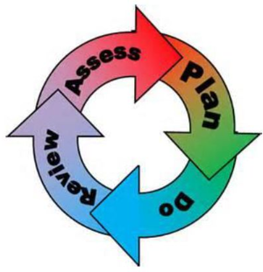
How will the school staff support my child?
The graduated response-Identifying, planning for and supporting pupils with SEND
Where a pupil is identified as having a special educational need, School will follow a graduated approach which takes the form of cycles of ‘Assess, Plan, Do, Review’. ​
• Assess a child’s special educational need. ​
• Plan the provision to meet your child’s aspirations and agreed outcomes. ​
• Do put the provision in place to meet those outcomes. ​
• Review the support and progress.

How does the school know if children need extra help and what do I do if I think my child has special educational needs?

- Assess
Identification – Your child will be identified as special educational needs and/or a disability if they have significantly greater difficulty in learning than the majority of children of the same age or if they have a disability preventing or hindering the use of educational facilities provided for children of the same age within the Local Education Authority.
First steps: if, from our rigorous tracking and monitoring of your child’s progress, it becomes apparent that he/she is not making expected progress then you will be invited to a meeting with their teacher and Mrs Flounders or Mrs Daly (SEND team). Where appropriate your child will be involved in this meeting. At the meeting we will begin to explore the possible barriers to learning and you will be asked how we can best support your child.
Observations and assessments will then be carried out and, if required, input from specialist services may be sought with your permission.
Where appropriate your child may be placed on our school’s SEND Support Register and a passport will be devised by the class teacher that will set SMART targets. These will be reviewed and updated at least half-termly and new targets set. Your child will have a copy of their targets (a bookmark) to use in the classroom and a copy will be given to parent. Parents will sign to acknowledge a receipt of targets and this is then kept as a record by school.
CSP (coordinated support plan) will be sought when a child’s needs are deemed to be more complex and when input from a range of outside agencies may be involved with the child. This could be in the form of Educational Psychologists, Occupational Therapists or other professionals with an area of expertise, e.g. Autism.
EHCPs (Education, Health and Care Plans) may be sought when a child’s needs are deemed to be high needs and that the CSP review process has identified a very complex matrix of support is required. This will again require the input from a range of outside agencies - Educational Psychologists, Occupational Therapists or other professionals with an area of expertise, e.g. Autism. An EHCP helps to determine the level of educational, social and health support the child needs.
If you are concerned about your child’s progress or that your child may have SEN and/or a disability, please contact our SENDCo’s – Mrs Flounders or Mrs Daly – 01429 275040

- Plan
Our procedures are in line with the SEND Code of Practice 2014
The first point of contact is the class teacher, who has overall responsibility for the welfare of your child.
Additional provision is planned carefully and overseen by Mrs Flounders/Mrs Daly, the SENDCo (Special Educational Needs and Disabilities Co-ordinators). It is implemented by a skilled team of teachers and supported by experienced teaching assistants.
SEND Resources:
At St. Cuthbert’s we have an extensive range of different SEND resources and interventions available. These are closely matched to the needs of our children and their progress is monitored by the class teacher, the SENDCo’s, the headteacher and staff with specific curriculum responsibilities.
Where provision does not result in adequate progress, as outlined in the SEN Code of Practice, the SENDCo (Mrs Flounders or Mrs Daly) should be consulted for advice. Pupil progress meetings are held three times a year with the Headteacher, SENCO and class teacher to discuss and plan suitable teaching programmes for each child.
- Do
Our teachers are skilled at adapting teaching and learning to meet the diverse needs in each class. ​
Daily planning considers individual children’s needs and requirements and is annotated and adapted according to need. Explicit reference is made in the teacher’s planning to the needs of those children identified with SEND. ​
Adaptive teaching is approached in a range of ways to support access to the curriculum and ensure that all children can experience success and challenge in their learning. ​
Grouping arrangements consider the different skills and abilities of each child. This ensures that learning is maximised. ​

Additional adults support groups and individual children with the long-term goal of developing independent learning skills. The class teacher monitors this support to avoid students becoming over reliant on this. ​
We fully encourage parental support and offer opportunities for individual meetings with parents/carers to provide clarity and recommendations on how they can support their child at home.

- Review
If despite all steps taken, good progress is still not being made, we will refer back to our graduated approach and increase/change support whilst continuing to monitor and review progress. It may also be necessary, at this stage, to consult with the expertise and specialist services secured by the school. Parents will be consulted before these referrals take place.
Consultation sessions are held in the Autumn and Spring terms where you can meet your child’s teacher to discuss and look at their work in different subject areas. A longer appointment is offered for parents of children with SEND in the Spring term when the class teacher and SENCO will book a meeting with parents to discuss progress, look at books and collect parent voice feedback/discuss any concerns or adaptations needed.
Parents that have children with a coordinated plan are invited to review their child’s plan and targets. If appropriate, your child will be involved in reviewing their targets at appropriate times throughout the term, with the class teacher or teaching assistant, and during the setting of new targets on a termly basis. If, of course, you would like to meet Mrs Daly/Mrs Flounders or your child’s class teacher at any point during the term, this can easily be arranged.

For every child who is in the care of the Local Authority, (a looked after child - LAC), a electronic Personal Education Plan (ePEP) will be devised. This Plan will establish clear targets and actions to respond effectively to each child’s needs and provide a continuous record of their achievements. If your child has an EHC Plan, you will be invited to an annual review of this plan. Homework is given regularly and your child may have the opportunity to access computer programmes to support their learning at home through the school website. You are encouraged to support your child’s learning at home and the teacher or SENDco can suggest the best ways to do this. Reading records are used to support communication between home and school and you are encouraged to use these daily and read with or to your child every day depending on their need. Reading is a key skill at St Cuthbert’s.

How will the curriculum at our school be matched to my child’s needs?
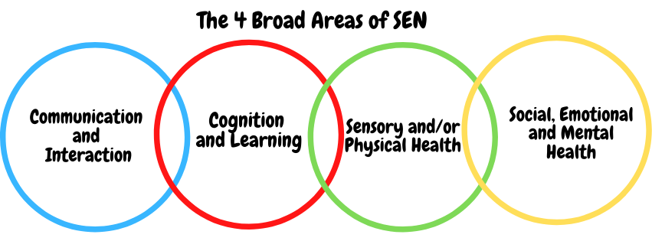SEN needs are classified under four broad areas of need. Below are the strategies, in class support and interventions that school may put in place to support your child.
Communication and Interaction
Strategies to support children with these needs include:
Children and young people with communication and interaction needs (including those with specific SLCN) have difficulty in communicating with others. This may be because they have difficulty saying what they want to, understanding what is being said to them or they do not understand or use social rules of communication.
The profile for every child with SLCN is different and their needs may change over time. They may have difficulty with one, some or all of the different aspects of speech, language or social communication at different times of their lives.
Children and young people with ASD difficulties (including ADHD, Asperger’s Syndrome, Autism, dyslexia, dyspraxia etc.) are likely to have particular difficulties with social interaction. They may also experience difficulties with language, communication and imagination, which can impact on how they relate to others.

How support will be provided:
- Access to small group and/or individualised interventions to develop skills in communication and interaction with others. We work with speech and language services in school to deliver strategies to support those accessing therapeutic services
- Visual timetables used in classroom where appropriate
- Flexible approaches to timetable when necessary
- Access to additional aids/technology
- Explicit teaching of generalising skills from one context to another
- Careful planning of transitions, e.g. advance notice, familiar resources when moving between year groups as they progress through school
- Mentoring and/or buddy systems
- Detailed and enhanced Y6 transition package when moving to secondary school – PCP (person centred planning meetings), extra visits to secondary school setting, detailed meetings with professionals (when needed) with parents and child (if appropriate) to discuss needs, plan steps and resources needed to enable the child to transition to secondary provision successfully.
- Transition meetings for any SEND child leaving St Cuthbert’s when moving to a new setting so transfer of information can take place. This is with parents involved and child if appropriate.
Cognition and Learning
Strategies to support children with these needs include:
Support for learning difficulties may be required when children and young people learn at a slower pace than their peers, even with appropriate adaptation of the curriculum.
Learning difficulties cover a wide range of needs, including moderate learning difficulties (MLD), severe learning difficulties (SLD), where children are likely to need support in all areas of the curriculum and associated difficulties with mobility and communication, through to profound and multiple learning difficulties (PMLD), where children are likely to have severe and complex learning difficulties as well as a physical disability or sensory impairment.
Specific learning difficulties (SpLD), affect one or more specific aspects of learning. This encompasses a range of conditions such as dyslexia, dyscalculia and dyspraxia.
How support will be provided:
- Regular, individual or small group focused interventions, e.g. reading (Lexia), Sounds Write, numeracy (Becoming 1st Class Number, 1st Class Number 1 and 2)
- Increased access to small group support in class
- Practical aids for learning, e.g. place value counters, number lines, pictures, photos, coloured overlays, accessible reading material suited to age and individualised success criteria
- Flexible groupings
- Access to technical aids e.g. spell checker, ICT software and/or hardware
- Adaptations to assessments to enable access e.g. readers, scribe, ICT
- Curriculum/delivery adaptations to meet the learning needs of individuals
- Frequent repetition and overlearning

Sensory/Physical
Strategies to support children with these needs include:
Some children and young people require special educational provision because they have a disability which prevents or hinders them from making use of the educational facilities generally provided. These difficulties can be age related and may fluctuate over time. Many children and young people with vision impairment (VI), hearing impairment (HI) or a multi-sensory impairment (MSI) will require specialist support and/or equipment to access their learning. Children and young people with an MSI have a combination of vision and hearing difficulties. Some children and young people with a physical disability (PD) require additional ongoing support and equipment to access all the opportunities available to their peers.
How support will be provided:
- Occupational Therapy Support sought when necessary and suggestions followed.
- Specialist OT referrals to Sunflower programme for parents to engage in training and support for their child at home and in school
- Parental contact and engagement with Daisy Chain services specifically around sensory needs and ASD – number and information give by PSA or SENCO to parent and referral receipt from Neurodiversity pathway when an ASD/ADHD referral is made on behalf of child from school
- Concrete apparatus available to support learning, e.g. Numicon materials (numeracy)
- Sensory resources available e.g. Chew Buddies, seat wedge, writing wedge, heavy work activities
- Access to support for personal care, e.g. school nurse service
- Adaptations made to the curriculum when needed to avoid sensory overload

Social, Emotional and Mental Health
Strategies to support children with these needs include:
Children and young people may experience a wide range of social and emotional difficulties which manifest themselves in many ways.
These may include becoming withdrawn or isolated, as well as displaying challenging, disruptive or disturbing behaviour.
These behaviours may reflect underlying mental health difficulties such as anxiety or depression, self-harming, substance misuse, eating disorders or physical symptoms that are medically unexplained.
Other children and young people may have disorders such as attention deficit disorder, attention deficit hyperactive disorder or attachment disorder.
How support will be provided:
- Access to time out/individual work area
- Access to counselling services, e.g. CAMHS, Alliance
- Referral to Neurodiversity pathway for ASD/ADHD if SEMH is linked to behaviours that reflect a need for assessment
- A dedicated Family and Inclusion Support Worker (PSA Rebecca Garside)
- ELSA (supporting social and emotional learning)
- Bereavement support via Rainbows group with Mrs Cullen/Mrs Currell
- When possible, increased access to additional adults in and out of the classroom
- Supported transition programme with chosen secondary school
- Applications made for SEMH IPS funding when necessary to further support a child
- Virtual school and LAC team support where necessary

What training is provided for staff supporting children with SEND?
- All teachers have Qualified Teacher Status and our teaching assistants have a minimum of a level 3 qualification.
- All staff are either teachers of or are supporting students with SEND.
- St. Cuthbert’s values staff training and organises courses/training programmes to ensure teachers and teaching assistants stay up to date with current research into teaching and learning

How do we support transition in our school?

Transition within classes/key stages: ​
Information will be passed on to the new class teacher in advance and a transition meeting will take place with the new teacher. Individual targets/requirements for all SEND children will be discussed with the new teacher and agreed by Mrs Daly or Mrs Flounders. Flexible entry to Early Years Foundation Stage dependent on need. Children who require additional support to ensure a smooth transition to their new class, will be included in a programme supported by Mrs Daly, Mrs Flounders and the class teacher.
Transition to Secondary settings: ​
Within Hartlepool Local Authority transition to secondary school is supported by a robust transition model that has been in place since 2019/20. Transition begins in the summer term of Y5 when Transition Lead (Mrs Daly) identifies those children in need of enhanced transition model. Discussions with parents take place in summer term of Y5 for those children with SEND. Parents are advised to visit secondary schools and look at provision in readiness for school application.
We work closely with all secondary schools in the area.
- The majority of our children move on to English Martyrs Secondary School.
- The transition process in Autumn of Y6 supports more vulnerable children.
- PCP (person centred planning) meetings are held for the transfer of essential information relating to EHCPs, Child and Family Services and pastoral matters.
- Mrs Garside, our Parent Support Advisor, works closely with the SENDCo and Y6 class teacher to support children who require additional provision during their transition period. This may be extra visits, meetings with parents and secondary schools to discuss needs and plan.
- We can also support you in organising meetings with secondary school staff if you wish to speak to them personally.
- When reviewing an EHCP for children in Y6, staff from the secondary school will always be invited to the review meetings.
- During the last term, staff from English Martyr’s come to meet our Y6 children and in addition to this, our Y6 children attend their chosen secondary school for a period of transition decided by the secondary school. This year that is 4 days
- Vulnerable, SEN and PP children are invited to a summer school at EMS during the first week of the summer holidays

Where can I get further information about services for my child?

The Local Offer
https://www.hartlepoolnow.co.uk/local_offer
Hartlepool Borough Council's Local Offer of Information, where we have brought together useful information for children, young people with special educational needs and disability (SEND) and their families.
Here you can find information, advice and guidance about the type of services and support for you in your local area and further afield.
We have worked with our Parent Carer Forum (1Hart, 1Mind, 1Future) and other agencies to develop our offer.
For more information, telephone 01429 284284 or email childrenshub@hartlepool.gov.uk

What key school documents refer to support and provision for pupils with SEND?

- SEND Policy​
- Admissions Policy​
- Supporting Pupils with Medical Needs Policy​
- Accessibility Plan​

Accessibility​
https://stcuthbertshartlepool.bhcet.org.uk/wp-content/uploads/2022/08/Accessibility-Plan-and-Audit.pdf

Activities Outside of School​
Support groups are advised via the school such as the Daisy Chain support group. However It is up to parents to ensure these activities are attended.

What to do if you have a complaint, a compliment, or a query.

The school details and relevant contacts
Please contact the school on 01429 275040 to arrange an appointment with the head teacher or SENco or email admin@stcuthbertshartlepool.bhcet.org . If unhappy with this response then please follow our complaints policy and contact our Chair of Governors Karen Merifield via the school.
​
Name of school SEND governor.
Louise Robson

