Class 1  Nursery/ Reception | Autumn 1 | Autumn 2 | Autumn Poetry | Spring 1 | Spring 2 | Spring Poetry | Summer 1 | Summer 2 | Summer Poetry
 | 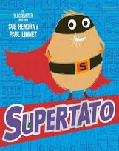 | 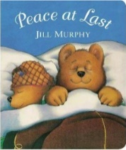  Peace at Last by Jill Murphy | Creepy Crawly by Anon & Busy Bugs by James Carter | 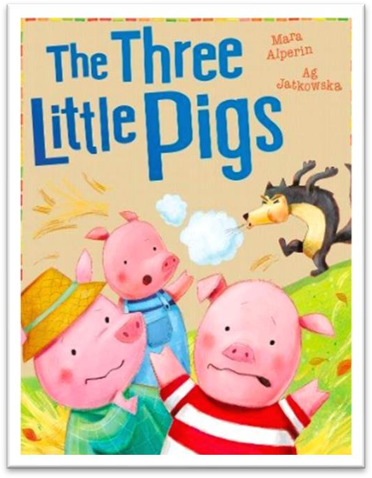 | 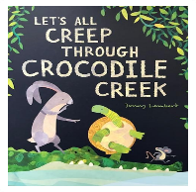 | The Farmyard by A. A. Attwood | 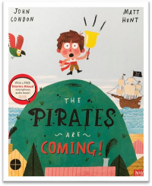 | 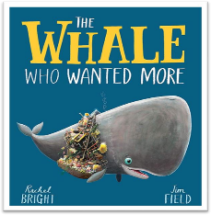 | Behold by Mary  Kawena Pukui
Writing Outcome | Nursery outcome:  Some pupils may choose to draw/mark make some of the story.  Reception children:  Oral retelling of story.  Draw images and write labels to represent the story. | Nursery outcome:  Use story images for pupils to join in with key events and phrases in a retelling of the story.  Reception children:  Oral retelling of story.  Draw images and write labels to represent the story. | Class Performance Poem | Nursery outcome:  A representation of a favourite character in the story. Able to say which character it is and express some information about the character.  Reception outcome:  To label a plan and attempt to write a simple caption. | Nursery outcome:  To draw/make a crocodile and be able to describe some of its features to a familiar adult.  Reception outcome:  To create a story map of the journey and write labels/captions/sentences describing the crocodile. | Performing for an audience | Nursery outcome:  To create a pirate ship and interact with their peers to role play parts of the story. This may involve relevant mark making  Reception outcome:  To write a letter from the point of view of Tom to his mother, describing what he has learned about pirate ships | Nursery outcome:  To draw/paint/make a fish individually or in a small group. To be able to contribute orally to a short story about their fish  Reception outcome:  To rewrite a story | Observation Poem
Nursery | Communication and language  Can start a conversation with an adult or a friend.  Reading  Understand the five key concepts about print:  print has meaning, print can have different purposes.  we read English text from left to right and from top to bottom.  the names of the different parts of a book  page sequencing.  Non-negotiables  Add some marks to their drawings, which they give meaning  Enjoy drawing freely | Communication and language  Know many rhymes.  Use a wider range of vocabulary.  Can start a conversation with an adult or a friend.  Reading  Understand the five key concepts about print:  print has meaning, print can have different purposes.  we read English text from left to right and from top to bottom.  the names of the different parts of a book  page sequencing.  Non-negotiables  Add some marks to their drawings, which they give meaning to e.g. “That says mummy”  Enjoy drawing freely  Make marks on their picture to stand for their name  Mastery  Use some of their print and letter knowledge in their early writing | Communication and  Language  Children in reception  Begin to understand  how to listen carefully  and why listening is  important  Engage in storytimes  Engage in non-fiction  Books  Learn new vocabulary  Articulate their ideas  and thoughts  Describe events in  some detail  Reading  Children in reception  Develop their  phonological awareness  so that they can spot rhymes  count and clap syllables n a word and recognise  words with the same  initial sound. | Communication and language  Enjoy listening to longer stories  Use longer sentences of four to six words  Know many rhymes  Use a wider range of vocabulary  Can start a conversation with an adult or a friend  Reading  Understand the five key concepts about print:  print has meaning, print can have different purposes.  we read English text from left to right and from top to bottom.  the names of the different parts of a book  page sequencing.  Non-negotiables  Add some marks to their drawings, which they give meaning to. For example: “That says mummy.”  Enjoy drawing freely  Make marks on their picture to stand for their name  Mastery  Use some of their print and letter knowledge in their early writing | Communication and language  Know many rhymes, be able to talk about familiar books  Can start a conversation with an adult or a friend and continue it for many turns  Reading  Understand the five key concepts about print:  print has meaning, print can have different purposes.  we read English text from left to right and from top to bottom.  the names of the different parts of a book  page sequencing.  Non-negotiables  Use some of their print and letter knowledge in their early writing  Mastery  Use some of their print and letter knowledge in their early writing  Write some or all of their name | Communication and  Language  Children in reception  Understand how to listen  carefully and why  listening is important  Use new vocabulary  throughout the day  Describe events in some  Detail  Begin to use talk to help  work out problems and  organize thinking and  activities  Begin to articulate their  ideas and thought in  well-formed sentences  Learn rhymes poems and  Songs  Listen carefully to rhyme  and songs paying  attention to how they  sound  Reading  Children in reception  Read individual letters by  saying the sounds for  them  Blend sounds into words  so that they can read  short words made up of  known letter-sound  correspondence  Read simple phrases and  sentences made up of  words with known lettersound  correspondences  and, where necessary, a  few exception words  Writing  Children in reception  Form lower case letters  correctly  Spell words by identifying  the sounds and then  writing the sound with  letter/s | Communication and language  Enjoy listening to longer stories and can remember much of what happens  Develop their communication (irregular tenses and plurals)  Sing a large repertoire of songs (check unit for opportunities)  Reading  Develop their phonological awareness, so that they can:  -spot and suggest rhymes  -count or clap syllables in a word  -recognise words with the same initial sound, such as money and mother  Non-negotiables  Use some of their print and letter knowledge in their early writing  Write some or all of their name  Mastery  Use some of their print and letter knowledge in their early writing  Write some or all of their name | Communication and language  Know many rhymes, be able to talk about familiar books, and be able to tell a long story  Understand ‘why’ questions  Be able to express a point of view and to debate when they disagree with an adult or a friend, using words as well as actions  Understand a question or instruction that has two parts  Use talk to organise themselves and their play  Reading  Develop their phonological awareness, so that they can:  -spot and suggest rhymes  -count or clap syllables in a word  -recognise words with the same initial sound, such as money and mother  Engage in extended conversations about stories, learning new vocabulary  Non-negotiables  Use some of their print and letter knowledge in their early writing  Write some or all of their name  Mastery  Use some of their print and letter knowledge in their early writing  Write some letters accurately | Communication and language  Use new vocabulary in different contexts  Articulate their ideas and t houghts in well-formed sentences  Use talk to help work out problems and organize thinking and activities  Articulate their ideas and thoughts in well-formed sentences  Reading  Read simple phrases and sentences made up of  words with known letter sound correspondences and, where necessary, a  few exception words  Writing  Form lower case and capital letters correctly  Spell words by identifyingthe sounds and then  writing the sound with letter/s  Re-read what they have written to check that it  makes sense
Reception | Communication and language  Engage in storytimes  Understand how to listen carefully and why listening is important.  Learn new vocabulary.  Reading  Read individual letters by saying the sounds for them.  Non-negotiables  Use some of their print and letter knowledge in their early writing  Mastery  Spell words by identifying the sounds and then writing the sound with letter/s | Communication and language  Engage in storytimes  Understand how to listen carefully and why listening is important.  Learn new vocabulary.  Develop social phrases.  Engage in non-fiction books.  Listen carefully to rhymes paying attention to how they sound.  Reading  Read individual letters by saying the sounds for them.  Blend sounds into words, so that they can read short words made up of known letter-sound correspondences  Non-negotiables  Use some of their print and letter knowledge in their early writing  e.g. writing a pretend shopping list that starts at the top of the page  write ‘m’ for mummy  Write some or all of their name  Write some letters accurately  Mastery  Spell words by identifying the sounds and then writing the sound with letter/s  Form lower-case letters correctly |  | Communication and language  Listen to and talk about stories to build familiarity and understanding  Understand how to listen carefully and why listening is important  Learn new vocabulary  Engage in storytimes  Engage in non-fiction books  Reading  Read individual letters by saying the sounds for them  Blend sounds into words, so that they can read short words made up of known letter–sound correspondences  Read a few common exception words matched to the school’s phonic programme  Non-negotiables  Use some of their print and letter knowledge in their early writing. For example: writing a pretend shopping list that starts at the top of the page; write ‘m’ for mummy  Write some or all of their name  Write some letters accurately  Mastery  Spell words by identifying the sounds and then writing the sound with letter/s  Form lower-case letters correctly | Communication and language  Use new vocabulary through the day  Articulate their ideas and thoughts  Describe events in some detail  Listen to and talk about stories to build familiarity and understanding  Listen to and talk about selected non- fiction to develop a deep familiarity with new knowledge and vocabulary  Reading  Blend sounds into words, so that they can read short words made up of known letter-sound correspondences  Read some letter groups that each represent one sound and say sounds for them  Read simple phrases and sentences made up of words with known letter- sound correspondences and, where necessary, a few exception words  Read a few common exception words matched to the school’s phonic programme  Non-negotiables  Spell words by identifying the sounds and then writing the sound with letter/s  Form lower-case letters correctly  Re-read what they have written to check that it makes sense  Mastery  Form lower-case letters correctly  Write short sentences with words with known sound-letter correspondences  Spell words by identifying the sounds and then writing the sound with letter/s  Re-read what they have written to check that it makes sense |  | Communication and language  Use new vocabulary through the day  Articulate their ideas and thoughts in well-formed sentences  Describe events in some detail  Listen to and talk about stories to build familiarity and understanding  Connect one idea or action to another using a range of connectives  Learn rhymes, poems and songs (add to unit)  Reading  Read simple phrases and sentences made up of words with known letter- sound correspondences and, where necessary, a few exception words  Read some letter groups that each represent one sound and say sounds for them  Read a few common exception words matched to the school’s phonic programme  Non-negotiables  Form lower-case letters correctly  Write short sentences with words with known sound-letter correspondences  Spell words by identifying the sounds and then writing the sound with letter/s  Re-read what they have written to check that it makes sense  Mastery  Form lower-case and some capital letters correctly  Write short sentences with words with known sound-letter correspondences  Re-read what they have written to check that it makes sense | Communication and language  Articulate their ideas and thoughts in well-formed sentences  Use new vocabulary in different contexts  Ask questions to find out more and to check they understand what has been said to them  Use talk to help work out problems and organise thinking and activities  Explain how things work and why they might happen  Connect one idea or action to another using a range of connectives  Retell the story, once they have developed a deep familiarity with the text; some as exact repetition  Reading  Read simple phrases and sentences made up of words with known letter–sound correspondences and, where necessary, a few exception words  Read a few common exception words matched to the school’s phonic programme  Re-read these books to build up their confidence in word reading, their fluency and their understanding and enjoyment  Non-negotiables  Form lower-case and some capital letters correctly  Write short sentences with words with known sound-letter correspondences  Re-read what they have written to check that it makes sense  Mastery  Form lower-case and capital letters correctly  Write short sentences with words with known sound-letter correspondences using a capital letter and full stop  Re-read what they have written to check that it makes sense

Class 2  Year 1/2 | Autumn 1 | Autumn 2 | Autumn Poetry | Spring 1 | Spring 2 | Spring Poetry | Summer 1 | Summer 2 | Summer Poetry
 | 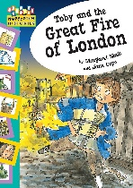  Toby and the Great Fire of London | 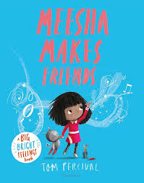  Meesha makes a friend by Tom Percival | There’s no such thing as Monsters | 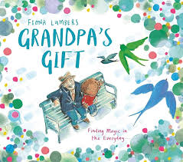  Grandpa’s Gift by Fiona Lumbers | 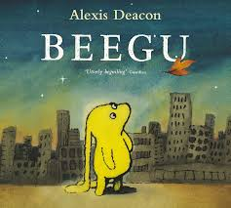  Beegu by Alexis Deacon | At the Zoo | 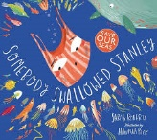  Someone swallowed Stanley by Sarah Roberts | 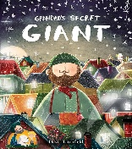  Grandad’s Secret Giant by David Litchfield | Poetry fruit salad
Writing Outcome | Write a recount of the Great fire of London | Write a diary entry | Rhyme | Write a letter recounting the events of the story | Write a fantasy story based on a fable | List poem | Write a historical narrative set in the Stone Age | Write an informative article for the protection of blue whales | Shape Poem
Year 1 | Sentence  Join words using and  Text  Use plural noun suffixes -s and -es  Sequence sentences to form short narratives (link ideas or events by pronoun)  Punctuation  Punctuate sentences using a capital letter and a full stop  Use a capital letter for names of people and places | Sentence  Combine words to make sentences.  Punctuation  Leave spaces between words.  Begin to use capital letters and full stops.  Use a capital letter for names of people and the personal pronoun ‘I’ | Reading  Link what is read or heard to  own experiences  Learn to appreciate rhymes and poems  Check that the text makes sense  Spoken language  Listen and respond  Maintain attention and  participate actively in  collaborative conversations  Speak audibly and fluently | Sentence  Join words and clauses using and  Text  Add suffixes to verbs where no change is needed to the root  Change the meaning of verbs and adjectives by adding the prefix un-  Punctuation  Punctuate sentences using a capital letter and a full stop, question mark or exclamation mark | Sentence  Join words and clauses using and  Text  Add suffixes to verbs where no change is needed to the root.  Punctuation  Punctuate sentences using a capital letter and a full stop, question mark or exclamation mark. | Reading  Listen to and discuss a wide  range of poems, stories and  non-fiction at a level beyond  that at which can be read  independently  Link what is read or heard to  own experiences  Learn to appreciate rhymes  and poems  Recite some rhymes and  poems by heart  Spoken language  Listen and respond  Build vocabulary  Select and use appropriate  registers for effective  communication  Speak audibly and fluently | Sentence  Join words and clauses using and  Text  Add suffixes to verbs where no change is needed to the root.  Change the meaning of verbs and adjectives by adding prefix un-  Punctuation  Punctuate sentences using a capital letter and a full stop, question mark or exclamation mark | Sentence  Join words and clauses  Use simple description  Punctuation  Use a capital letter for names of people and places.  Punctuate sentences using a capital letter, full stop, question mark or exclamation mark. | Reading  Listen to and discuss a wide range of poems, stories and non-fiction at a level beyond that at which can be read independently  Link what is read or heard to own experiences  Learn to appreciate rhymes and poems  Recite some rhymes and poems by heart  Explain clearly understanding of what is read to them  Spoken language  Listen and respond  Ask relevant questions  Build vocabulary  Articulate and justify answers
Year 2 | Sentence  Use co-ordination (but, or)  Add -ly to turn adjectives into adverbs  Punctuation  Use commas to separate items in a list | Sentence  Use subordination (because) and co-ordination (and)  Use expanded noun phrases to describe and specify  Punctuation  Use punctuation correctly - full stops, capital letters |  | Sentence  Write sentences with different forms: statement, question, exclamation, command.  Use subordination (apply because, introduce when)  Text  Use present and past tenses correctly and consistently (some progressive)  Punctuation  Use punctuation correctly - exclamation marks, question marks | Sentence  Use subordination (apply because, when; introduce that)  Text  Use present and past tenses correctly and consistently.  Use the progressive form of verbs in the present and past tense.  Punctuation  Use punctuation correctly - apostrophes for the possessive (singular) |  | Sentence  Use subordination (if, that)  Add -er and -est to adjectives.  Use homophones and near homophones.  Text  Write down ideas, key words, new vocabulary.  Punctuation  Use punctuation correctly – apostrophes for contracted forms | Sentence  Use subordination (using when, if, that, or because) and co-ordination (using or, and, or but)  Use expanded noun phrases to describe.  Add suffixes to spell longer words  Text  Use present and past tenses correctly and consistently including the progressive form  Make simple additions, revisions and corrections

Class 3  Year 2/3 | Autumn 1 | Autumn 2 | Autumn Poetry | Spring 1 | Spring 2 | Spring Poetry | Summer 1 | Summer 2 | Summer Poetry
 | 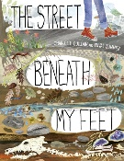  The street beneath my feet by Charlotte Gulian | 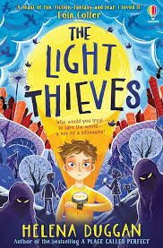  Light Thieves by Helena Duggan | Night Sounds by Berlie  Doherty | 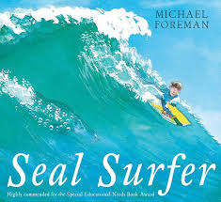  Seal surfer by Michael Foreman | 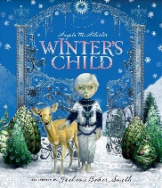  Winter’s child by Angela McAllister | The River’s Tale by Rudyard Kipling | 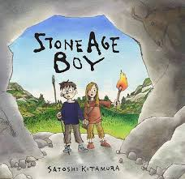  Stone Age Boy by Satoshi Kitamura | 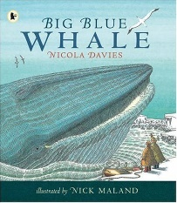  Big Blue Whale by Nicola Davies | Apes to Zebras
Writing Outcome | Write an information text about rocks | Write a story introduction with character and setting description | Senses poem | Write a letter recounting the events of the story | Write a fantasy story based on a fable | Descriptive poem | Write a historical narrative set in the Stone Age | Write an informative article for the protection of blue whales | Concrete Poem
Year 2 | Word  Use of scientific vocabulary  Sentence  Use of co-ordinating conjunctions  Text  Use of titles and subheadings  Punctuation  Use punctuation correctly – exclamation marks, question marks | Word  Using -ed suffix to show past tense.  Sentence  Use subordination  Text  Use of expanded noun phrases for description  Punctuation  Use punctuation correctly – exclamation marks, question marks | Poetry  Use adventurous word choices of nouns, adjectives and verbs to describe observations  Use structured language patterns, including simple  repeating phrases  Writing composition  Plan or say aloud what is going to be written about  Write down ideas, key words, new vocabulary  Read aloud with intonation  Reading  Continue to build up a repertoire of poems learnt by heart  Answer and ask questions  Participate in discussion about  books, poems and other works  Explain and discuss understanding of books, poems and other material  Spoken language  Listen and respond  Build vocabulary  Articulate and justify answers  Speak audibly and fluently | Sentence  Use subordination (because) and coordination (and)  Use expanded noun phrases to describe and specify.  Punctuation  Use punctuation correctly - full stops, capital letters. | Word  Add -ly to turn adjectives into adverbs.  Sentence  Use expanded noun phrases to describe and  specify  Use co-ordination (but, or)  Punctuation  Use commas to separate items in a list. | Poetry keys  Use language with increasing effect: choices of nouns,  adjectives and verbs.  alliteration; repetition and rhyme  Create own repeating patterns and use simple forms.  Writing composition  Plan writing by discussing the  structure, vocab and grammar of similar writing  Discuss and record ideas  Compose and rehearse sentences orally  Proof-read for spelling and punctuation errors  Reading  Use dictionaries to check the meaning of words  Discuss words and phrases that capture the reader’s interest and imagination  Recognise different forms of poetry  Explain meaning of words in context  Ask questions to improve understanding of a text  Spoken language  Listen and respond.  Ask relevant questions.  Build vocabulary.  Participate in discussions and role play | Sentence  Use subordination (apply because, introduce when)  Text  Use present and past tenses correctly and  consistently (some progressive)  Punctuation  Use punctuation correctly – exclamation marks, question marks | Word  Add -er and -est to adjectives.  Use homophones and near homophones.  Sentence  Use subordination (if, that)  Write sentences with different forms: statement, question, exclamation, command.  Punctuation  Use punctuation correctly –exclamation marks, question marks, commas in a list, possessive (singular) | Poetry keys  Use language with increasing  effect: choices of nouns,  adjectives and verbs;  alliteration; repetition and  rhyme  Writing composition  Plan writing by discussing the  structure, vocab and grammar of similar writing  Propose changes to grammar  and vocabulary to improve  consistency  Read aloud own writing using appropriate intonation and controlling the tone and  volume so that the meaning is clear.  Reading  Listen to and discuss a wide  range of texts  Identify themes and  Conventions  Prepare poems and play  scripts to read aloud and to  perform  Discuss words and phrases  that capture the reader’s  interest and imagination  Identify how language,  structure, and presentation  contribute to meaning  Retrieve and record  information from non-fiction  Participate in discussion about books  Spoken language  Listen and respond  Ask relevant questions  Build vocabulary  Use spoken language: speculating, hypothesising, imagining and exploring ideas  Consider and evaluate different viewpoints
Year 3 | Sentence  Use a range of conjunctions  Text  Format choices to aid the reader  Punctuation  Use of commas within a list | Word  Use of homophones/ near homophones  Use of adverbs  Sentence  Use of fronted adverbials  Text  In narratives, create characters, setting and  plot  Punctuation  Use of commas when using fronted adverbials |  | Sentence  Use prepositions to express time, place (and  cause)  Text  Group related ideas into paragraphs.  Build a varied and rich vocabulary.  Punctuation  Introduce inverted commas to punctuate direct speech. | Word  Use a or an according to whether the next  word begins with a vowel or consonant.  Sentence  Use conjunctions and adverbs to express time, place and cause.  Text  In narratives, create characters, setting and  plot  Punctuation  Use inverted commas to punctuate direct speech |  | Word  Form nouns from a range of prefixes  Sentence  Use prepositions, conjunctions and adverbs to express time, place and cause  Text  Use present and past tenses correctly and  consistently including the progressive form  and present perfect  Build a varied and rich vocabulary  Punctuation  Use inverted commas to punctuate direct speech | Sentence  Build an increasing range of sentence structures.  Use adverbs to express time, place and cause.  Text  Use headings and subheadings to aid presentation.  Assess the effectiveness of own and others’ writing.

Class 4  Year 4/5 | Autumn 1 | Autumn 2 | Autumn Poetry | Spring 1 | Spring 2 | Spring Poetry | Summer 1 | Summer 2 | Summer Poetry
 | 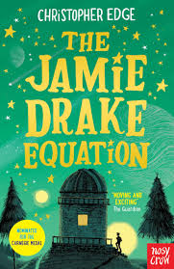  The Jamie Drake equation by Christopher Edge | 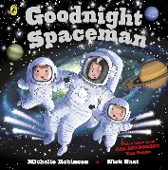  Goodnight, Spaceman by Michelle Robinson | The Moon | 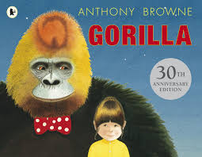  Gorilla by Anthony Browne | 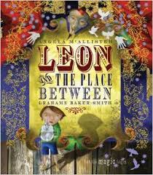  Leon and the place between by Graham Baker | The Roman Centurion’s Song  by Rudyard Kipling | 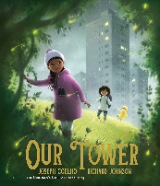  Our Tower by Joseph Coleho | 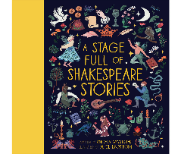  Julius Caeser | Look! by Grace Nichols
Writing Outcome | Write a narrative including speech | Write a biography about Tim Peake | Free verse with refrains and verses | Write a fantasy story | Write a diary from Leon’s point of view | Outcome – Cinquain | Write the adventure as a recount journal | Write a playscript | A list poem based  on a traditional rhyme
Year 4 | Sentence  Expanded noun phrases  Text  Organise paragraphs  Choose nouns or pronouns appropriately for clarity and cohesion and to avoid repetition.  Punctuation  Use inverted commas for direct speech.  Use of possessive apostrophes | Word  Using past tense verbs consistently  Sentence  Use subordination  Text  Use of layout features for the reader  Punctuation  Use of commas for lists | Poetry keys  Use a range of descriptive language techniques to create effective imagery  Experiment with a range of forms  Writing composition  Note and develop initial ideas, drawing on reading and research  Enhance meaning through selecting appropriate grammar and vocabulary  Describe settings, characters and atmosphere  Propose changes to  vocabulary, grammar and  punctuation to enhance effects and clarify meaning  Perform own compositions  using appropriate intonation,  volume and movement  Reading  Identify and discuss themes and conventions  Make comparisons within and across books  Learn poetry by heart  Prepare poems and plays for performance  Identify how language, structure and presentation  contribute to meaning  Spoken language  Listen and respond  Build vocabulary  Speak audibly and fluently  Participate in performances | Sentence  Expand noun phrases by the addition of modifying adjectives, nouns, and prepositional phrases.  Use fronted adverbials.  Text  Organise paragraphs around a theme (to organise and sequence more extended narrative structures)  Choose nouns or pronouns appropriately for clarity and cohesion and to avoid repetition.  Punctuation  Use commas after fronted adverbials.  Use inverted commas for direct speech. | Sentence  Extend the range of sentences with more than one clause by using a wider range of conjunctions including when, if, because, although  Use Standard English forms for verb inflections.  Text  Build a varied and rich vocabulary.  Punctuation  Indicate possession by using the possessive apostrophe with plural nouns.  Recognise the grammatical difference between plural and possessive ‘s’ | Poetry keys  Use language with increasing effect: choices of nouns,  adjectives, adverbs and verbs alliteration; hyperbole  Create own repeating pattern and experiment with simple forms  Writing composition  Plan writing by discussing the structure, vocab and grammar of similar writing  Discuss and record ideas  Propose changes to grammar and vocabulary to improve  Consistency  Proof-read for spelling and punctuation errors  Read aloud own writing using appropriate intonation and controlling the tone and  volume so that the meaning is clear  Reading  Prepare poems and play  scripts to read aloud and to perform  Discuss words and phrases that capture the reader’s interest and imagination  Explain meaning of words in context  Identify how language,  structure, and presentation contribute to meaning  Spoken language  Build vocabulary  Use spoken language: speculating, hypothesising,  imagining and exploring ideas  Speak audibly and fluently  Participate in discussions | Text  Organise paragraphs around a theme (using fronted adverbials to introduce or connect paragraphs)  Variety of verb forms used correctly and consistently including the progressive and the  present perfect forms  Use Standard English forms for verb inflections.  Punctuation  Use and punctuate direct speech (using dialogue to show the relationship between characters) | Sentence  Extend the range of sentences with more than one clause by using a wider range of conjunctions including when, if, because, although  Text  Build a varied and rich vocabulary.  Organise paragraphs around a theme.  Variety of verb forms used correctly and  consistently including the progressive and the  present perfect forms | Poetry keys  Use increasingly effective  similes to create imagery  Create own repeating patterns and experiment with simple forms  Writing composition  Plan writing by discussing the structure, vocab and grammar of similar writing  Discuss and record ideas  Assess the effectiveness of  own and others’ writing  Proof-read for spelling and  punctuation errors  Reading  Recognise different forms of  Poetry  Discuss words and phrases  that capture the reader’s  interest and imagination  Explain meaning of words in  Context  Identify how language, structure, and presentation contribute to meaning  Spoken language  Listen and respond  Build vocabulary  Maintain attention and  participate actively in  collaborative conversations  Use spoken language:  speculating, hypothesising,  imagining and exploring ideas
Year 5 | Sentence  Use a range of conjunctions  Text  Format choices to aid the reader  Punctuation  Use of commas within a list | Word  Use of adverbs  Sentence  Use of fronted adverbials  Punctuation  Use of commas when using fronted adverbials  Use of parenthesis |  | Sentence  Use expanded noun phrases to convey complicated information concisely.  Text  Organise paragraphs around a theme.  Identify the audience and purpose of writing.  Punctuation  Use commas to clarify meaning or avoid ambiguity. | Sentence  Extend the range of sentences with more than one clause by using a wider range of conjunctions including when, if, because, although (Y4 recap)  Text  Describe settings, characters and atmosphere.  Link ideas using tense choices.  Punctuation  Use commas to clarify meaning or avoid ambiguity in writing |  | Sentence  Use relative clauses beginning with who, which, where, when, whose, that or an omitted relative pronoun  Text  Link ideas across paragraphs using adverbials.  Variety of verb forms used correctly and consistently including the progressive and the present perfect forms.  Punctuation  Integrate dialogue to convey character and advance the action.  Use and punctuate direct speech (using dialogue to show the relationship between characters) | Sentence  Use relative clauses beginning with who,  which, where, when, whose, that or an omitted relative pronoun  Use adverbs to indicate degrees of possibility.  Text  Use a wide range of devices to build cohesion across and within paragraphs.  Choose the appropriate register

