Year 6 | Autumn 1 |  |  | Autumn 2 |  |  | Spring 1 |  |  | Spring 2 |  |  | Summer 1 |  |  | Summer 2
Books | F  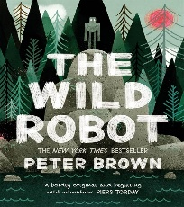  The Wild Robot | NF    Nelson Mandela | O  Pie Corbet: What Am I? | F  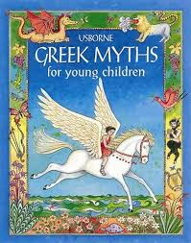  Various Greek myths/short stories | NF  Santa Strategy: Christmas Flight | O  Advertisements | F  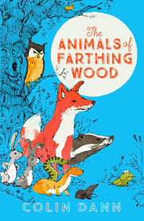  The Animals of Farthing Wood | NF  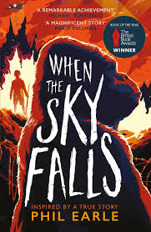  When the sky falls | O  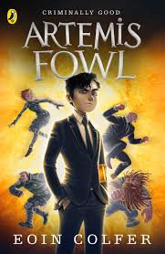  Artemis Fowl | F  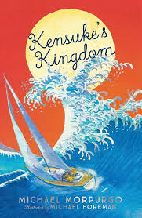  Kensuke’s Kingdom | NF  Pie Corbet: Dragons  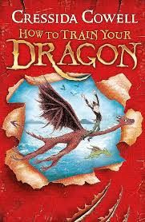  How to train your dragon | O  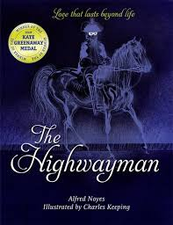  The Highwayman | F  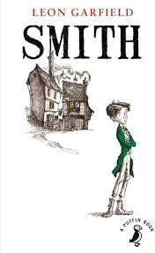  Smith – Leon Garfield | NF  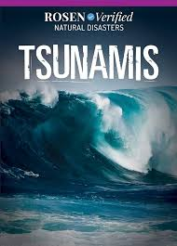  Tsunamis | O  Flannan Isle  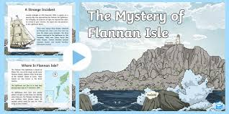 | F  Flannan Isle | NF  Should children be given the vote? | O  Shakespeare  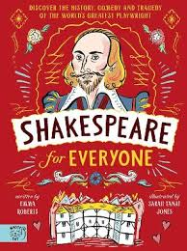
Writing  Outcome | Science Fiction | Biographies | Poem | Myths Legends Fables | Instructions | Persuasive advert | Stories with Dilemmas | Recount | Prose | Adventure | Non-Chronological report | Narrative Poem | Historical fiction | Explanation text | Poem | Mystery | Discussion/Persuasion | Playscript
Year 6 | - Use expanded noun phrases  - Use brackets, dashes or commas to indicate parenthesis  - Recognise vocabulary and structures for formal speech  - Use passive verbs  - Use language carefully to  influence the reader’s opinion of a character, place or  situation  - Use paragraphs to vary pace and emphasis  - Give clues to the reader about when the story takes place  - use further prefixes and suffixes and understand the guidance for adding them | - Use devices to build cohesion within a paragraph  - Link ideas using tense choices  - Recognise vocabulary and structures for formal speech and writing, including subjunctive forms  - Use a wider range of devices to build cohesion  - Variety of verb forms used correctly and consistently including the present perfect form  - Use colons or dashes to mark boundaries between independent clauses  - Write in consistent tense using a range of verb forms  - Include the 5Ws – who, what, where, when, why and how –and conclude with a clear summary  - Use real life facts, including dates and place names  - spell some words with ‘silent’ letters [for example, knight, psalm, solemn] | - Articulate and justify answers  - Give well structured descriptions, explanations  - Identify and discuss themes and conventions  - Prepare poems for  performance  - Learn poetry by heart  - Draw inferences  - Make authorial choices, selecting from a range of forms, to suit the purpose  - Make effective language choices, drawing on a  range of descriptive techniques  - Perform own  compositions  using appropriate  intonation, volume and movement | • Use devices to build  cohesion within a paragraph  • Develop and keep characters  consistent through vivid  description  • Use language carefully to  influence the reader’s  opinion of character, place  or situation  • Use dialogue to explain the  plot, reveal new  information, show character  or relationships or to convey  mood  - Use passive verbs  • Enhance meaning through  selecting appropriate  grammar and vocabulary  • Use a wider range of devices  to build cohesion  (adverbials and  conjunctions)  • Use semi-colons, colons or  dashes to mark boundaries  between independent  - clauses  use knowledge of morphology and etymology in spelling and understand that the spelling of some words needs to be learnt specifically. | - accurately punctuated sentences with full stops and used capital letters for all proper nouns (names, places, days, months etc.).  - organisational choices for the impact of the reader  - numbered bullets to make the order clear.  - Imperatives  - Modal verbs  • Punctuate bullet points consistently  - Use persuasive language  e.g. quotes, slogans, rhetorical questions  • Directly appeal to the reader  - use dictionaries to check the spelling and meaning of words | - Organise paragraphs  around a theme  • Use expanded noun  phrases to convey  complicated  information concisely  • Use relative clauses  to add detail and  description  - Use modal verbs to indicate  degrees of possibility  • Use devices to build cohesion  within a paragraph  • Choose the appropriate register  • Enhance meaning through  selecting appropriate grammar  and vocabulary  • Use a wider range of devices to  build cohesion  • Use a colon to introduce a list and  use semi-colons within lists  • Use a colon to introduce a list | - Use expanded noun phrases  to convey complicated  information concisely  • Describe settings, characters  And atmosphere  • Integrate dialogue to convey  character and advance the  action  - Use language carefully to  influence the reader’s  opinion of a character, place  or situation  • Use dialogue to explain the  plot, reveal new  information, show character  or relationships or convey  mood.  • Use emotive language  including use of modals and  adverbs for possibility (e.g.  surely, every right-thinking  person would)  • Support points using  persuasive examples and  provide evidence  • Create authority through a  formal style where | • Use passive verbs  • Link ideas across paragraphs  using a wider range of  cohesive devices  • Use clear organisational  features  • Enhance meaning through  selecting appropriate  grammar and vocabulary  • Use modal verbs and  adverbs to indicate degrees  of possibility  • Use brackets, dashes or  commas to indicate  parenthesis  • Use concise word choices  • Clarify technical vocabulary  • Adapt formality to suit  purpose and audience  • Provide well-developed  factual information for the  reader  - use a thesaurus  - using commas to clarify meaning or avoid ambiguity in writing  - continue to distinguish between homophones and other words which are often confused | - A strong plot as well as fantastical elements  - Very clear and detailed description to help the reader imagine  - Use imagery for description  - Vary story structure: start with a  flashback or dramatic event, use 2  narrators to tell a story from different  perspectives  • Use paragraphs to vary pace and  Emphasis  - use he first 3 or 4 letters of a word to check spelling, meaning or both of these in a dictionary | - Use expanded noun phrases.  to convey complicated  information concisely  • Select appropriate grammar  and vocabulary  • Integrate dialogue to convey  character and advance the  action  • Use a wide range of devices  to build cohesion  • Use semi-colons, colons or  dashes to mark boundaries  between independent  clauses  • Use powerful and varied  verbs for action  • Use paragraphs to vary pace  and emphasis  • Combine action, dialogue and  description | - Use precise word choices  • Select language to appeal to the reader  • Clarify technical vocabulary  • Use a formal tone  • Adapt formality to suit purpose and  audience  • Use fronted adverbials e.g. also,  additionally, usually, commonly  • Provide well-developed factual  information for the reader  • Manipulate style for specific purpose and  audience (hybrid texts)  • Include a summarising statement | - Evaluate authors’  language choice  - Explain and  discuss  understanding of  reading  - Note and develop  initial ideas,  drawing on  reading and  - research  Describe settings,  characters and  atmosphere  - Use  organisational  and  presentational  devices to  structure text  - Propose changes  to vocabulary,  grammar and  punctuation to  enhance effects  and clarify  meaning  - Experiment with  personification to  create effective  imagery | - Re-telling with a flashback which could begin with the final event fictional but use real event  - Historical setting  - Accurate historical detail  - Give clues to the reader about when the story takes place- archaic  language might be appropriate  • Use paragraphs to vary pace and  emphasis  • Use dialogue to explain the plot, reveal  new information, show character or  relationships or to convey mood  - Use language carefully to influence the  reader’s opinion of a character, place or  situation | - Link ideas across paragraphs  using a wider range of  cohesive devices (e.g.  repetition, adverbials,  ellipsis)  • Choose the appropriate  register  • Use semi-colons, colons or dashes to mark boundaries  between independent  clauses  - Clarify technical  vocabulary  • Use a formal tone  • Adapt formality to suit purpose and audience  • Use fronted adverbials  - using relative clauses beginning with who, which, where, when, whose, that or with an implied (ie omitted) relative pronoun  - using hyphens to avoid ambiguity | - Participate in  discussions and  performances  - Gain, maintain  and monitor the  interest of the  listener(s)  - Prepare poems for  performance  - Make effective  language choices,  drawing on a  range of  descriptive  techniques  - Identify and  discuss themes  and conventions  - Enhance meaning  through selecting  appropriate  grammar and  vocabulary  - Make effective  language choices,  drawing on a  range of  descriptive  techniques  - Identify the  audience for an  purpose of  writing  - Enhance meaning  through selecting  appropriate  grammar and  vocabulary | • Link ideas across paragraphs  using adverbials of time,  place and number  • Use of inverted commas and  other punctuation to  punctuate direct speech  • Use consistent and correct  tense  • Use passive verbs  • Link ideas across paragraphs  using a wider range of  cohesive devices  • Integrate dialogue to convey  character and advance the  action  • Use small details for  characters to amuse,  entertain or create drama  • Engage reader through  selecting effective grammar  and vocabulary  - Manipulate tense and verb  forms  • Use paragraphs to vary pace  and emphasis | - Link ideas using tense  choices  - Recognise vocabulary and structures for formal speech and  writing, including subjunctive forms  • Use a wider range of devices to build cohesion  • Use a colon to introduce a list and  use semi-colons within lists  • Punctuate bullet points  Consistently  Adapt formality to suit  purpose and audience  • Clarify technical vocabulary  - Create authority through a  formal style where  appropriate | - identifying the  audience for and  purpose of the  writing, selecting  the appropriate  form and using  other similar  writing as models  for their own  - noting and  developing initial  ideas, drawing on  reading and  research where  necessary  - draft and write by  selecting appropriate  grammar and  vocabulary,  understanding how such  choices can change and  enhance meaning,  - proofread for spelling  and punctuation  errors evaluate by  assessing the  effectiveness of their own writing  proposing changes to vocabulary, grammar and punctuation to  enhance effects and clarify meaning

