SEND Information Report
Approved on:
July 2023
Next review:
June-July 2024
St. Cuthbert’s Catholic Primary School

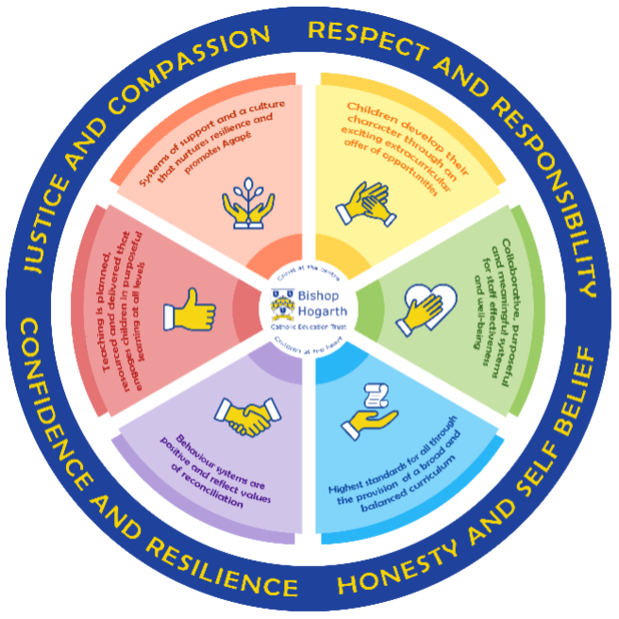
As part of the family of Bishop Hogarth Catholic Education Trust, our school has at its core, the virtues, and values of:
Respect for others and themselves, recognising that we are all created in the image of God and therefore must be compassionate towards others, especially the vulnerable. ​
Confidence in their own abilities, knowing that their talents are gifts from God and resilience to persevere when things become difficult. ​
Honesty in regard to the world around them and themselves and the ability to take responsibility for the times we may fall short of the mark. ​
Gratitude for all the amazing gifts from God and willingness to share their gifts both personal and material. ​

As an inclusive school, all teachers are teachers of pupils with Special Educational Needs & Disabilities. We deliver a curriculum and create an environment that meets the needs of every pupil within our school. We ensure that every pupil with Special Educational Needs and / or disabilities makes the best progress possible. We foster and promote effective working partnerships with parents / carers, pupils, and outside agencies. We consider the ‘whole’ child and strive to ensure that all our SEND pupils are prepared for adulthood.​

Our school’s approach to supporting pupils with SEND
school to populate this section
St. Cuthbert’s Catholic Primary School aims to offer children an educational experience where staff will strive to identify and remove barriers to learning and create an environment in which every child is encouraged to reach their potential and ensure “no child is left behind”.
- Teachers are responsible for the progress of ALL pupils in their class. High quality teaching is personalised to meet every child’s need. This is the first step in supporting pupils who may have SEND (Special Educational Needs and Disabilities). All children are challenged to do their very best regardless of their starting point.
- All children will be taught a broad and balanced curriculum; adapted to the needs of each individual. Where children require extra support, specialist resources or extension materials, these will be provided wherever possible.
- All children are known well by their class teacher, who develops strong relationships with them with good behaviour and effort in work being rewarded.
- Your child can express their views through school council representatives or directly to staff. Student council representatives encourage all pupils to have a voice in school.
- We manage medical needs by working closely with parents and healthcare professionals. We listen to and act on their advice, providing staff training when needed. (‘Supporting Children with Medical Conditions Policy’ June 22)
- We run a wide range of fully inclusive extra curricular clubs throughout the year that provide opportunities for children of all ages to participate in a range of activities including Dance, Games, Choir, Science and Football.

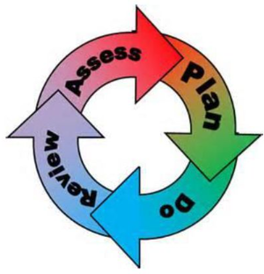
How will the school staff support my child?
The graduated response-Identifying, planning for and supporting pupils with SEND
Where a pupil is identified as having a special educational need, School will follow a graduated approach which takes the form of cycles of ‘Assess, Plan, Do, Review’. ​
• Assess a child’s special educational need. ​
• Plan the provision to meet your child’s aspirations and agreed outcomes. ​
• Do put the provision in place to meet those outcomes. ​
• Review the support and progress.

How does the school know if children need extra help and what do I do if I think my child has special educational needs?

- Assess
Identification
Your child will be identified as having SEN and/or a disability if they have significantly greater difficulty in learning than the majority of children of the same age or if they have a disability preventing or hindering the use of educational facilities provided for children of the same age within the Local Education Authority.
First steps If from our rigorous tracking and monitoring of your child’s progress, it becomes apparent that he/she is not making expected progress then you will be invited to a meeting with their teacher and Mrs Bissell (SENCo). Where appropriate your child will be involved in this meeting. At the meeting we will begin to explore the possible barriers to learning and you will be asked how we can best support your child. Observations and assessments will then be carried out and, if required, input from specialist services may be sought with your permission. Where appropriate your child may be placed on our school’s SEN Support Register and a plan will be devised by the class teacher that will set achievable targets. These will be reviewed and updated at least half-termly. EHCPs (Education, Health and Care Plans) will be used when a child’s needs are deemed more complex and require the input from a range of outside agencies. This could be in the form of Educational Psychologists, Occupational Therapists or other professionals with an area of expertise, e.g., Autism. An EHCP helps to determine the level of educational, social and health support the child needs.
If you are concerned about your child’s progress or that your child may have SEN and/or a disability, please contact our SENCo Mrs. Bissell on 01388 762889.

- Plan
The first point of contact is the class teacher, who has overall responsibility for the welfare of your child. Additional provision is planned carefully and overseen by Mrs Bissell, the SENCo (Special Educational Needs and Disabilities Co-ordinator). It is implemented by a skilled team of teachers and supported by experienced teaching assistants.
SEND Resources
At St. Cuthbert’s we have an extensive range of different SEND resources and interventions available. These are closely matched to the needs of our children and their progress is monitored by the class teacher, the SENCo and staff with specific curriculum responsibilities.
Where provision does not result in adequate progress, as outlined in the SEN Code of Practice, the SENCo (Mrs Bissell) should be consulted for advice.

- Do
Our teachers are skilled at adapting teaching and learning to meet the diverse needs in each class. ​
Daily planning considers individual children’s needs and requirements and is annotated and adapted according to need. Explicit reference is made in the teacher’s planning to the needs of those children identified with SEND. ​
Adaptive teaching is approached in a range of ways to support access to the curriculum and ensure that all children can experience success and challenge in their learning. ​
Grouping arrangements consider the different skills and abilities of each child. This ensures that learning is maximised. ​

Additional adults support groups and individual children with the long-term goal of developing independent learning skills. The class teacher monitors this support to avoid students becoming over reliant on this. ​
We fully encourage parental support and offer opportunities for individual meetings with parents/carers to provide clarity and recommendations on how they can support their child at home.

- Review
If despite all steps taken, good progress is still not being made we will refer back to our graduated approach and increase/change support whilst continuing to monitor and review progress. It may also be necessary, at this stage, to consult with the expertise and specialist services secured by the school.

Consultation sessions are held in the Autumn and Spring terms where you can meet your child’s teacher to discuss and look at their work in different subject areas. A further opportunity is provided in the Summer term for you to discuss your child’s end of year report.

Parents that have children on the school’s SEN Support Register, are also invited to termly meetings to review their child’s Individual Education Support Plan with the class teacher.
If, of course, you would like to meet Mrs Bissell or your child’s class teacher at any point during the term, this can easily be arranged

How will the curriculum at our school be matched to my child’s needs?
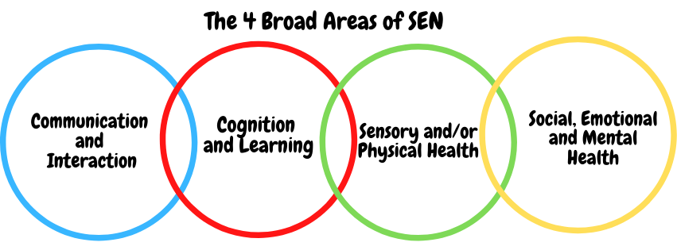SEN needs are classified under four broad areas of need. Below are the strategies, in class support and interventions that school may put in place to support your child.
Communication and Interaction
Strategies to support children with these needs include:
- Access to small group and/or individualised interventions to develop skills in communication and interaction with others, e.g. Time to Talk, Mabel, Conversation Train, Neli, Socially Speaking
- Visual timetables
- Modifications to lunch and/or break times, e.g. small groups
- Access to additional aids/technology
- Explicit teaching of general skills from one context to another
- Careful planning of transitions, e.g. advance notice, familiar resources
- Small group or individual work to support development of relationships

Cognition and Learning
Strategies to support children with these needs include:
- Regular, individually focused interventions, e.g. reading (Boost Reading Primary), phonics (RWInc.),
- Timetabled support – may also be before or after school
- Increased access to small group support in class
- Practical aids for learning, e.g. table squares, time/number lines, pictures, photos, accessible reading material suited to age, individualised success criteria, manipulatives
- Flexible groupings
- Access to technical aids e.g. spell checker, ICT software and/or hardware
- Adaptations to assessments to enable access e.g. readers, scribe, ICT
- Curriculum adaptations to meet the learning needs of individuals
- Frequent repetition and reinforcement

Sensory/Physical
Strategies to support children with these needs include:
- Occupational Therapy interventions sensory diet
- Self Regulation - Zones of Regulation
- Concrete apparatus available to support learning, e.g. tens frames
- Adapted curriculum to enable full access e.g. alternative recording devices, modified PE curriculum
- Sensory resources available e.g. wobble board, headphones/ear defenders
- Access to support for personal care, e.g. school nurse service

Social, Emotional and Mental Health
Strategies to support children with these needs include:
- Access to time out/individual work area/station/busy box
- Individualised rewards system
- Access to counselling services, e.g. CAMHS, Road Centre
- Increased access to additional adults in and out of the classroom
- Supported transition programme with chosen secondary school
- Opportunities to develop Social and Emotional aspects of learning through small group work, e.g. Just the Right State programme (Future Steps)
- Occupational Therapy services, e.g. Sensory Diet
- Zones of Regulation/Social Stories
- Mental Health Support Team (MHST) workshops/support

What training is provided for staff supporting children with SEND?
- Our SEND lead is currently accessing the NASENCO qualification
- All staff attended Trust training for whole school development.
- Staff attend the training provided by the Col.
- We have an identified and trained mental health lead in school.
- A member of staff has completed counselling training.
- All teachers have Qualified Teacher Status and our teaching assistants have a minimum of a level 2 qualification.
- All staff are either teachers of or are supporting students with SEND.
- St. Cuthbert’s values staff training and organises courses/training programmes to ensure teachers and teaching assistants stay up to date with current research into teaching and learning.

Recent CPD includes:
Details of Full Staff Training | Details of Individual Staff Training
Child Protection training | Intensive Interaction
Positive Handling | SENDCO Network
SEND updates | SEND LEAD- Zones of regulation
Teacher SEND Responsibilities and how
To complete support plans

How do we support transition in our school?

Transition within classes/key stages: ​
Information will be passed on to the new class teacher in advance and a transition meeting will take place to ensure the new teacher knows about your child and their specific needs. (What works well and any difficulties they encounter) Individual targets/requirements for all SEND children will be discussed with the new teacher and agreed by Mrs Bissell.

Children who require additional support to ensure a smooth transition to their new class, will be discussed during transition meetings to ensure their needs are met. On occasions, according to need, a child may spend time with their new teacher to begin to form relationships and alleviate concerns.

Transition to Secondary settings: ​
- We work closely with our Secondary feeder schools, organising meetings, sharing information and providing enhanced transition as needed.
- Whole class transition sessions are held with the MHST team to support children with any concerns.
- Meetings are held for the transfer of essential information relating to Send Support Plans, EHCPs, Child and Family Services and pastoral matters.
- When reviewing an EHCP for children in Y6, staff from the secondary school will always be invited to the review meetings.
- During the last term, staff from St John’s come to meet our Y6 children and in addition to this, our Y6 children attend their chosen secondary school for two transition days.

Where can I get further information about services for my child?

The Local Offer
* SEN Code of Practice (graduated response) https://www.gov.uk/government/consultations/revision-of-the-send-code-of-practice-0-to-25-years

* Local Authority’s Local Offer
Special educational needs and disabilities (SEND) and our Local Offer - Durham County Council

What key school documents refer to support and provision for pupils with SEND?

- SEND Policy​
- Admissions Policy​
- Supporting Pupils with Medical Needs Policy​
- Accessibility Plan​

Accessibility​
- With due regard to our admission policy, parental choice and accessibility of the school building all children with special educational needs who apply will be accepted by the school. (Admission Policy)
- The school is all on one level and is fully wheelchair accessible via a ramp onto the site including main playing areas.
- Disabled toilet facilities are located near the school community entrance and a further one can be accessed from the Atrium.
- Communication with parents whose first language is not English is supported by advice from the Local Authorities EAL (English as an additional language) team.

Activities Outside of School​
- St. Cuthbert’s is an inclusive school and we will put in place appropriate support, whenever possible, to enable your child to be educated alongside their peers. This may include extra staffing and/or equipment.
- Staff who are arranging an offsite trip will discuss with parents and the SENCo any requirements needed and the suitability of any trip which the school is taking part in.
- We will not stop your child from going on a trip due to their special educational needs and/or disability if the trip is suitable for your child and their safety and the safety of others is not compromised. (Equality Act)
- The Head of School oversees all trips to ensure children are safe and included where possible.

What to do if you have a complaint, a compliment, or a query.

The school details and relevant contacts
If you need to speak to someone please contact school on
office@stcuthbertscrook.bhcet.org.uk
Or telephone 01388 762889
Please ask to speak to your child’s class teacher initially or Mrs Bissell our SEND lead.
If further help is needed please speak to Miss McElhone (Headteacher)
​
Name of school SEND governor.
Anne Timothy - Chair of Governors.

