Friday 13th September 2024

Dear Parents and Carers,

It is hard to believe that we are already at the end of our second week together.  I am writing to you today to confirm some of the new arrangements that we have implemented so far this term.  We have agreed as a staff team that we will always have the highest expectations of every child in St Cuthbert's School.  We want our children to be the very best that they can be and our high expectations are at the centre of this.



We introduced our new behaviour policy to the children on their first day of school last week.  St Cuthbert's children are always Ready, Responsible and Respectful.  We have promised the children that as the adults in school, we will also be Ready, Responsible and Respectful and we invite you, as members of our school family, to do the same.   Children are rewarded for 'behaving the way we do at St Cuthbert's' through merit points and are all working towards various merit point certificates.

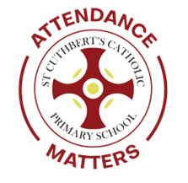

Today, we have introduced our 'Attendance Matters' piggy bank scheme to t the children.  In its simplest form, children earn 'St Cuthbert's Money' for b being in school and on time.  They will work together as a class to save this m money into their class piggy bank and decide which rewards they would ke to like to spend their savings on.  To be 'Ready', we need to be in school on time, every day.

I would like to thank the many of you that have taken the time to introduce yourselves to me and a very big thank you for taking the time to tell me how much you appreciate the changes that we have made this term.

With my very best wishes for a lovely weekend

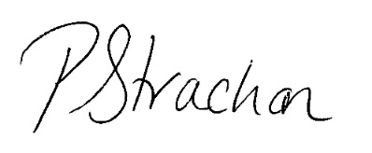

Mrs P Strachan

Executive Head Teacher