Pupil premium strategy statement

This statement details our school’s use of pupil premium (and recovery premium for the 2024 to 2025 academic year) funding to help improve the attainment of our disadvantaged pupils.

It outlines our pupil premium strategy, how we intend to spend the funding in this academic year and the effect that last year’s spending of pupil premium had within our school.

School overview
Detail | Data
School name | St Cuthbert’s Catholic Primary School, Stockton
Number of pupils in school | 216
Proportion (%) of pupil premium eligible pupils | 36%
Academic year/years that our current pupil premium strategy plan covers (3 year plans are recommended) | 2024-2027
Date this statement was published | September 2024
Date on which it will be reviewed | September 2025
Statement authorised by | S Parnell
Pupil premium lead | S Parnell
Governor / Trustee lead | Mrs M Dowson
Funding overview
Detail | Amount
Pupil premium funding allocation this academic year | £112,195
Recovery premium funding allocation this academic year | £0
Pupil premium funding carried forward from previous years (enter £0 if not applicable) | £0
Total budget for this academic year  If your school is an academy in a trust that pools this funding, state the amount available to your school this academic year | £112,195

Part A: Pupil premium strategy plan

Statement of intent
‘Delight in the Lord, Delight in the Good’ (Psalm 37:4)
At St Cuthbert’s Catholic Primary School we have high aspirations for all pupils and as our school serves an area of high deprivation, where 36% of our pupils are eligible for the pupil premium grant, and where more families are advising us that they struggle financially, we understand the importance of enhancing the educational experience for all children. We aim to improve outcomes for all children at St Cuthbert’s and funds are allocated accordingly.
Educationally we aim for all children to leave St Cuthbert’s ready for secondary school with solid foundations in core subjects and key knowledge in foundation subjects to help them make wise choices in studies and careers options. Early reading is key to success for all children and at St Cuthbert’s we aim for all children to be fluent readers by the time they leave Key Stage One. We further aim for all children to have full access to the curriculum regardless of ability ensuring key skills and knowledge are in place ready for the next steps of learning.
We encourage extra-curricular activities and provide a variety of extra-curricular activities which are available to all or identified groups of children – for example, those with English as an additional language. The school aims to engage 100% of those children eligible for PPG in extra-curricular activities. No one child is the same and this is reflected in the variety of ways the Pupil Premium is utilised. The provision provided encompasses both direct approaches to and other more creative interventions which influence academic achievement and, importantly, enhance the child’s social and emotional well-being.
Our routines and expectations are grounded in the ‘hierarchy of needs in education’ model created by Maslow and developed here at St Cuthbert’s Catholic Primary School. Christ is at the centre of all that we do here at St Cuthbert’s and is a place where care and respect for all is reflected in all that we do.
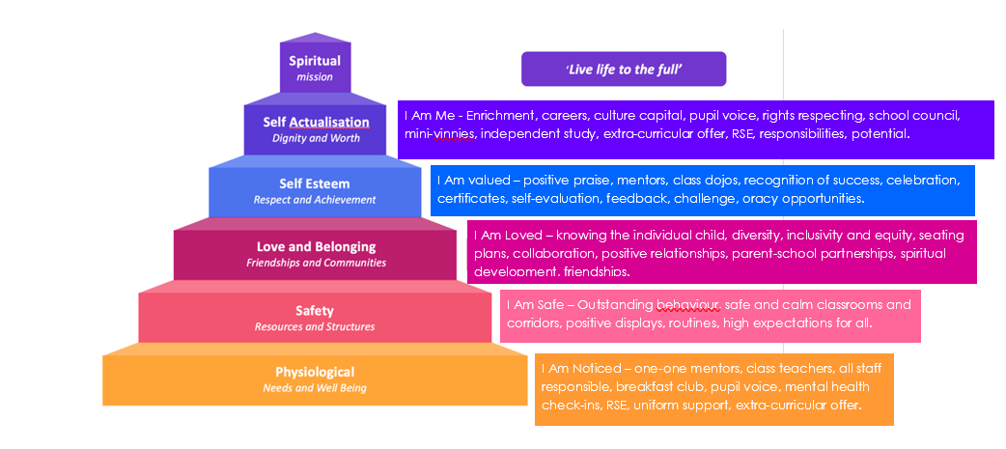
‘Live life to the full’
At St Cuthbert’s Catholic Primary School, we want to ensure that all children receive the required support to become successful learners and reach their full potential. We are prioritising –
-providing support to families to improve attendance
-ensuring teachers and teaching assistants are experts in the teaching of phonics (Sounds Write)
-emotional behaviours and well-being to ensure all children are ready to learn
-structured interventions for vulnerable learners

Challenges

This details the key challenges to achievement that we have identified among our disadvantaged pupils.
Challenge number | Detail of challenge
1 | Overall attendance is in line with national average however persistent absent rates remain higher than national.
2 | Reading in EY and achievement in phonics below national average in KS1.
3 | Emotional, social and wellbeing of children (including behaviour for learning). Ensuring children are ready to learn by stabilising emotional behaviours.
4 | Learners who struggle with retention and recall. Structure intervention or one to one support where necessary.

Intended outcomes
This explains the outcomes we are aiming for by the end of our current strategy plan, and how we will measure whether they have been achieved.
Intended outcome | Success criteria
Attendance improves. | The attendance figures overall continue to be above national, and persistent absences are below national average.
Children make good progress in phonics and reading in Early Years. | Reading strand in EY to be above national figures alongside phonics in KS1
Social and emotional resilience is improved and has a positive impact on their learning. | Support from Learning Mentor to ensure children feel supported socially and emotionally.  Children able to demonstrate strategies to cope with challenges and are ready to learn.
Children are supported in KS1 and KS2 to make good progress and reach ARE | To close the gap between disadvantaged and non-disadvantaged and results to be above national

Activity in this academic year
This details how we intend to spend our pupil premium (and recovery premium funding) this academic year to address the challenges listed above.

Teaching (for example, CPD, recruitment and retention)
Budgeted cost: £70,500
Activity | Evidence that supports this approach | Challenge number(s) addressed
Sounds Write training for staff. Aiming to ensure all staff fully trained. Reading Leadership time. MyOn subscription to continue across school. | EEF guidance states that implementation of phonics should cover:  ‘Training staff to ensure they have the necessary linguistic knowledge and understanding | 1,2
Grouping and setting of  children into targeted  small group, one to one  support and structured  intervention  programmes in phonics  throughout EYFS, KS1  and group  support in KS2 | THE EEF state:  1. Phonics has a positive impact overall (+5 months) with very extensive evidence and is an important component in the development of early reading skills, particularly for children from disadvantaged backgrounds.  2. The teaching of phonics should be explicit and systematic to support children in making connections between the sound patterns they hear in words and the way that these words are written.  3. The teaching of phonics should be matched to children’s current level of skill in terms of their phonemic awareness and their knowledge of letter sounds and patterns (graphemes).  Studies in England have shown that pupils eligible for free school meals typically receive similar or slightly greater benefit from phonics interventions and approaches. This is likely to be due to the explicit nature of the instruction and the intensive support provided.  It is possible that some disadvantaged pupils may not develop phonological awareness at the same rate as other pupils, having been exposed to fewer words spoken and books read in the home. Targeted phonics interventions may therefore improve decoding skills more quickly for pupils who have experienced these barriers to learning. | 2
Additional teacher in KS2 (am).  Quality First Teaching | EEF evidence:  Reducing class size has a positive impact of 2 months+ on average where reductions are 10 pupils or more  The EEF state: ‘The best available evidence indicates that great teaching is the most important lever schools have to improve pupil attainment. Ensuring every teacher is supported in delivering high quality teaching is essential to achieving the best outcomes for all pupils, particularly the most disadvantaged among them’ | 1,2,3,4

Targeted academic support (for example, tutoring, one-to-one support structured interventions)
Budgeted cost: £25695
Activity | Evidence that supports this approach | Challenge number(s) addressed
Pre-teaching and gap-getting. | The EEF stage:  On average, pre-teaching/gap getting approaches have an impact of 4 months additional progress | 1,2
Deployment of staff to ensure planned interventions and post teaching sessions in place where needed to ensure accelerated progress. | Where TAs are given precision interventions, the gaps close and children stay at age related – monitored in school. Same day intervention. | 1,2

Wider strategies (for example, related to attendance, behaviour, wellbeing)
Budgeted cost: £ 16,000
Activity | Evidence that supports this approach | Challenge number(s) addressed
Learning mentor to support in class and 1-1sessions removing barriers to learning | Children whose home arrangements are chaotic can be pre-occupied and need a voice before settling to work. (Louise Bomber –know me to teach me) Learning mentor ‘picks up’ children who enter school distracted by other issues to listen and remove barriers wherever possible | 2,3,4
Parent support advisor Supporting attendance, supporting socioeconomic issues including language barriers, housing, food shortages, attendance | Families where children are eligible for PPG have told us they need support in other areas which leads to children being distracted from and unable to focus on school and education. PSA works with families directly, with local agencies to signpost. Further work in the social care arena eg. Early Help to support families | 2,3,4
Poverty proof trips –school subsidise extracurricular activities to poverty proof for all | EEF All children cannot access trips etc. if school do not subsidise the cost | 3
Breakfast Club | EEF ‘Our updated evaluation found that supporting schools to run a free of charge, universal breakfast club before school delivered an average of 2 months’ additional progress for pupils in Key Stage 1 with moderate to low security’ | 3,4
A variety of extra-curricular activities (including sports). | Report from Sutton Trust indicates disadvantaged children are less likely to participate in extra-curricular activities. | 3,4

Total budgeted cost: £ 112,195

Part B: Review of outcomes in the previous academic year

Pupil premium strategy outcomes
This details the impact that our pupil premium activity had on pupils in the 2023 to 2024 academic year.
Y1 Disadvantaged – attainment is up on 2023, which has reduced the gap to national other pupils to 12% and is 4% above figure for national disadvantaged.
Multiplication Table Check (Y4) – Attainment is up by 3.3 marks on 2023 and is now above the latest national average. Disadvantaged – attainment is up by 1.2, reducing the gap to national other pupils to -2.5.
KS2 Expected Standard – attainment is up on 2023 in all three subjects with performance back above national in both Writing and Maths. Combined Reading, Writing and Maths is up 24% on 2023 and is above national. Disadvantaged – is up by 12%, reducing the gap to national other pupils to -17%. Disadvantaged attainment has improved in each subject, reducing the gap to national other pupils. The in-school gap is also closing in both Writing and Reading.
KS2 Higher Standard – Attainment has improved in all three subjects with Maths now 13% higher than national and Reading back in-line with national. Disadvantaged – gap to national other pupils has reduced to 3%, and in-school gap has closed this year. Disadvantaged gap to national other pupils is closing in all three subjects, with the gap now at 8% in Maths and 9% in Writing.

Externally provided programmes
Please include the names of any non-DfE programmes that you purchased in the previous academic year. This will help the Department for Education identify which ones are popular in England
Programme | Provider
Accelerated Reader | Renaissance
Spelling Shed, Literacy Shed, Vocabulary Ninja | ED Shed

