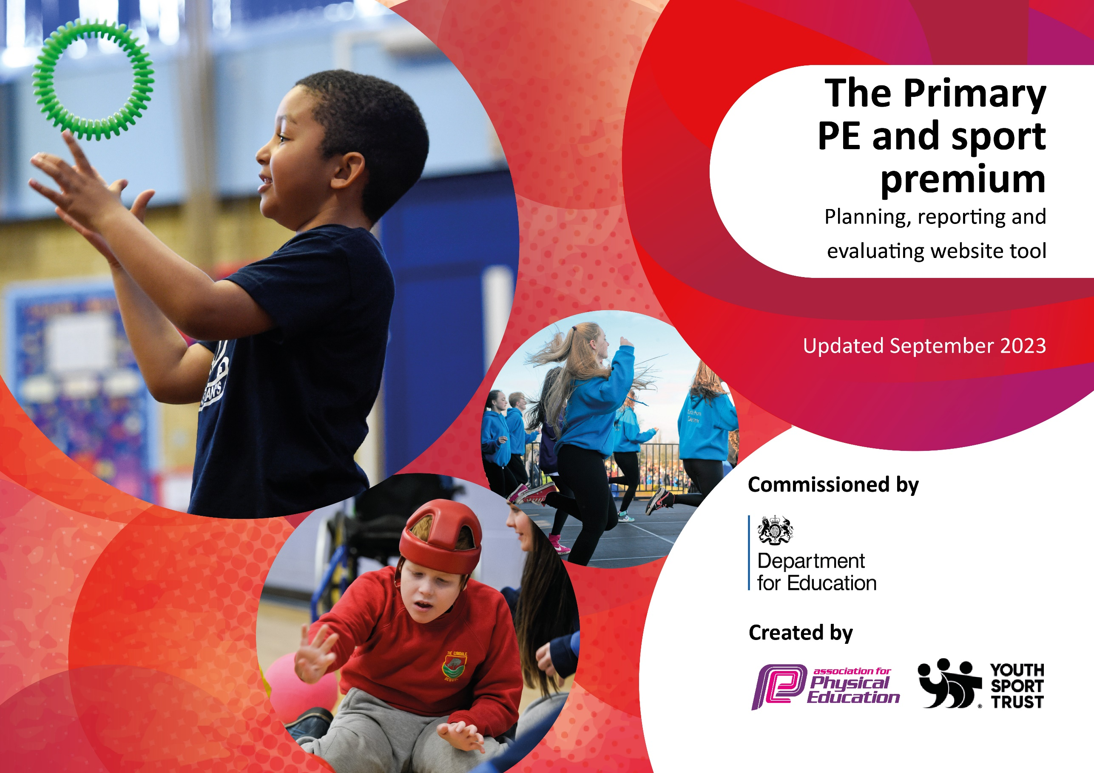

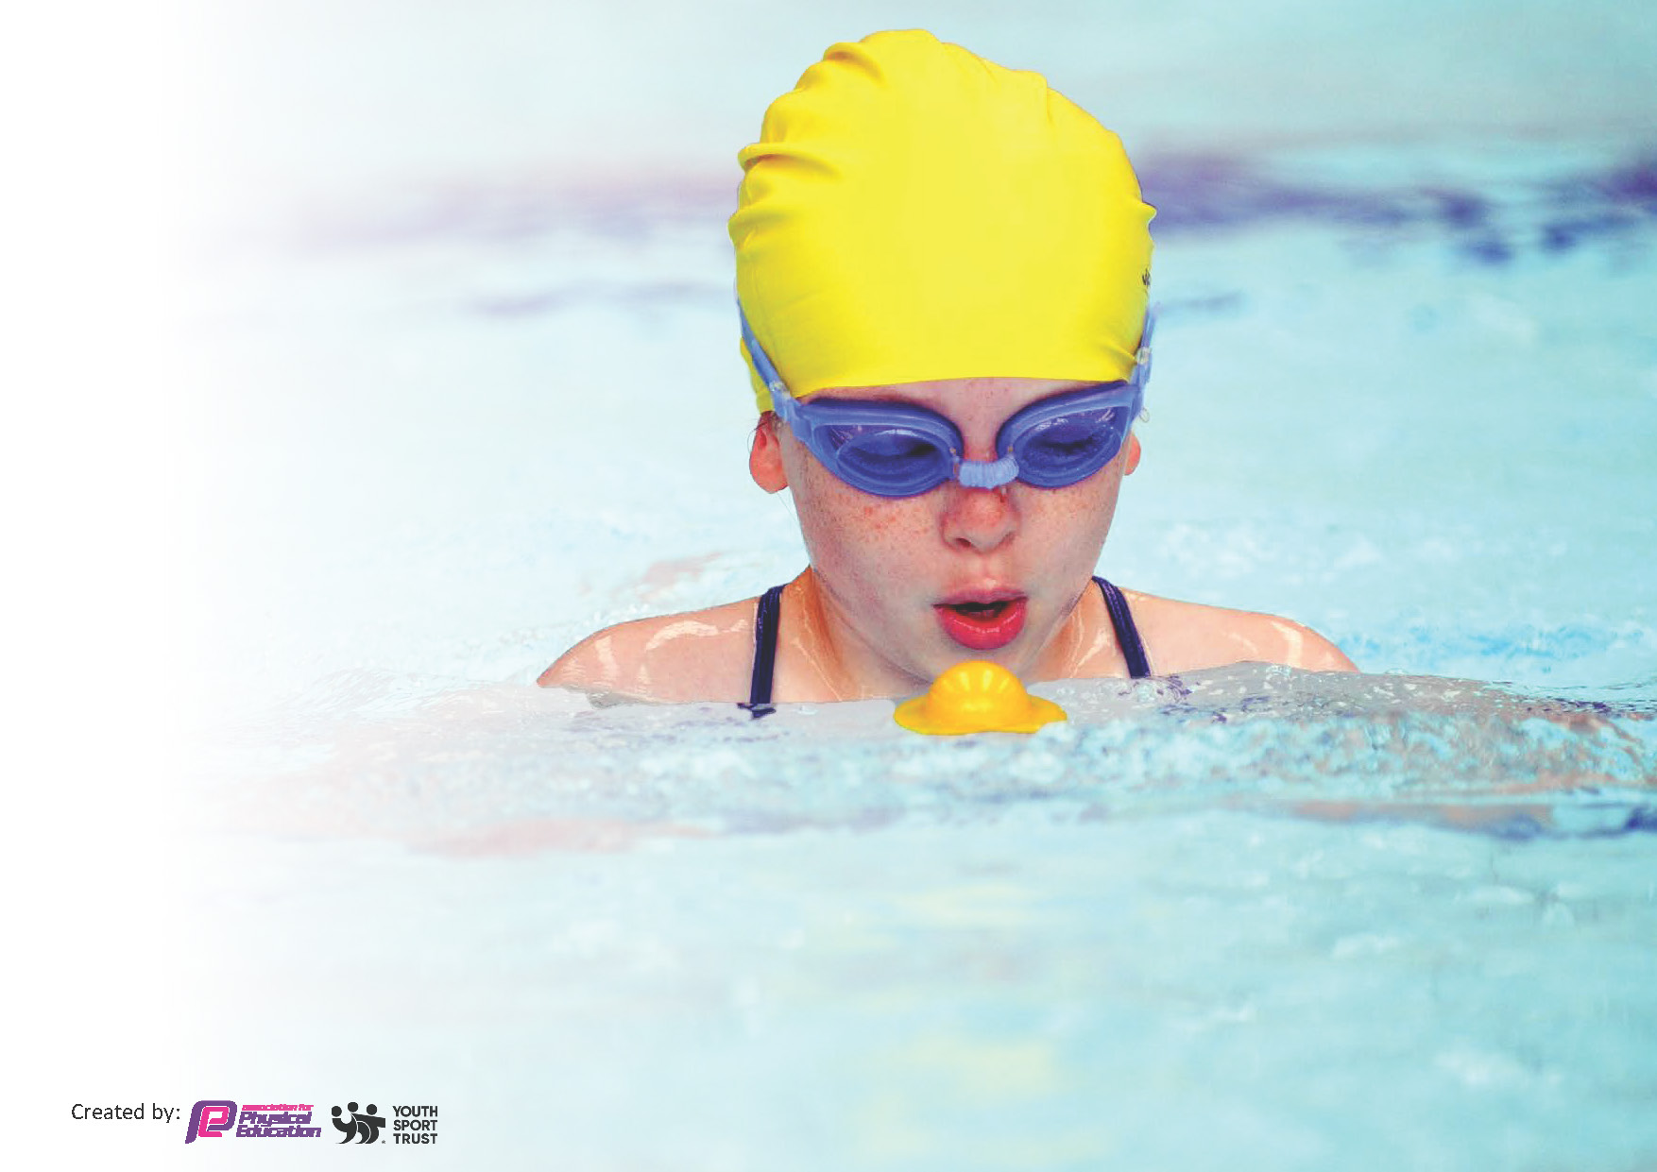
This template can be used for multiple purposes:
by:
- It enables schools to effectively plan their use of the Primary PE and sport premium
- It helps schools to meet the requirements (as set out in guidance) to publish information on their Primary PE and sport premium
- It will be an effective document to support Ofsted inspections enabling schools to evidence progress in Physical Education (PE) and evidence swimming attainment, which forms part of the PE National Curriculum. We would recommend schools consider
the Intent, Implementation and Impact of any spend, as examined within the Education Inspection Framework.

It is important that your grant is used effectively and based on school need.

Schools must use the funding to make additional and sustainable
improvements to the quality of the PE, School Sport and Physical Activity (PESSPA)
they offer. This means that you should use the Primary PE and sport premium to:

- Build capacity and capability within the school to ensure that improvements made now will benefit pupils joining the school in future years
- Develop or add to the PESSPA activities that your school already offers.

The Primary PE and sport premium should not be used to fund capital spend projects; the school’s core budget should fund these. Further detail on capital expenditure can be found in the updated Primary PE and sport premium guidance.

The Primary PE and sport premium guidance, outlines 5 key priorities that funding should be used towards. It is not

necessary that spending has to meet all the key priorities, you should select the priorities that you aim to use any funding towards.

Although completing this template is not a requirement for schools, schools are required to publish details of how they spend this funding. Schools must also outline what the impact this funding has had on pupils’ PE and sport participation and attainment and how any spending will be sustainable in the future. All funding must be spent by 31st July 2024.

The Department for Education has worked closely with the Association for Physical Education (afPE) and the Youth Sport Trust (YST) to develop this template and encourages schools to use it. This template is an effective way of meeting the reporting requirements of the Primary PE and sport premium.
Review of last year’s spend and key achievements (2022/2023)

We recommend you start by reflecting on the impact of current provision and reviewing your previous spend.

Activity/Action | Impact | Comments
-To encourage children to engage in meaningful lunchtime play and activity.  -To provide high quality additional PE sessions.  -To provide extra curriculum PE clubs both on a lunchtime and after school.  -Ensure children have access to age appropriate active travel training in order to encourage them to walk or cycle to school safely.  -To develop leadership skills in children through sports leaders.  -To raise the profile of Physical Education to all children in school.  -Staff and pupils know what the end points for the subject will be for each lesson and year group.  -Staff have the opportunity to observe the sports coach and to use the skills and knowledge gained in own practice at immediate intervals during the week.  -Purchase new scheme Complete PE to enhance teacher confidence delivering high quality PE.  -To ensure that equipment and kits are updated to provide the best experiences for children to participate in a range of activities, both curricular and extra-curricular.  -To ensure that all children enjoy some form of sport or physical activity.  To ensure all children can access a range of sports activities both in school and outside of school.  -All children regardless of sporting levels should be able to engage in competitive sport.  -Retain Platinum School Games Award. | -Children are actively engaged in meaningful activities during their free play at lunch time, facilitated by the use of appropriate equipment.  -Children are active more regularly at school due to some extra PE sessions and due to the presence of sports leaders on a lunchtime.  -Children are more physically active and skill level improves in certain areas due to the extra clubs they are welcome to access.  Children engage in lunchtime activities as well as those qualified as leaders to develop their own physical literacy and skill base.  Increased staff confidence  Children have access to high quality equipment to facilitate progress and enjoyment within PE, allowing the enhancement of skills in a broad range of sports.  The children enjoy and engage in lots of physical activity at festivals/development days.  Children have an increased awareness of different  activities outside of school.  Self-confidence improved in those children representing school. | Increased number of children accessed extra-curricular activities  Well established now in school and children well prepared for the next academic year.  Complete PE impact on staff confidence and child participation.  Sports specialist – regular audits to ensure well resourced  School Games Award Platinum 22/23 – achieved  Children all accessed inter house sports

Key priorities and Planning
This planning template will allow schools to accurately plan their spending.

Action – what are you planning to do | Who does this action impact? | Key indicator to meet | Impacts and how sustainability will be achieved? | Cost linked to the action
- Sports Coach  -delivery of PE sessions/extra-curricular  -team teach with staff  -sports leader trainer/co-ordinator  -co-ordinates break/lunchtime activities  -co-ordinates extra-curricular activities  - Stockton Schools Sport Partnership  /Transport  - Complete PE  - ActivAll Board  - PE Equipment/  Playground Equipment -purchase and replenish | Whole school  Whole school  Whole school  Whole school  Whole school | Key Indicator 1: Increased confidence, knowledge, and skills of all staff in teaching PE and sport.  Key indicator 4: Broader experience of a range of sports and activities offered to all pupils.  Key indicator 5: Increased participation in competitive sport.  Key indicator 3: The profile of PE and sport is raised across the school as a tool for whole-school improvement  Key Indicator 1: Increased confidence, knowledge, and skills of all staff in teaching PE and sport.  Key indicator 2 -The engagement of all pupils in regular physical  Key indicator 2 -The engagement of all pupils in regular physical activity – the Chief Medical Officer guidelines recommend that all children and young people aged 5 to 18 engage in at least 60 minutes of physical activity per day, of which 30 minutes should be in school. | More pupils meeting their daily physical activity goal, more pupils encouraged to take part in PE and Sport Activities.  Increased staff confidence through team teach.  Increased confidence in sports leaders  Range of events accessed by children of all ages. Where possible due to location – can walk to some events.  Increased staff confidence  Accessible to all and shown to increase confidence in children | £7,800  £2100 (SSP)  £2000 (Travel)  £200  £5000  £500

Key achievements 2023-2024
This template will be completed at the end of the academic year and will showcase the key achievements schools have made with their Primary PE and sport premium spending.

Activity/Action | Impact | Comments
Sports Specialist to deliver active content to all children. Staff have opportunity to observe and use skills and knowledge gained. Complete PE subscription continued.  All children no matter age, stage or ability will have the chance to represent their class, house or school in competitive sports. Continued with SSP – Stockton partnership.  To purchase and replenish outdoor playground equipment/PE equipment  To develop leadership skills in children through sports leaders.  To increase the number of children gaining their 25m in Y6 by delivering lessons in a two week block.  ActivAll board purchased. | All children will receive high quality delivery of activities across school. Improved staff confidence.  Increased self confidence  Children engage in lunchtime activities as well as those qualified as leaders.  Double the number of children achieving 25m in comparison to 23/24  It has encouraged communication and improved personal development.  Improved concentration and can improve fitness. | Staff survey shows increased confidence in delivering PE lessons using Complete PE.  Achieved School Games Mark Platinum 2024  Increased cost of transport – will impact next academic year  ‘Playtimes and lunchtimes are fun filled. There is so much to do and enjoy. The ‘dance squad’ prepares dance routines for younger pupils to master, who brim with excitement as they join in. At the same time, the sports leaders look to improve pupils’ ball skills by giving expert tips.’ Ofsted March, 24  Children report how much more confident they are by accessing blocks.  Very successful so looking to purchase a further board next academic year so one based in each key stage.

Swimming Data
Meeting National Curriculum requirements for swimming and water safety.
Priority should always be given to ensuring that pupils can perform safe self-rescue even if they do not fully meet the first two requirements of the National Curriculum programme of study

Question | Stats: | Further context  Relative to local challenges
What percentage of your current Year 6 cohort can swim competently, confidently and proficiently over a distance of at least 25 metres? | 60% | This is a much higher proportion of children achieving 25 metres in comparison to the previous two years. The impact of having a block of lessons as opposed to weekly sessions has had an impact on this.
What percentage of your current Year 6 cohort can use a range of strokes effectively [for example, front crawl, backstroke, and breaststroke]? | 60% | This has improved as children have become more confident in the water. We have had an increase in both the distance swam and the range of strokes. The block lessons that were implemented over the last two years has definitely had an impact on this.

What percentage of your current Year 6 cohort are able to perform safe self-rescue in different water-based situations? | 60% | Significant increase in the number of children who achieved safe self-rescue from previous academic year.
If your schools swimming data is below national expectation, you can choose to use the Primary PE and sport premium to provide additional top-up sessions for those pupils that did not meet National Curriculum  requirements after the completion of core lessons. Have you done this? | No
Have you provided CPD to improve the knowledge and confidence of staff to be able to teach swimming and water safety? | No | Staff receive some CPD from swimming instructors at the school sessions.

Signed off by:

Head Teacher: | Mrs Parnell
Subject Leader or the individual responsible for the Primary PE and sport premium: | Miss Conlon
Governor: | Mrs Dowson
Date: | July 2024

