SEND Information Report
St Cuthbert’s Catholic Primary School

Approved on:
July 2023
Next review:
June-July 2024

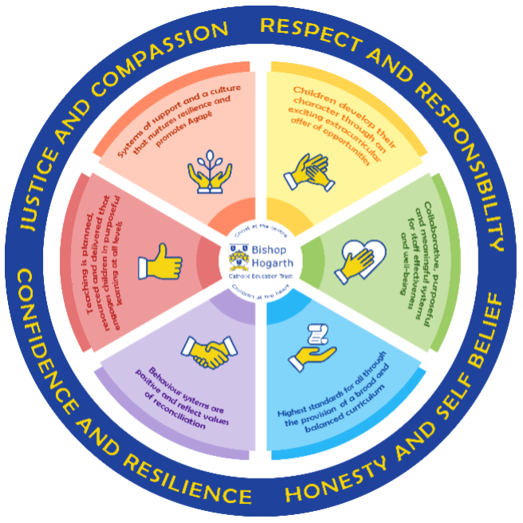

As part of the family of Bishop Hogarth Catholic Education Trust, our school has at its core, the virtues, and values of:
Respect for others and themselves, recognising that we are all created in the image of God and therefore must be compassionate towards others, especially the vulnerable. ​
Confidence in their own abilities, knowing that their talents are gifts from God and resilience to persevere when things become difficult. ​
Honesty in regard to the world around them and themselves and the ability to take responsibility for the times we may fall short of the mark. ​
Gratitude for all the amazing gifts from God and willingness to share their gifts both personal and material. ​

As an inclusive school, all teachers are teachers of pupils with Special Educational Needs & Disabilities. We deliver a curriculum and create an environment that meets the needs of every pupil within our school. We ensure that every pupil with Special Educational Needs and / or disabilities makes the best progress possible. We foster and promote effective working partnerships with parents / carers, pupils, and outside agencies. We consider the ‘whole’ child and strive to ensure that all our SEND pupils are prepared for adulthood.​

Our school’s approach to supporting pupils with SEND?

We are an inclusive school and all teachers at St Cuthbert’s Catholic Primary School:

- Are doing everything they can to meet pupils’ special educational needs.
- Ensure that pupils with SEND engage in activities alongside their peers
- Are responsible and accountable for the progress and development of the pupils in their class.
- Provide high-quality teaching, differentiated for individual pupils.

‘Delight in the Good’

All pupils are taught by their class teacher via excellent targeted classroom teaching also known as Quality First Teaching.

For your child this would mean:

- That the teacher has the highest possible expectations for your child and all pupils in their class.
- That all teaching is based upon building upon what your child already knows, can do and can understand.
- At times the teacher may direct a class-based teaching assistant, to work with your child as part of normal working practice.
- Adapted or scaffolded activities and different ways of presenting information are in place so that your child is fully involved in learning in class.
- Specific strategies (which may be suggested by the SENCO or outside agencies) are in place to support children.
- Your child’s teacher will have carefully checked on your child’s progress and may decide that gaps in their understanding/learning requires some extra support to help them make the best possible progress. All children in school may access this as part of excellent classroom practice.
- Precision teaching for a smaller group of children may be used. This group, often called intervention groups by schools, may be: run in the classroom or outside in a work area, run by a teacher or a teaching assistant who has had training to run these groups.
- If needed, pupils have access to the support available from outside agencies e.g. Speech and Language therapy, CAMHS, Occupational Therapy, Educational Psychology, Specialist Learning Teachers or Behaviour Support.

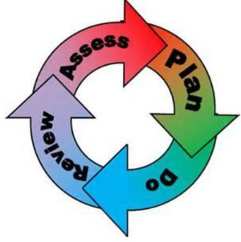
How will the school staff support my child?
The graduated response-Identifying, planning for and supporting pupils with SEND
Where a pupil is identified as having a special educational need, School will follow a graduated approach which takes the form of cycles of ‘Assess, Plan, Do, Review’. ​
• Assess a child’s special educational need. ​
• Plan the provision to meet your child’s aspirations and agreed outcomes. ​
• Do put the provision in place to meet those outcomes. ​
• Review the support and progress.

How does the school know if children need extra help and what do I do if I think my child has special educational needs?

- Assess
Teachers plan, deliver then assess. If concerns continue then differentiated or scaffolded activities will be prepared. The SENDCo will be informed and a cause for concern may be completed.
Parents can contact the SENDCo, Miss Shaw, before/after the school day. An appointment can be made to have an in-depth conversation.
We offer a variety of teaching styles, programs and strategies to enable pupils to achieve their full potential, this is our CORE offer available to all pupils.
Parents can contact the Class Teacher before/after school or make an appointment to have an in-depth conversation.
Pupils are fully involved in their learning, being made aware of objectives and what they need to do to make progress.

- Plan
SEND pupils will be included in all classroom activities. Their tasks will be prepared and marked by the Class Teacher or TA. They will be taught directly by the Teacher wherever possible.
We are fortunate to have a number of experienced teachers and teaching assistants on our staff and we share our expertise. Teachers may also seek advice from external agencies.
We ensure that information about a child’s SEN Support Plan or EHC plan is shared and understood by teachers and all relevant staff who work with that child.
We will include parents and the child in writing SEN Support plans.
Our school and staff aim to do everything to meet pupils’ special educational needs.
All SEND children have the same right to facilities and extra-curricular activities.
We carefully plan for transition for children with SEND, for both in year transition and transitions to secondary school.

- Do
Our teachers are skilled at adapting teaching and learning to meet the diverse needs in each class. ​
Daily planning considers individual children’s needs and requirements and is annotated and adapted according to need. Explicit reference is made in the teacher’s planning to the needs of those children identified with SEND. ​
Adaptive teaching is approached in a range of ways to support access to the curriculum and ensure that all children can experience success and challenge in their learning. ​
Grouping arrangements consider the different skills and abilities of each child. This ensures that learning is maximised. ​

Additional adults support groups and individual children with the long-term goal of developing independent learning skills. The class teacher monitors this support to avoid students becoming over reliant on this. ​
We fully encourage parental support and offer opportunities for individual meetings with parents/carers to provide clarity and recommendations on how they can support their child at home.

- Review
Keeping in touch with the parent/carer is vital.
You will be invited to SEN support meetings at least three times a year (termly). If concerns arise or needs change, then a meeting can be organised as appropriate.
We monitor progress via half-termly tracking. Decisions will be made as to how best to move a child forward. Interventions are reviewed to monitor their effectiveness. We also observe teaching to ensure the needs of all pupils are catered for. Parents/carers are involved in the setting of clear outcomes for their child and the review of provision and progress.
We hold parent consultation evenings in the autumn and spring terms. Parents receive a written report in the summer term.
Parents/carers find additional information in our SEND policy and also on the Stockton Local offer and portal.

How will the curriculum at our school be matched to my child’s needs?
Class teachers, supported by the senior leadership team, make regular assessments of progress for all pupils. Where pupils are falling behind or not making expected progress given their age and starting point extra support will be given.
Special educational provision is education that is consistently additional to or different from that of others of the same age, i.e. provision that goes beyond the differentiated approaches and learning arrangements normally provided as part of high-quality, personalised teaching. Parents can contact Mrs Parnell Headteacher if they wish to discuss any specific adaptations.
Once a potential SEND need has been identified, school takes action to remove barriers to learning and put effective special educational provision in place. This is ‘SEN support’ which takes the form of a four-part cycle – assess, plan, do, review. This is known as the graduated approach.
Using this graduated approach, we will ensure to match learning to your child’s needs in any way which is needed. We will adapt activities, offer additional support and cater learning in order to support what your child needs to access the curriculum.
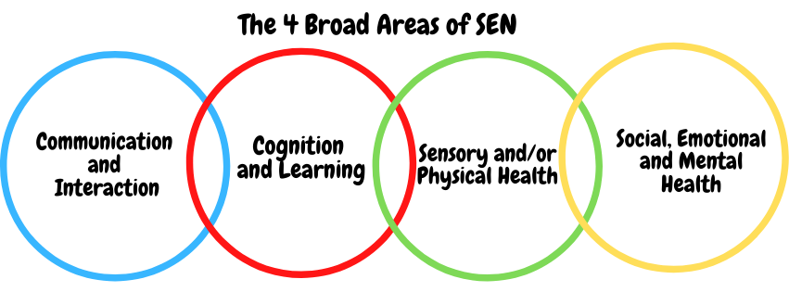SEN needs are classified under four broad areas of need. Below are the strategies, in class support and interventions that school may put in place to support your child.

Communication and Interaction
Strategies to support children with these needs include:
Access to small group and/or individualised interventions.
Access to Theraplay to develop social skills.
Interventions such as Wellcomm and Blast to aid communication skills.
Access to low stimulus area.
Flexible approaches to timetable.
Modifications to lunch and break times.
Enhanced access to additional aids, such as sensory boxes, visual timetables, ear defenders and work stations.
Access to technology-Laptops, software.
Social and emotional stories, feelings cards.
Careful planning of transitions.
Mentoring with PSA and buddy systems.
Access to Speech and Language Therapist.
Access to Educational Psychologist.
Access to Sunflower sensory service.
Access to communication aids, such as books and strips.

Cognition and Learning
Strategies to support children with these needs include:
Small group or individual intervention.
Practical aids for learning, working memory boards, task cards, overlays etc.
Increased adult support if needed.
Rest breaks
Phonic/reading development programmes-eg RWI, Lexia, iDL and Reading Plus, Spelling Shed, SPAG.com
Maths programmes- Times table Rockstars and Maths shed, My Maths and Numicon.
Increased access to ICT- e.g. laptops, visualisers and zoomtext.
Adaptations to assessments to enable access e.g. readers, scribe, additional time.
Curriculum will be adapted to meet the learning needs of the child.
Differentiation or Scaffolding.
Pre and post teaching of vocabulary and new concepts.
Frequent repetition and reinforcement.

Sensory/Physical
Strategies to support children with these needs include:
School meets statutory requirements of DDA
Zoom text and home access.
Radio Aids.
Staff trained in epilepsy and diabetes
PECs/Communication boards.
Access to Speech and Language.
Access to outreach from SEN nurse.
Access to a specialist teacher/LSA for the hearing/visual impaired.
Concrete apparatus available to support learning.
Access to support for intimate care.
Access to ear defender, chew buddies etc.
Therapy programmes delivered in school, designed by specialists e.g. Occupational Therapists, Physiotherapists etc.
Adapted curriculum to enable full access e.g. alternative recording devices, modified PE curriculum.

Social, Emotional and Mental Health
Strategies to support children with these needs include:
Access to break out spaces
Mentoring with PSA or key adult.
Meet and Greets
Individual rewards system.
Behaviour Support Plans.
Emotion coaching.
Increased access to additional adults in the classroom.
Alternative curriculum opportunities including reduced timetables.
Theraplay.
Forest Schools.
Visual timetables.
Incredible 5-point scale.
Social and emotional stories
Qualified staff to support behaviour.
Transition programmes in place.
Access to CAMHS and Educational Psychologist.
Outreach to support SEMH needs.
Emotional resilience nurse
Access to children’s hub and wellbeing interventions, such as Relax kids.
Managed moves.

What training is provided for staff supporting children with SEND?
All staff at St Cuthbert’s want to ensure that the necessary provision is made for any individual who has SEN. They are able all responsible and accountable for all pupils in their class wherever or with whoever the pupils are working.
St Cuthbert’s has a number of teaching assistants and teachers who have training in a range of SEND conditions. The school regularly has CPD to improve outcomes for SEND pupils. We work alongside outside agencies such as: Speech and Language therapy, CAMHS, Occupational Therapy, Educational Psychology, Specialist Learning Teachers or Behaviour Support to support learners in our setting.
Staff are encouraged to access CPD where needed to support the needs of their SEND pupils. In some instances, the SENDCO will identify areas where further training is needed and signpost staff to attend. This would be if there was a new pupil with needs we were unfamiliar with, or in preparation for a new pupil after transitional period. All staff act upon advice from attending CPD and use it to develop their knowledge. Often, they will share new knowledge with their staff to further benefit those children with SEND.

How do we support transition in our school?

Transition within classes/key stages: ​
Class teachers meet with each other to hand over all information regarding SEND pupils before the start of the academic year so that they are fully prepared for the child coming into their class. Where needed, SEND children will be given the opportunity for enhanced transition. A familiar adult may accompany them for a short period to ensure transition goes smoothly.

Transition to Secondary settings: ​
The majority of pupils who attend St. Cuthbert’s transfer to Our Lady and St. Bede Comprehensive School. Where necessary, provisional recommendations will be made at a review meeting when the child is in Y5/Y6 so that parents can consider options at the same time as other parents. The Annual Review recommendations, parents’ views and the response to consultation by the LA with the schools concerned will be in place before the transfer. The SENDCO of the receiving school will be invited to attend the review meeting. During the term prior to transfer, liaison will take place between the pupil’s Y6 class teacher and both SENDCOs to enable a smooth transfer to the Secondary School to take place.

Where can I get further information about services for my child?

The Local Offer
Stockton’s Local Offer - Parents/carers can find additional information on the Stockton Local offer and portal.
Special Educational Needs and Disabilities 0-25 | Stockton Information Directory
Support and advice:
SENDIASS
Tel: 01642 527158
email: SENDIASS@stockton.gov.uk

What key school documents refer to support and provision for pupils with SEND?

- SEND Policy​
- Admissions Policy​
- Supporting Pupils with Medical Needs Policy​
- Accessibility Plan​

Accessibility​
At St Cuthbert’s, we ensure to work towards inclusion for all. We will always aim for all pupils, including the ones with disabilities, to have access to the curriculum and physical environment of the school.
Our accessibility plan intends to:
- Increase the extent to which pupils with disabilities can participate in the curriculum.
- Improve the physical environment of the school to enable pupils with disabilities to take better advantage of education, benefits, facilities and services provided.
- Improve the availability of accessible information to pupils with disabilities.

Activities Outside of School​
To ensure access to activities outside of school, all trips and visits are risk assessed taking SEND needs into account. We aim to ensure that children with SEND needs are able to access the same as their peers where possible. Additionally, we ensure the same in after school and enrichment activities. These are offered to all pupils, and where pupils with SEND want to attend, relevant adaptations are made to allow their access. Where possible, we are totally inclusive for all children.

What to do if you have a complaint, a compliment, or a query.

The school details and relevant contacts
Head Teacher: Mrs S Parnell
SENDCo: Miss E Shaw
PSA: Mrs F Knight

Phone: 01642 601567
Email: admin@stcuthbertsstockton.bhcet.org.uk
Bishop Hogarth Trust website: https://bhcet.org.uk/
Trust Contact - Mike Shorten: 01325 254525

​
Name of school SEND governor.
Chair of Governors: Mrs M Dowson
SEND Governor: Mrs S Butler

