Menu
Halal and vegetarian options are provided at all meals.
(Breakfast, lunch and tea)
Week 1 | 6/9/21 | 27/9/21 | 18/10/21 | 8/11/21 | 29/11/21 | 20/12/21
Week 2 | 13/9/21 | 4/10/21 | 25/10/21 | 15/11/21 | 6/12/21
Week 3 | 20/9/21 | 11/10/21 | 1/11/21 | 22/11/21 | 13/12/21

 |  | Monday | Tuesday | Wednesday | Thursday | Friday
Week 1 | Lunch | Jumbo Fish fingers, mashed pots, peas and parsley sauce | Homemade Keema Curry with Rice and naan bread and yoghurt dip | Homemade Pizza, chips and beans | Homemade Chicken Pie, baby potatoes, carrot, broccoli and gravy | Vegetable Pasta with cheese, Garlic Bread and Salad
 | Pudding | Strawberry Mousse | Lemon Cheesecake | Cornflake Tart and Custard | Homemade Rice Pudding and Strawberry Sauce | Strawberry and Cream Cake
 | Tea | Veggie Cheeseburgers.  Veggie Sticks and dip | Vegetable Ravioli on toast | Homemade Pasta Salad and Veggie Samosa | Fishcake in a Bun | Picnic Platter
Week 2 | Lunch | Homemade Quiche, Herby Potato Cubes and Beans | Homemade Chilli, potato wedges, cheese chopped salad and dip | Homemade Paprika Chicken, herby potato cubes, salad and dip | Vegetable Biryani and naan bread and dip | Fish cakes, chips and beans
 | Pudding | Vanilla Yoghurt and strawberry sauce | Homemade Cookies | Chocolate Pudding and Chocolate Sauce | Strawberry Cheesecake | Raspberry Cream cake
 | Tea | Cheese and Tomato Pasta and Garlic Bread | Creamy Tomato and Pepper Soup and Buttered Bread | Veggie Sausage Hotdogs,  Veggie stick, dip | Beans on toast | Pizza and pasta salad
Week 3 | Lunch | Homemade Pizza, chips and spaghetti hoops | Homemade Chicken Curry, rice, naan and yoghurt dip | Vegetable Lasagne, Salad and Garlic Bread | Homemade Shepherd’s Pie, new potatoes, broccoli, gravy | Cheese and Onion Pie, Baby potatoes, bean
 | Pudding | Lemon Pudding and Custard | Chocolate Mousse | Jelly and Delight | Homemade Cookies | Chocolate Cream cake
 | Tea | Veggie Ravioli on toast | Vegetable Fingers and Potato waffles and dip | Jacket Potatoes, cheese and beans | Veggie Cheeseburgers | Asst Sandwiches, babybels, lentil chips, salad

Breakfast

Breakfast is available each day, consisting of:
- Choice of cereals or porridge
- Range of breads
- Fresh fruit
- Milk
Menu information
- All main meals are accompanied with seasonal vegetables or 5 individual salad items, and either potato, rice, pasta, chapattis, or naan bread. In addition, bread is available each day.
- All meat and poultry used is fresh and locally sourced.
- All our fish, vegetarian & cheese dishes are suitable for Muslims.
- We do not use any preservatives or additives that are unsuitable for children.
- All menus are subject to availability and may change without notice.

From our Food Policy…
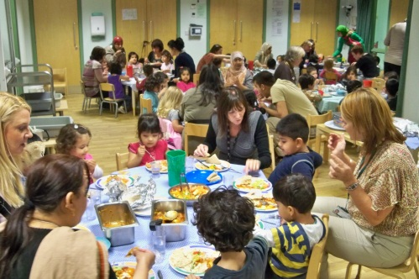
We serve only healthy food and drink and all meals will be prepared by our own staff, with reference to national, nutritional guidelines.
- Mealtimes are seen as a learning experience and all opportunities for counting, problem solving and communicating are exploited. Older children set the tables and act as servers.
- Mealtimes are unhurried and relaxed with children being allowed ample time to eat.
- Babies are introduced to an open or free-flowing cup at 6 months and are discouraged from using a bottle from this time.
- Babies and children are encouraged to develop their physical feeding skills by feeding themselves using their fingers as early as possible, moving to spoons, spoon and fork and then knife and fork as their control develops
Please talk to a member of staff for more information.

