The Lilycroft and St Edmund's
Nursery Schools' Federation

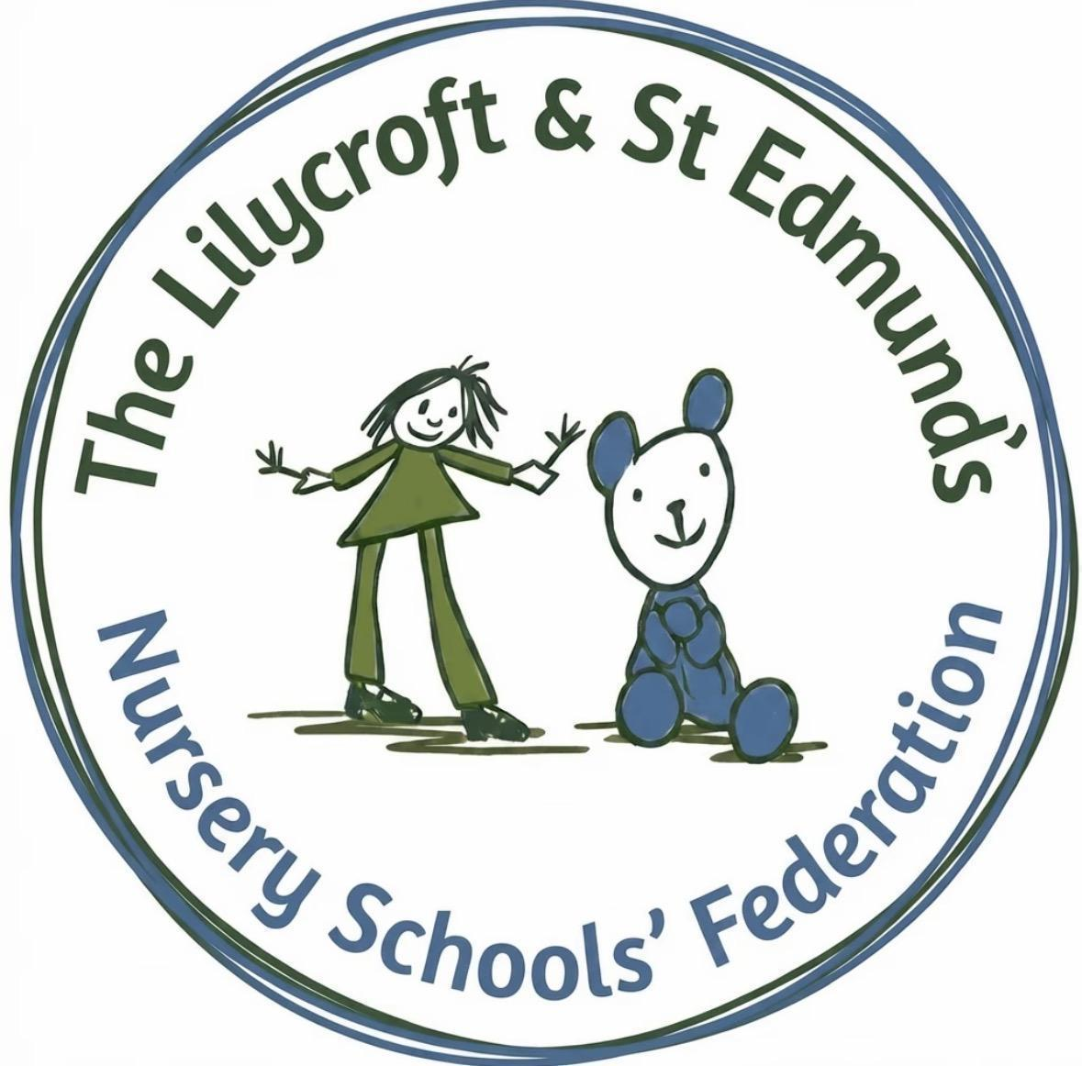

Equality, Equity, Diversity, and Inclusion
(EEDI) Policy

Last Reviewed: June 2026
Approved By: Full Governing Board
Next Review Due: June 2028
Content

Definitions of Equality, Equity, Diversity and Inclusion
- Our Welcoming Vision and Commitment
- Who Our Policy Embraces
- Valuing Every Difference (Principles of Non-Discrimination)
- Embracing Neurodiversity
4a. For Our Children and Curriculum
4b. For Our Staff Team
4c. Supporting Emotional Wellbeing and Regulation
- Language of Inclusion
- Upholding British Values: Universal Foundations for our Inclusive Federation
- Honouring Beliefs and Supporting Health
7a. Religious and Cultural Observance
7b. Dietary Requirements
- Building Our Community: Promoting Respectful Behaviour and Positive Conduct
8a. Our Positive Promise
8b. Staff: Guiding with Care
8c. Children
8d. Families and Visitors
- Talking Things Through (Dealing with Concerns and Complaints)
- Keeping Our Promise Fresh (Policy Monitoring and Review)
- Related Federation Policies
- Summary of Key Legal References
This policy is underpinned by the Equality Act 2010, the Early Years Foundation Stage (EYFS) Statutory Framework, the SEND Code of Practice and other relevant legislation and statutory guidance.

Definitions of Equality, Equity, Diversity and Inclusion

To ensure a shared understanding across the Federation, we define our core values as follows:

Equality: “Equality of opportunity” means ensuring that everyone has a fair chance to achieve their potential, regardless of their background or characteristics.

Equality is closely linked to equity, which focuses on the different support individuals may need to achieve fair outcomes.

- Equity: Promoting fairness by understanding that not everyone starts from the same place and taking steps to address barriers and disadvantages.
Equity supports equality by helping to remove barriers to participation

Equality is fair opportunity; equity is fair support.

Diversity: Recognising, valuing, and celebrating differences between people. It acknowledges that every person is unique and includes both visible and non-visible characteristics such as background, culture, age, ability, beliefs, and personality

Diversity is supported by our commitment to equality, equity, and inclusion.

Inclusion: Creating an environment where everyone feels welcomed, respected, valued, and able to participate fully, regardless of their differences or individual needs.

Inclusion brings together the principles of diversity, equality, and equity in everyday practice.

1. Our Welcoming Vision and Commitment

At The Lilycroft and St Edmund’s Nursery Schools’ Federation, we believe that every child, every family, and every staff member is unique and individual. We are devoted to creating a place where everyone feels included, safe, valued, and respected, a true sense of belonging across both Federation sites.

We aim to provide warm, nurturing Nursery School environments in which every person feels valued and able to thrive. By celebrating the rich diversity of our community, we are helping our children grow up ready to succeed in an ever-changing world.

2. Who This Policy Applies To?

This policy is our promise to everyone involved in the life of The Lilycroft and St Edmund’s Nursery Schools’ Federation, covering:
● All the children in our care at Lilycroft and St Edmund’s
● All our families who entrust their children to us
● All our staff across both Nursery Schools
● Anyone else we work with, including students, applicants, contractors, and visitors

It guides everything we do, from choosing our learning activities to managing our team and welcoming new families across the Federation.

3. Valuing Every Difference (Principles of Non-Discrimination)

At The Lilycroft and St Edmund’s Nursery Schools’ Federation we believe that differences are strengths! We are committed to promoting a culture of fairness, inclusion, and respect for all children, families, and staff members, regardless of who they are. We do not tolerate unlawful discrimination, harassment, victimisation, or bullying on the basis of any of the protected characteristics defined by the Equality Act 2010. These protected characteristics are:

● Age
● Disability
● Gender reassignment
● Marriage and civil partnership
● Pregnancy and maternity
● Race (including colour, nationality, ethnic or national origin)
● Religion or belief
● Sex
● Sexual orientation

This commitment ensures we meet our statutory duty to promote equality in the provision of our services and employment. We also celebrate the differences in cultural backgrounds, home languages, family structures, and personal strengths that enrich our Federation community. Our team is representative of diverse cultures and speaks a range of languages, enabling us to effectively serve and engage with families across our near and wider community.

4. Embracing Neurodiversity

4a. For Our Children and Curriculum
Celebrating All Brains: We recognise and celebrate neurodiversity, acknowledging that differences in how brains work is a natural and valuable part of human diversity.

Learning That Fits: Our curriculum is planned to be flexible and fun, allowing every child at Lilycroft and St Edmund’s to learn in a way that feels natural to them. This inclusive practice aligns with the mandatory requirements of the Early Years Foundation Stage (EYFS) Statutory Framework to provide a positive environment and meet the needs of all children.

Inclusion of Children with Special Educational Needs and Disabilities (SEND):
- Proactive Identification: We actively promote the success and holistic development of every child. Our skilled staff maintain continuous, positive engagement, systematically observing and celebrating each child's unique progress in their development, behaviour, and learning. This enables us to provide timely, tailored support whenever it is beneficial

- The Graduated Approach: We implement the SEND Code of Practice's 'graduated approach' (Assess, Plan, Do, Review). Our Federation SENDCO (Special Educational Needs & Disabilities Coordinator) will work with key staff and families to put targeted support in place

- Partnership with Families: We believe that parents and families are the child's primary educators. We work closely with families, respecting their expertise, to jointly plan and review the child's Individual Education Plans (IEPs) or equivalent documents

- Making Reasonable Adjustments (Equity in Action): If a child needs additional help or has SEND, we meet the requirements of the Equality Act 2010 by putting reasonable adjustments in place. This includes adapting the environment, resources, routines, or communication methods to ensure the child has equitable access to the curriculum and all activities

- External Support: We actively engage with and seek advice from external professionals and specialists (e.g. Speech and Language Therapists, Educational Psychologists, Health Visitors) to ensure the highest quality of provision for every child.

(For more information, please refer to our SEND Policy).

4b. For Our Staff Team
Fair Opportunities: We aim to build a diverse workforce and use safe, fair, and consistent recruitment processes to ensure we appoint suitable individuals to care for and educate children within the Federation.

Supporting Mental Health and Wellbeing: We are deeply committed to supporting the mental health and well-being of our staff. The Federation offers a comprehensive supportive package including:

- Dedicated Wellbeing Time: Staff receive dedicated well-being time each term

- Pause and Reflect Sessions: Half-termly Pause and Reflect sessions are conducted with all staff to evaluate and enhance our professional practice, fostering a culture of open communication and continuous improvement

- Team Building Time: Dedicated time for team building to cultivate strong, supportive relationships across Lilycroft and St Edmund's

- Mental Health and Wellbeing Package: Staff have access to a confidential package offering professional support services such as counselling, physiotherapy, and direct access to a GP.

4c. Supporting Emotional Wellbeing and Regulation
A Nurturing Approach: We recognise that learning to manage feelings and behaviour is a key developmental skill. Our staff are trained to support children through co-regulation, calmly modelling and guiding them through strong emotions, helping them to develop their own self-regulation skills. We ensure all children are supported to develop the emotional skills needed to feel safe and included in their environment.

Policy Connection: Our strategies for supporting emotional development and promoting the mental health of our children and staff are detailed in our separate Lilycroft and St Edmund’s Nursery Schools’ Federation ‘Mental Health and Wellbeing Policy’ and ‘Regulation and Behaviour Policy and Guidelines’.

5. Language of Inclusion

At The Lilycroft and St Edmund’s Nursery Schools’ Federation, we use the Language of Inclusion. This means we speak about all children, families, and staff in a positive and respectful way, celebrating the neurodiversity and uniqueness of every individual.

Some Examples of inclusive language in practice:
- Speaking about children in a strengths-based way, e.g. “They are developing their communication skills at their own pace” rather than focusing on what they cannot do, and using the term “pre-verbal” rather than “non-verbal” to recognise early stages of communication development

- Using respectful and person-centred language, e.g. “a child with additional needs” rather than labels such as “SEND child”

- Celebrating neurodiversity e.g. “All children learn and experience the world in different ways”

- Describing behaviour without judgement e.g. “They are learning to manage their emotions” rather than “Challenging behaviour”

- Speaking positively about families e.g. “We work in partnership with families” rather than suggesting deficits or blame

- We recognise that individuals may choose different ways of describing themselves, and we will always respect and use a person's preferred language wherever appropriate

6. Upholding British Values: Universal Foundations for our Inclusive Federation

Our commitment to Equality, Diversity, and Inclusion (EDI) is strengthened by our active promotion of fundamental British Values. These principles reflect values that help people live together respectfully in a diverse democratic society and underpin our inclusive Federation. They are deeply reflective of the positive values championed by our diverse families in Bradford, underpinning successful, cohesive communities across the world.

We actively model and embed these shared values, ensuring they contribute directly to our positive and empowering culture where every child and family can thrive:

Democracy
We champion the principle that all voices are heard, beginning with our youngest children. Our commitment to democracy is demonstrated by:
● Participation and Choice: Encouraging children's choices in play, learning activities, and daily routines, giving them ownership over their environment

● Shared Ownership: Involving children in setting simple, fair group rules and engaging staff and families in open, consultative processes to shape the future of our schools. This ensures the Family Voice is central to our decision-making.

The Rule of Law
We establish clear boundaries and routines that help children, staff, and families understand the importance of rules for fairness, safety, and cooperation. Our commitment ensures:

● Consistency and Fairness: Rules are applied consistently across both settings, with an emphasis on understanding the purpose of rules and the natural consequences of actions, fostering a sense of responsibility from an early age

● Safety and Accountability: We adhere to all relevant UK legislation and Federation policies (e.g. Safeguarding and Child Protection Policy), prioritising safety, accountability, and consistent application of the system for everyone

Individual Liberty
We promote and protect the freedom of choice and self-expression for every individual within a safe and supportive environment. This is central to promoting well-being and achievement:

● Empowerment: We empower children to be confident, take appropriate risks, and lead their own play. For staff, we support personal development and encourage the freedom to express preferences and opinions respectfully

● Respecting Rights: We respect the protected characteristics and individual life experiences of all staff and families, ensuring confidence, autonomy, and choice are actively nurtured, free from discrimination

● Mutual Respect & Tolerance of Those with Different Faiths and Beliefs: This value is at the heart of our EDI efforts and our engagement with our diverse Bradford community. We actively cultivate a culture of kindness, understanding, and appreciation for difference

● Celebrating Diversity: We celebrate bilingualism and enjoy being at the heart of a diverse community. We actively provide a rich, inclusive curriculum that introduces and celebrates different cultures, languages, religions, and family structures

● Inclusion: We model kindness, empathy, and respect for all differences, ensuring that Inclusion, valuing difference, and eliminating prejudice are embedded in our daily interactions with children, families, and colleagues

By actively modelling and promoting these universal values, we fulfil our federation’s ethos of inclusion and our aim to enable and support all children and families to achieve their full potential.

7. Honouring Beliefs and Supporting Health

At The Lilycroft and St Edmund’s Nursery Schools’ Federation, we value and respect the cultural traditions, beliefs, and health needs that make each family unique.

7a. Religious and Cultural Observance
Celebrating Diversity: Our curriculum explores many different holidays and festivals from various cultures and faiths, helping children appreciate the wider world

Respectful Choices: No child or staff member will ever be pressured to take part in an activity that conflicts with their beliefs

Appearance: We respect the choice of clothing or hairstyles worn for religious or cultural reasons, whilst ensuring they are always safe for active nursery play.

7b. Dietary Requirements

Safe and Happy Meals: Please let us know immediately about any specific religious, cultural, medical (allergies), or ethical dietary needs your child has.

Catering with Care: Our kitchen team at St Edmund’s takes great care to provide delicious, healthy meals that meet these specific needs, always following strict allergen safety guidelines.

Packed Lunches: At The Lilycroft and St Edmund’s Nursery Schools Federation, we actively encourage and support families in making sure that packed lunches contain nutritious and healthy choices, reinforcing our commitment to children's long-term health and well-being. This approach aligns with the Early Years Foundation Stage (EYFS) statutory requirement (September 2025) for all providers to "have regard to" the new DfE nutrition guidance.

Training and Vigilance: Our team is trained to manage allergies and dietary differences to ensure every child eats safely and happily.

8. Building Our Community: Promoting Respectful Behaviour and Positive Conduct

At The Lilycroft and St Edmund’s Nursery Schools’ Federation we believe in fostering a kind, supportive, and respectful atmosphere for everyone. When challenges arise, our focus is on teaching, healing, and restoring positive relationships.

8a. Our Positive Promise
The Federation has a zero-tolerance approach to discrimination, harassment, bullying and victimisation. Our commitment is to address issues quickly and thoughtfully.
8b. Staff: Guiding with Care
Role Models: Our staff are central to creating a positive environment, consistently modelling respectful and inclusive practice in all interactions.

Support and Correction: If a staff member’s conduct causes concern, we address it with fairness and confidentiality using the Federation Disciplinary Policy and Procedure, focusing on support and learning for better future conduct.

8c. Children: Developing Empathy and Compassion
Teaching Moments: When children engage in behaviour that impacts others negatively, we view this as a valuable learning opportunity because we understand that all behaviour is a form of communication. We aim to look beyond the surface of an action to understand the underlying feeling or need the child is trying to express.

Positive Strategies: We use gentle, positive behaviour strategies, focusing on helping the child understand empathy, value differences, and learn how to make kind choices appropriate to their age.

8d. Families and Visitors: Our Partnership
Working Together: We ask all families and visitors to join us in maintaining this respectful environment by treating all staff and children with courtesy.

Resolution and Safety: If an adult's behaviour is unkind, discriminatory, or harassing, we will always try our very best to speak with them and resolve the issue constructively through understanding and dialogue. However, because the safety and wellbeing of our children, families and staff are our most important priority, in rare and necessary circumstances, we may need to make the difficult decision to temporarily adjust or limit that person's access to the schools’ premises. This would only be done as a last resort to protect the well-being of our community.

9. Talking Things Through (Dealing with Concerns and Complaints)

If you have a concern related to this policy, please come and talk to us right away. Follow the guidelines in our Complaints Policy.We promise to listen, treat your concerns seriously and confidentially, and investigate everything promptly and fairly.

10. Keeping Our Promise Fresh (Policy Monitoring and Review)
The Executive Head Teacher and the Federation Governing Body are responsible for regularly checking in on how well this policy is working. We look at feedback and formally update this policy annually to make sure our commitment to inclusion remains strong and aligned with the very best practice.

The Federation will monitor the implementation and impact of this policy through feedback from children, families, staff and governors, alongside relevant equality information where appropriate, to ensure our practice continues to promote equality, diversity and inclusion.

This policy should be read alongside the Pact HR Equality, Diversity and Inclusion Policy adopted by The Lilycroft and St Edmund’s Nursery Schools’ Federation. Together, these policies ensure that all aspects of equality, diversity, and inclusion are addressed across the Federation.

11. The `Lilycroft and St Edmund’s Nursery Schools Federation Equality, Diversity, and Inclusion Policy refers to the following Federation Policies:

Policy/Procedure | Referenced Section | Purpose in the EDI Policy
Mental Health and Well-Being Policy (available on our website)  Regulation and Behaviour Policy and Guidelines (available on our website) | Section 4c. | Provides the strategies and approaches the Federation uses for supporting children's and staff’s emotional development, co-regulation, and mental health.
Disciplinary Policy and Procedure | Section 8b. | Outlines the fair and confidential process to be followed if a staff member's conduct (especially relating to EDI principles) causes concern, focusing on support and learning.
Complaints Procedure (available on our website) | Section 9. | Gives the formal guidelines for families, staff, or visitors to follow if they feel they or their child have been treated in a way that is not in line with this policy or have a concern related to the policy.
SEND Policy (available on our website) | Section 4a. | Provides a detailed framework for the practices, procedures, and standards that guide how the policy is implemented in everyday practice across the setting.
Safeguarding and Child Protection Policy (available on our website) | Section 6. | For full details on roles, responsibilities, procedures for managing concerns, record-keeping, and safer recruitment, please refer to the Federation’s Safeguarding and Child Protection Policy.

12. Summary of Key Legal References

This policy is written in compliance with the following statutory and regulatory frameworks relevant to early years provision in England:

Reference | Scope | Impact on Policy
The Equality Act 2010 | UK Law defining protection against discrimination, harassment, and victimisation. | Defines the 9 Protected Characteristics (Section 3) and mandates the provision of Reasonable Adjustments (Section 4).
Public Sector Equality Duty (Equality Act 2010, Section 149) | A statutory duty requiring public bodies, including maintained nursery schools, to have due regard to eliminating discrimination, advancing equality of opportunity, and fostering good relations between people who share a protected characteristic and those who do not. | Underpins the Federation's commitment to embedding equality, diversity and inclusion throughout its policies, decision-making, employment practices, curriculum, and provision for children and families. It ensures equality considerations are integral to all aspects of the Federation's work.
Early Years Foundation Stage (EYFS) Statutory Framework | The mandatory standards for all early years providers. | Requires settings to promote equality of opportunity and anti-discriminatory practice, and meet the needs of all children (Section 4.A).
SEND Code of Practice (2015) | Statutory Guidance | Provides detailed guidance on how schools and LAs must fulfil their legal duties, focusing on a more child- and family-centred approach.
EYFS Statutory Framework (Nutrition Requirement) | Mandatory standards for all early years providers regarding health and nutrition, effective September 2025. | Mandates that providers "have regard to" new DfE nutrition guidance, supporting the health and packed lunch policy (Section 5B).
General Data Protection Regulation (GDPR) | Governs the handling of personal and sensitive data. | Ensures we handle confidential information (e.g. dietary, medical, religious data in Sections 5 and 7) with privacy and security.
Keeping Children Safe in Education (KCSiE) | Statutory safeguarding guidance for schools and colleges in England. It sets out the responsibilities of education settings to safeguard and promote the welfare of children. | Requires the Federation to have robust safeguarding procedures, safer recruitment processes, staff training, and clear systems for identifying, reporting, and responding to concerns about a child’s welfare.
Human Rights Act 1998 | Protects fundamental rights and freedoms of all individuals. | Supports the Federation’s commitment to dignity, respect, inclusion, liberty, and fair treatment for all members of the community.
Children and Families Act 2014 | Legislation relating to SEND provision and support for children and families. | Underpins the Federation’s duties relating to SEND support, partnership with families, and inclusive provision.

