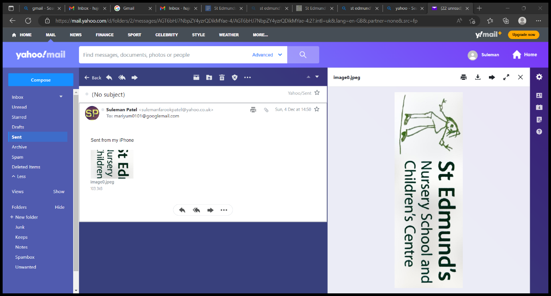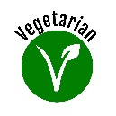 **Spring/Summer Term Menu 2022/2023**

**Halal and Vegetarian options are provided at all meals.**

|  |  |  |  |  |  |  |
| --- | --- | --- | --- | --- | --- | --- |
| WEEK 1 | 17/04/2023 | 08/05/2023 | 29/05/2023 | 19/06/2023 | 10/07/2023 | 31/08/2023 |
| WEEK 2 | 24/04/2023 | 15/05/2023 | 05/06/2023 | 26/06/2023 | 17/07/2023 | 07/08/2023 |
| WEEK 3 | 01/05/2023 | 22/05/2023 | 12/06/2023 | 03/07/2023 | 24/07/2023 | 14/08/2023 |

|  |  |  |  |  |  |  |
| --- | --- | --- | --- | --- | --- | --- |
|  |  | **MONDAY** | **TUESDAY** | **WEDNESDAY** | **THURSDAY** | **FRIDAY** |
| **WEEK 1** | **LUNCH** | **Fish fingers, Chips and Beans** | **Chicken Sheesh Kebab, Savoury Rice, Salad, Yogurt Dip** | **Cheese Tomato Pasta, Garlic Bread, and Salad** | **Meat Potato Pie, Broccoli, Carrots, and Gravy** | **Chicken Pizza, Chips, and Beans** |
| **PUDDING** | **Jelly** | **Oreo**  **Cheesecake** | **Cookies** | **Ice Cream** | **Chocolate Cake and Chocolate Sauce** |
| **TEA** | **Veg Cheese Burgers, Cheese and Ketchup** | **Pizza, Potato Cubes** | **Jacket Potatoes, Beans and Cheese** | **Fish fingers, Hot Dog Rolls** | **Tuna and Cheese Sandwiches** |
| **WEEK 2** | **LUNCH** | **Chicken Burger, Chips, and Salad** | **Lamb Burrito, Potato Wedges, and Salad** | **Fishcake, Baby Potatoes, Sweet Corn, Peas, and Cheese Sauce** | **Chicken Curry, Rice, and Naan Bread** | **Cheese and Onion Pastie, Chips, and Beans** |
| **PUDDING** | **Chocolate Mousse** | **Marble Sponge and Custard** | **Yoghurt and Jam** | **Fruit Salad** | **Swirled Strawberry and Vanilla Ice Cream** |
| **TEA** | **Cheese Tomato Pasta and Garlic Bread** | **Veg Fingers, Potatoes Waffles, Potato Cubes and Ketchup** | **Cheese and Onion Pasties and Spaghetti Hoops** | **Fishcake Butty and Ketchup** | **Samosas, Pakoras, Yoghurt Dip, Salad** |
| **WEEK 3** | **LUNCH** | **Pizza, Chips, and Beans** | **Pasta Bolognese, Salad, and Garlic Bread** | **Cheese Pie, Carrots. Broccoli, and Cheese Sauce** | **Chicken Biryani, Salad, Garlic Naan, and Yogurt Dip** | **Fishcake, Potato Cubes, and Beans** |
| **PUDDING** | **Victoria Sponge Cake** | **Jelly Delight** | **Mango Cheesecake** | **Lemon Short Cookies** | **Apple Crumble and Custard** |
| **TEA** | **Veggie Ravioli, Toast** | **Spaghetti Hoops, and Toast** | **Jacket Potato, Beans and Coleslaw** | **Pizza, Potato Cubes, and Ketchup** | **Sandwiches** |