Summer Term Menu 2022
Halal and vegetarian options are provided at all meals.
(Breakfast, lunch and tea)
Week 1 | 02/05/22 | 23/05/22 | 13/06/22 | 04/07/22 | 25/07/22 | 15/08/22
Week 2 | 09/05/22 | 30/05/22 | 20/06/22 | 11/07/22 | 01/08/22 | 22/08/22
Week 3 | 16/05/22 | 06/06/22 | 27/06/22 | 18/07/22 | 08/08/22 | 29/08/22

 |  | Monday | Tuesday | Wednesday | Thursday | Friday
Week 1 | Lunch | Fish and Chips and Garden peas and Curry Sauce | Chicken Fajitas, Tex-Mex rice, salad and yoghurt dip | Roast Veggie Pasta Bake, Garlic Bread, Salad | Meat and Potato Pie, Mash Potatoes, carrots, broccoli and gravy | Homemade Pizza, Chips and Beans
 | Pudding | Lemon Cream Cake | Vanilla Yoghurt and Strawberry Sauce | Ice cream | Strawberry Jelly and delight | Homemade Chocolate Chips Cookies
 | Tea | Cheese and Tomato Pasta and Garlic Bread | Fishcake Butty,  Veggie sticks | Ravioli on toast | Samosas and Pakoras, salad, raita | Picnic Platter
Week 2 | Lunch | Creamy Vegetable Pie, new potatoes, broccoli, gravy | Pasta Bolognese, garlic bread and salad | Paprika Chicken, rice, salad and yoghurt dip | Homemade Chilli, potato wedges, salad, cheese, yoghurt dip | Fish Cake, Potato Cubes and Beans
 | Pudding | Ice Cream and Sprinkles | Chocolate Sponge and Chocolate sauce | Strawberry Mousse | Homemade Lemon Cookies | Assorted Yoghurts and Fruity Sauce
 | Tea | Jacket Potatoes with beans and cheese | Fish finger hotdogs | Pizza and Spaghetti hoops | Mac and Cheese Bake and Garlic Bread | Homemade Onion bhajis, chutney and raita
Week 3 | Lunch | Fish fingers, chips and beans | Homemade Chicken Curry, rice, naan, yoghurt dip | Homemade Quiche, potato wedges and beans | Cheese, Tomato and Spinach Pasta, salad and Garlic Bread | Cheese and Onion Pie new Potatoes Broccoli and Gravy
 | Pudding | Strawberry sponge and Custard | Ice cream | Lemon Cheesecake | Chocolate Mousse | Raspberry Cream Cake
 | Tea | Vegan Sausage Roll and Spaghetti Hoops | Veggie Cheese burgers, salad | Vegetable Fingers and Potato waffles | Fish Stars and Beans | Assorted Sandwiches

Breakfast

Breakfast is available each day, consisting of:
- Choice of cereals or porridge
- Range of breads
- Fresh fruit
- Milk
Menu information
- All main meals are accompanied with seasonal vegetables or 5 individual salad items, and either potato, rice, pasta, chapattis, or naan bread. In addition, bread is available each day.
- All meat and poultry used is fresh and locally sourced.
- All our fish, vegetarian & cheese dishes are suitable for Muslims.
- We do not use any preservatives or additives that are unsuitable for children.
- All menus are subject to availability and may change without notice.

From our Food Policy…
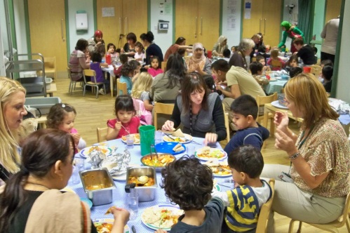
We serve only healthy food and drink and all meals will be prepared by our own staff, with reference to national, nutritional guidelines.
- Mealtimes are seen as a learning experience and all opportunities for counting, problem solving and communicating are exploited. Older children set the tables and act as servers.
- Mealtimes are unhurried and relaxed with children being allowed ample time to eat.
- Babies are introduced to an open or free-flowing cup at 6 months and are discouraged from using a bottle from this time.
- Babies and children are encouraged to develop their physical feeding skills by feeding themselves using their fingers as early as possible, moving to spoons, spoon and fork and then knife and fork as their control develops
Please talk to a member of staff for more information.

