Replacement Free School Meals Scheme

Application process for the Replacement Free School Meals Scheme
Website
Please follow the link below
https://secure.manchester.gov.uk/info/500361/coronavirus/7938/coronavirus_-_benefits_and_money/4

- Ensure that you read the eligibility on the webpage before applying.
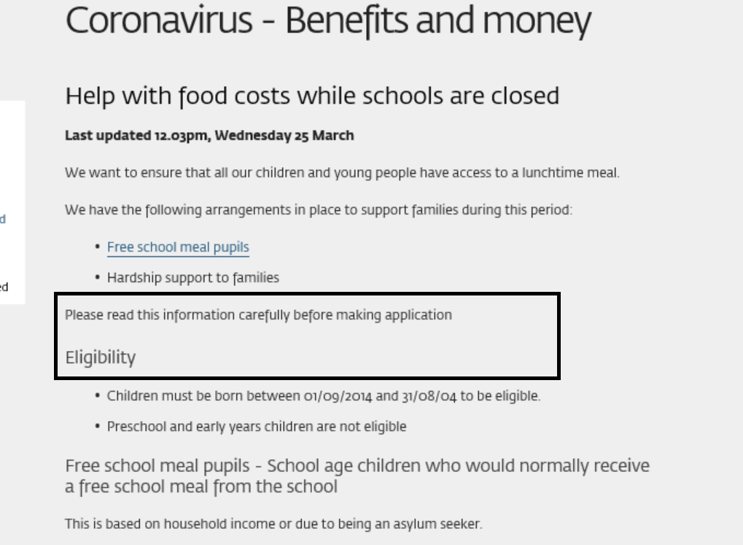

- Only if you are eligible; click on the link (Council’s Welfare Provision Scheme)
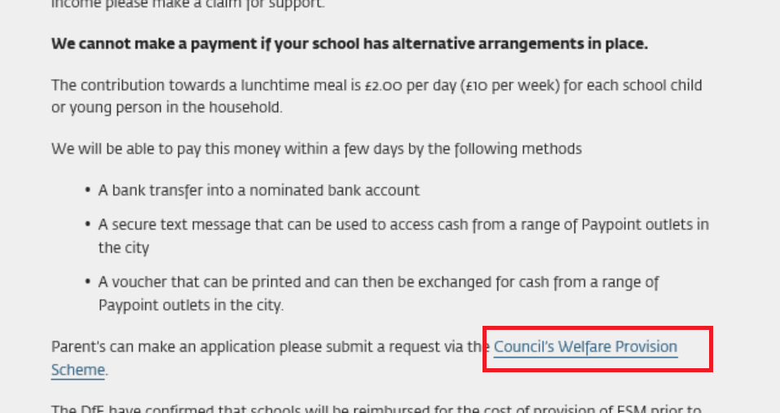
- Scroll to the bottom of the page and click on Apply for a Cash Grant.
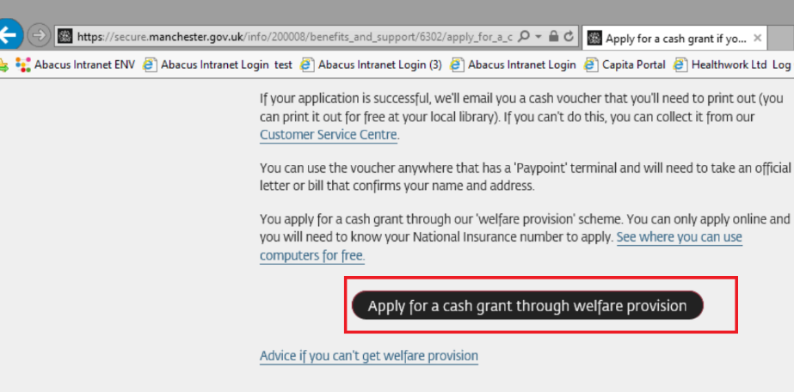

- Ensure you accept cookies.
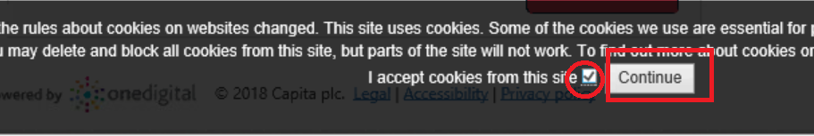

- Click Apply Online
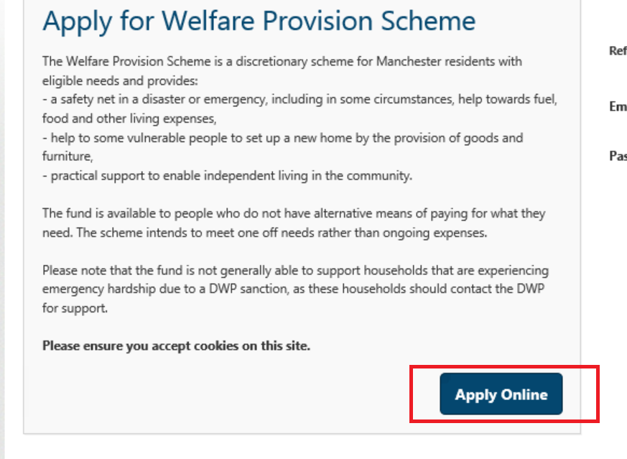

Application Basic Info

- Input your National Insurance Number and your date of birth (these will be used to check that you are financially responsible the child(ren). Then start application.
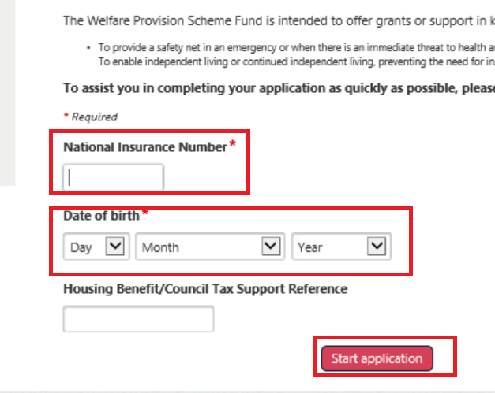

The Replacement Free School Meals scheme will only entitle you to a cash grant (if eligible). Other goods type relate to Welfare Provision Scheme applications only.
- Select the Cash Grant good type and select School Closure from the Assistance Reason dropdown.
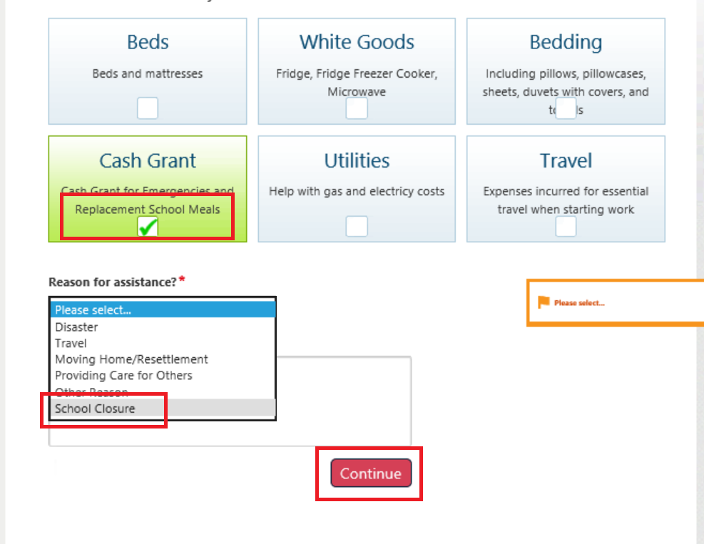
About You

The About section gathers basic details about the applicant.
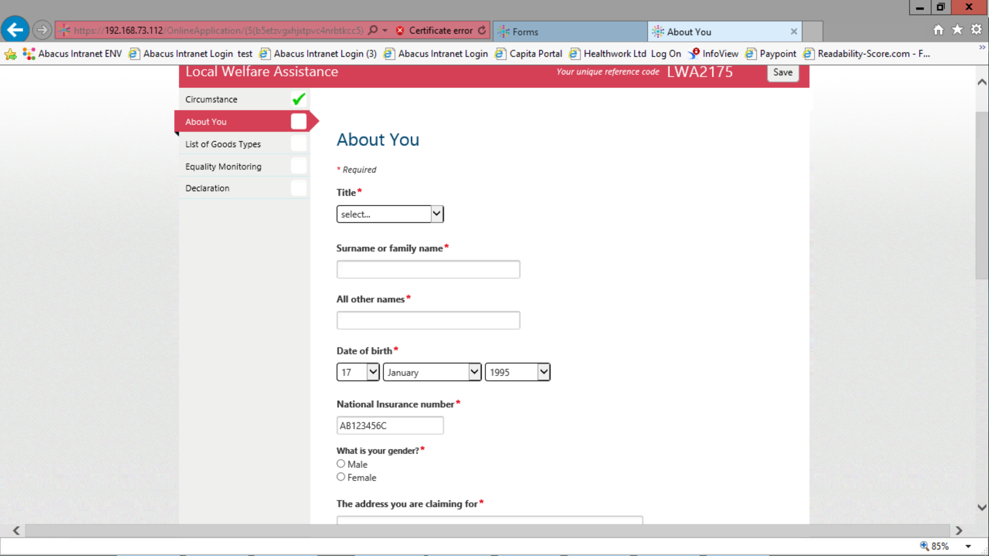

- You must indicate whether you have children living with you.
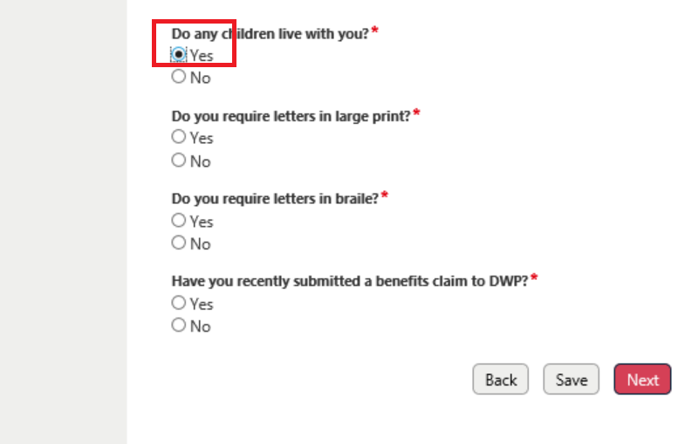

Your Children
In this section we need to know about your children and the school they attend
- You must indicate the number of children you are applying for.
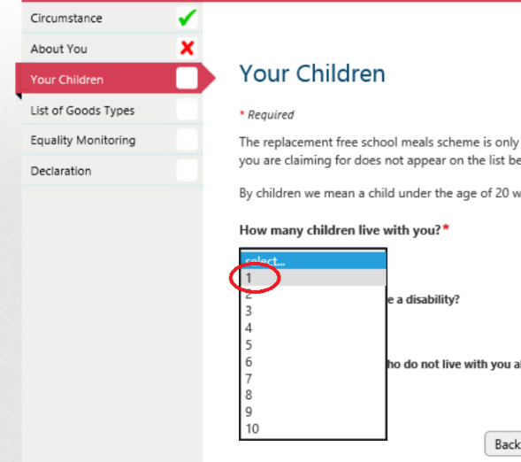
- Provide each child’s Date Of Birth and select the school they attend.
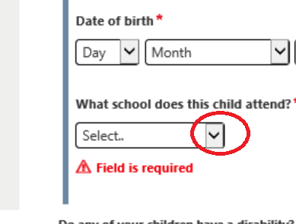
- The picklist contains all Manchester schools. We will check child registration against the school. We also will check which schools provide their own support.
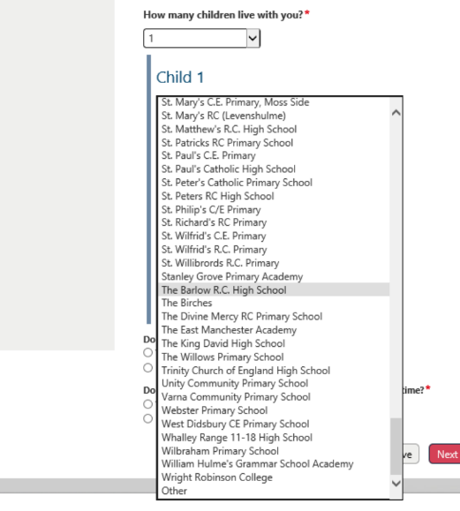

- If you cannot find the school; select other and type the school name in the text field
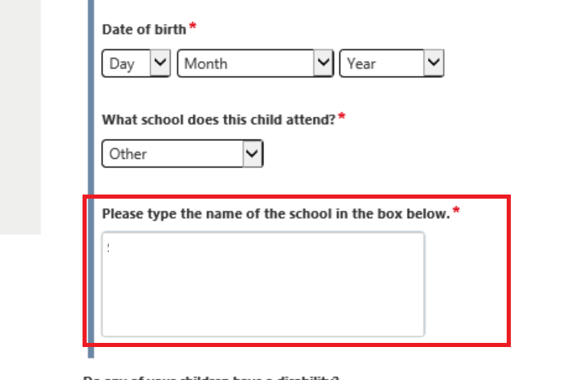

List of Good Types
This is where we gather Grant details and preferences.
- Indicate whether you are applying due to school closure.
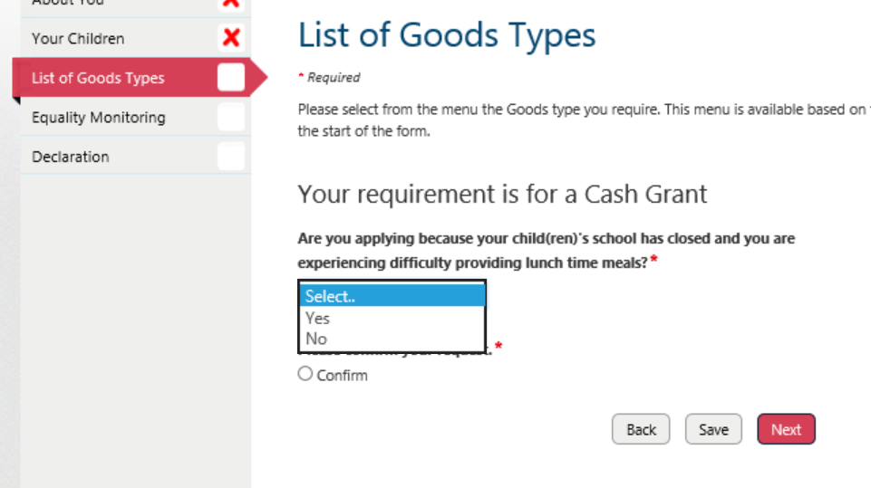

- If you are, you will need to Confirm the request and you will be asked whether your child currently receives Free School Meals (we will check this against information we have received from the schools)
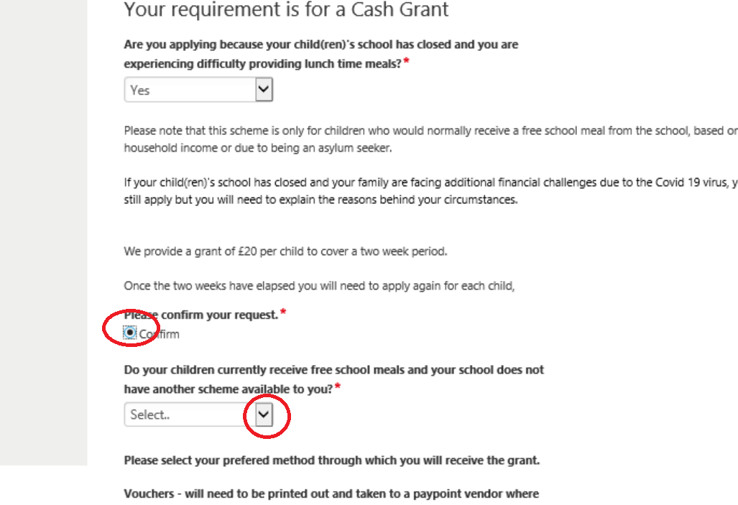

- If your child does not currently receive Free School Meals we will ask whether the applicant is an Asylum Seeker
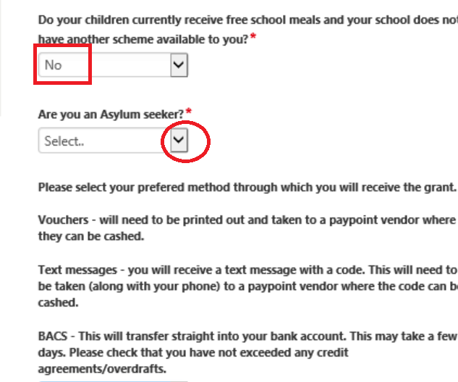

- If not, you will need to explain why you are applying for a grant under this scheme
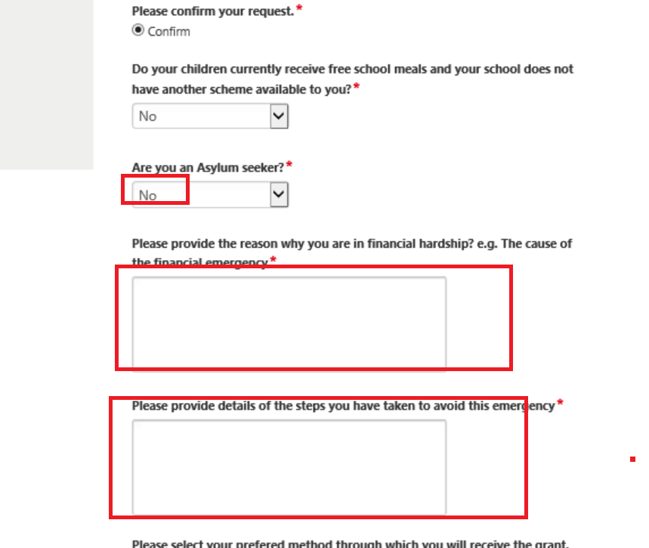

- You will then need to select how you would like your grant delivered
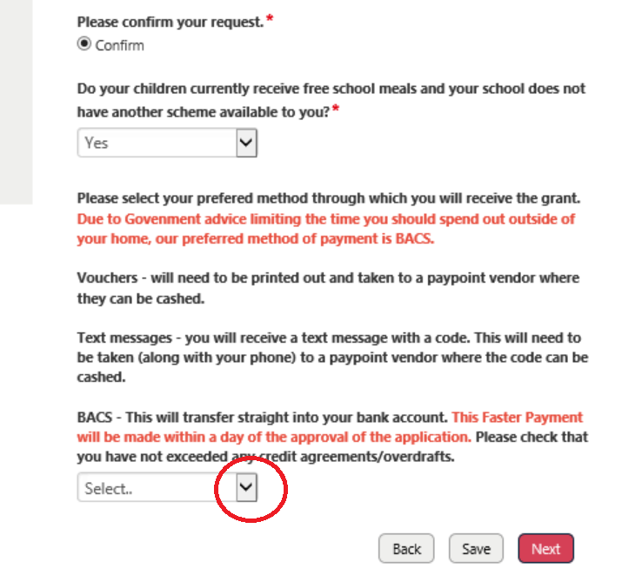

Declaration
Finally you will need to complete the Declaration section. If you have not fully completed the form you will see red crosses on the sections and will be advised which mandatory questions you have not been answered.
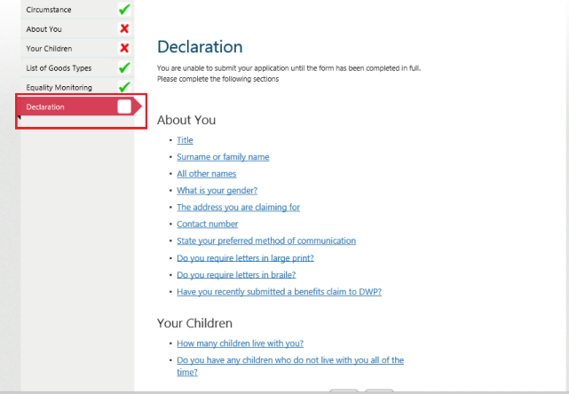
Once fully complete you will need state whether you have completed the form for yourself or on behalf of someone else
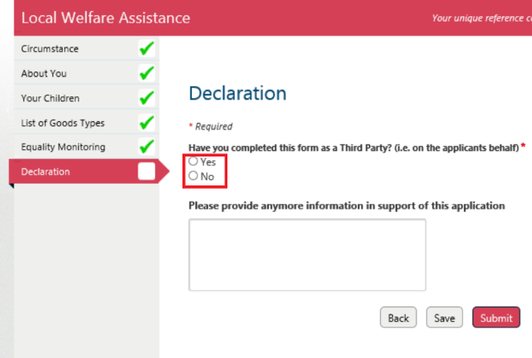

If you are acting as a Third Party you will need complete the fields that appear.
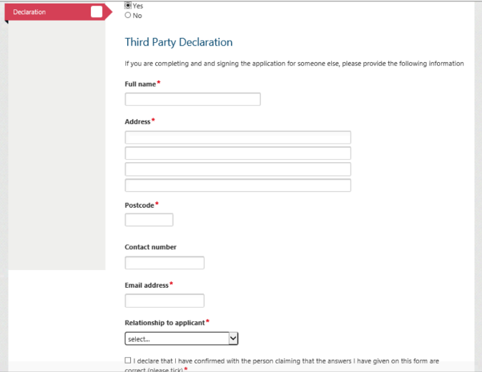

Once fully completed click Submit


