1834 | The lease on the property is taken over by William Crisp who advertises it as "Belle Vue Tea Gardens".
1843 | Jennison extended the existing gardens by opening up another 13 acres. This included the Small Lake, a Natural History Museum, and an entrance at the Longsight end of the property.
1855 | A train station was opened close to the Hyde Road entrance. It was later named Ashbury's Station.
1876 | The Belle Vue Railway Station was opened and the Lake Hotel and the Lake Entrance were built.  The original Elephant House was relaced by a new building and the Lion House was extended.
1910 | The Kings Hall was built and a roller skating area was constructed in the ballroom block.
1929 | The speedway started in 1929 but the team didn't adopt the name "Aces" until a later date.
1942 | The Hallé Orchestra started a 30 year association with Belle Vue during which regular concerts were given at the park.
1954 | Stock Car racing was introduced at the speedway stadium.
1955 | The Children's Zoo opened.
1977 | Belle Vue Zoo closed.
1979 | The Amusement Park was sold to Mr. Wadbrooke, who ran it at weekends in the season.
1981 | The final Christmas Circus ran at the Kings Hall from December 26, 1981 to January 30, 1982.
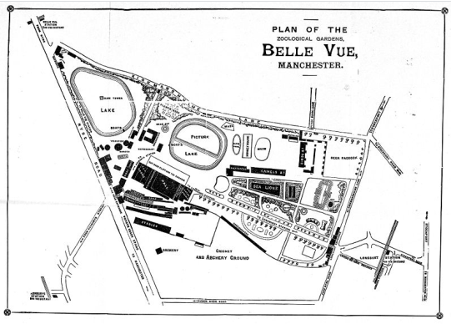
History of Belle Vue

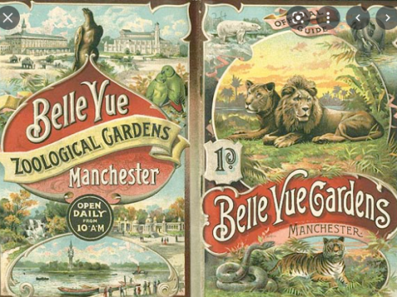
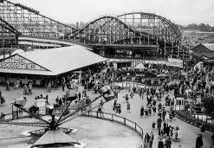

Key words:
Prejudice -an opinion that is formed without knowing or considering all the facts
Significant – having meaning or being meaningful
Local history – the history of the place near where I live
Discrimination -when a person is treated differently (not in a good way) because of some aspect of their identity.
