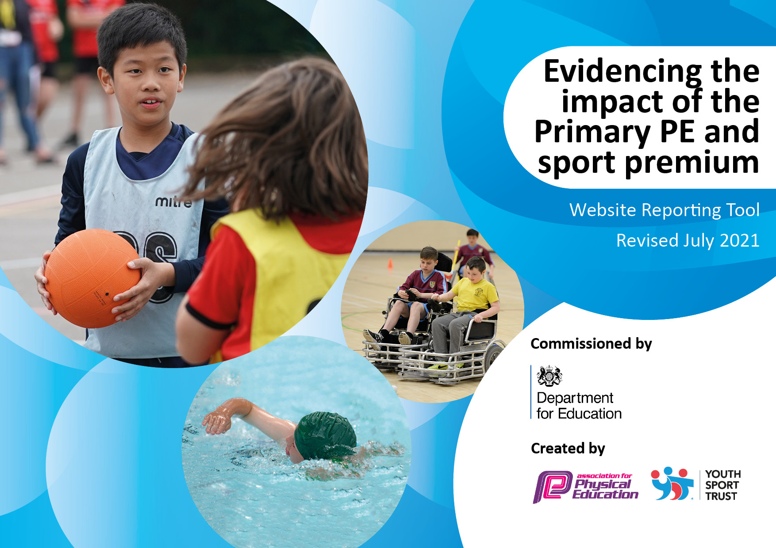

Details with regard to funding
Please complete the table below.

Total amount carried over from 2019/20 | £0
Total amount allocated for 2020/21 | £17’750
How much (if any) do you intend to carry over from this total fund into 2021/22? | £0
Total amount allocated for 2021/22 | £17’750
Total amount of funding for 2021/22. To be spent and reported on by 31st July 2022. | £17’750
Swimming Data
Please report on your Swimming Data below.

Meeting national curriculum requirements for swimming and water safety.

N.B. Complete this section to your best ability. For example you might have practised safe self-rescue techniques on dry land which you can then transfer to the pool when school swimming restarts.
Due to exceptional circumstances priority should be given to ensuring that pupils can perform safe self rescue even if they do not fully meet the first two requirements of the NC programme of study
What percentage of your current Year 6 cohort swim competently, confidently and proficiently over a distance of at least 25 metres?  N.B. Even though your pupils may swim in another year please report on their attainment on leaving primary school at the end of the summer term 2020.  Please see note above | 93%
What percentage of your current Year 6 cohort use a range of strokes effectively [for example, front crawl, backstroke and breaststroke]?  Please see note above | 60%
What percentage of your current Year 6 cohort perform safe self-rescue in different water-based situations? | 53%
Schools can choose to use the Primary PE and sport premium to provide additional provision for swimming but this must be for activity over and above the national curriculum requirements. Have you used it in this way? | No

Support for review and reflection - considering the 5 key indicators from DfE, what development needs are a priority for your setting and your pupils now and why? Use the space below to reflect on previous spend and key achievements and areas for development.

Key achievements 2020-2021: | Areas for further improvement and baseline evidence of need:
- Created a new links with Lancashire Cricket club and Hide Out Youth Zone.  - Introduced a new and exciting P.E scheme which the children and staff have really enjoyed.  - Individual winners in the Virtual football skills competition (boys and boys).  - New school athletics records in long jump and the mile.  - Entered 4 virtual competitions with Manchester PE association.  - Entered 4 sports festivals with Manchester PE association.  - A very successful in house sports week.  - Lunchtime organisers and sports squad training delivered to enhance 60 active minutes for all pupils.  - Daily mile competition jersey winners.  - P.E lead invited to join the Manchester P.E Teacher Training (MPETT) board.  - Online live lessons were successful during lockdowns and bubble closures.  - Pupil confidence and passion has grown immensely due to personal challenge and wellbeing input into P.E lessons.  - All of Year 6 attended at least one competition and represented the school excellently.  - 3 pupils attended the Manchester Boys football trials and one boy selected for the squad.  - 1 pupil talent spotted at the Manchester Quad Kids festival.  - Girls football increased from 10% to 45% participation at lunch and dinner times. | - Large focus on swimming: Current year 5 pupils will go swimming for the majority of 2021-2022. Our aim is to start with the year 4 class by the Summer term.  - Sports leadership and sports squad programme to continue to evolve to include training and implementation of Health Champions.  - Focus on before, during and after school clubs and club links, to offer a wider range of sport and activities to the pupils.  - Use physical activity opportunities to target punctuality.  - Continue to celebrate the ‘Whole P.E child’.  - Continue to celebrate success outside of school to promote more role models for all pupils.  - Embed school games, St. Francis and Olympic values throughout PESSPA.

Action Plan and Budget Tracking
Capture your intended annual spend against the 5 key indicators. Clarify the success criteria and evidence of impact that you intend to measure to evaluate for pupils today and for the future.

Academic Year: 2020/21 | Total fund allocated: £17’750 | Date Updated: 29/07/2021
Key indicator 1: The engagement of all pupils in regular physical activity – Chief Medical Officers guidelines recommend that primary school pupils undertake at least 30 minutes of physical activity a day in school |  |  |  | Percentage of total allocation:
 |  |  |  | 42%
Intent | Implementation |  | Impact
Your school focus should be clear what you want the pupils to know and be able to do and about  what they need to learn and to  consolidate through practice: | Make sure your actions to achieve are linked to your intentions: | Funding allocated: | Evidence of impact: what do pupils now know and what can they now do? What has changed?: | Sustainability and suggested next steps:
Improve pupil’s emotional health and wellbeing.  To ensure that with Covid-19 restrictions that pupils reach 30 active minutes daily and encourage 60 active minutes to the whole school.  To continue to promote fun and active break times. | Covid-19 has pushed this area to become even more of a priority and focus in our school. We have continued to look at the many opportunities to promote both pupils physical and emotional health and well-being in school through:  -Using more mindfulness activities.  - Using Travel to Tokyo as a tool to promote 30 active minutes.  -Continued development for lunchtime organisers and before and after school staff.  -Sports squad training in new activities and how to support pupils with mindfulness activities.  -Purchasing balance bikes for EYFS pupils to encourage more physical activities outdoors.  -Providing more equipment at playtimes for pupils to be more active.  -Weekly challenges uploaded to Class Dojo | £7400  Staff wellbeing training.  Lunchtime organiser training.  Before and after school club additional hours.  Balance bikes.  Extra playground equipment and cleaning fluids for bubbles. | Pupils feel confident in using strategies to them to help them deal with emotional situations they may be experiencing.  Through participation in regular online/home activities and a focus on the Olympic and Paralympic values pupils have developed a love of the outdoors and are developing their life skills including honesty, respect, teamwork and courage.  Behaviour at break times and lunchtimes has improved, reporting very little incidents.  Pupil voice, staff feedback and parental feedback. | Staff feel confident in using a range of resources and strategies to promote pupils physical and emotional health and well-being.  Staff and pupils will continue to use strategies and have a long term impact on their ability to deal with challenging situations.  Life skills developed will stay with pupils in future years.  Sports squads set as role models to encourage safe and fair play at break times for the future.
Key indicator 2: The profile of PESSPA being raised across the school as a tool for whole school improvement |  |  |  | Percentage of total allocation:
 |  |  |  | 15%
Intent | Implementation |  | Impact
Your school focus should be clear what you want the pupils to know and be able to do and about  what they need to learn and to  consolidate through practice: | Make sure your actions to achieve are linked to your intentions: | Funding allocated: | Evidence of impact: what do pupils now know and what can they now do? What has changed?: | Sustainability and suggested next steps:
To continue to ensure PE and sport has a high profile within the school. All Children are enjoying and excited about PE. High numbers of children wanting to be sports leaders, buddies and health champions.  To encourage School Games Values and Olympic and Paralympic values throughout the school.  To use: The Euros, Olympics and Paralympics as a tool to increase role models for sports and healthy lifestyles.  To continue with Healthy Me, Physical Me, Social Me and Thinking me to ensure a ‘whole P.E child’ is celebrated.  To continue to develop pupils understanding of success criteria and how to develop in P.E . | Review of school curriculum in light of Covid-19 restrictions and priorities for pupils.  All pupils to take part in: virtual competitions, Travel to Toyko competition and sports week.  Website and Class Dojo updated regularly to promote and celebrate learning and success.  Displays focused on values and role models.  Pupils encouraged to refill their water bottles at least once a day to promote and healthy body and mind.  Manchester P.E scheme of work still used to embed a ‘whole P.E child’ approach.  Sports week to finish off a year of learning and being active. All activities linked to previous lessons with a huge focus on ‘Whole P.E child’. | £2750  Sports week.  Water fountain.  School games membership. | Pupils having the confidence to participate in all P.E lessons online and in school.  Whole school taking part in physical activity initiatives and enjoying them.  Pupils recognised for their social and thinking skills in P.E for the first time by peers. Introduced ‘Most improved’ awards for each class.  Pupils celebrating finishing their water bottles daily and encouraging staff to drink more.  Assessments.  “The best sports week ever!”  Pupil voice, staff feedback and parental feedback. | Through the delivery of well-planned lessons and high quality teaching pupils have continued to make good progress in lessons and have develop their skills to a good level.  Pupils feedback on their enjoyment and engagement in lessons and this continues to grow so that all pupils have positive experiences, improved self-esteem, knowledge of the importance of being active and staying healthy and a love of PE.  Continue to host sports week at school and reward the ‘Whole P.E child’ as well as winners.  The governors, staff and parents of the school understand and support the subject and it is highly valued.

Key indicator 3: Increased confidence, knowledge and skills of all staff in teaching PE and sport |  |  |  | Percentage of total allocation:
 |  |  |  | 26%
Intent | Implementation |  | Impact
Your school focus should be clear | Make sure your actions to | Funding | Evidence of impact: what do | Sustainability and suggested
what you want the pupils to know | achieve are linked to your | allocated: | pupils now know and what | next steps:
and be able to do and about | intentions: |  | can they now do? What has
what they need to learn and to |  |  | changed?:
consolidate through practice:
To understand the implications of the covid-19 restrictions and what this means for PESSPA.  Embed staff confidence in following new curriculum overview and restrictions at break and lunchtimes with bubbles.  To ensure all staff are able to deliver high quality PE lessons with a clear skill based focus. | PE curriculum reviewed in light of covid-19 situation. Agreed that weaks and changes are needed long term. A new scheme introduced alongside the old one.  PESSPA CPD – lunchtime organiser training and continued MPETT attended.  Staff members with confidence in PE used to team teach and support other teachers within their key stage team and bubble.  P.E lead attended all MPETT meetings and was invited to become a member of the board. | £4671  Lunch time organiser training.  Manchester PE association.  MPETT (Manchester PE teacher training).  Mcr Schools alliance.  Twinkl scheme of work  Accelerate learning | Staff believed the new scheme of work was much easier to follow and believe the children enjoyed the input before the lesson.  The pupils enjoyed the variety of skills taught throughout the year and agreed to keep the new scheme of work.  Staff feedback, assessment and pupil voice. | Staff delivery and confidence to teach high quality PE remains high.  Pupils to benefit from the new scheme of work as a whole school with a clear and precise pathway throughout the years.  PE remains a well-managed and well led subject with PE leader using their knowledge to ensure high quality outcomes for the school.
Key indicator 4: Broader experience of a range of sports and activities offered to all pupils |  |  |  | Percentage of total allocation:
 |  |  |  | 7%
Intent | Implementation |  | Impact
Your school focus should be clear | Make sure your actions to | Funding | Evidence of impact: what do | Sustainability and suggested
what you want the pupils to know | achieve are linked to your | allocated: | pupils now know and what | next steps:
and be able to do and about | intentions: |  | can they now do? What has
what they need to learn and to |  |  | changed?:
consolidate through practice:
To allow all pupils to experience a wide breadth of sports and activities and understand the importance of this for their physical development and development.  To signpost pupils to continue to be active in the local area. | Promote and develop new and existing links with the school. Sale water park, Lancashire cricket and Hide Out Youth Zone to name a few.  To use the new scheme of work to introduce new skills and sport to the whole school.  Year 6 pupils to attend an adventure day at Sale waterpark to experience new opportunities and develop lifeskills. | £1200  Year 6 Sale Waterpark experience | A broad P.E curriculum.  Pupils have the confidence to try new experiences and enjoy new challenges.  Improved self-confidence and self-esteem.  Lesson observations, pupil voice, staff and parent feedback. | Continue and develop links with local clubs.  Rebook experience for pupils and include other year groups.  Pupils have gained lifelong skills through new experiences.

Key indicator 5: Increased participation in competitive sport |  |  |  | Percentage of total allocation:
 |  |  |  | 10%
Intent | Implementation |  | Impact
Your school focus should be clear | Make sure your actions to | Funding | Evidence of impact: what do | Sustainability and suggested
what you want the pupils to know | achieve are linked to your | allocated: | pupils now know and what | next steps:
and be able to do and about | intentions: |  | can they now do? What has
what they need to learn and to |  |  | changed?:
consolidate through practice:
All pupils to have access to high quality inter- and intra-school competitions.  To improve pupils confidence and self-esteem through personal challenge.  To continue a love and passion for competition at St. Francis. | All school games competitions accessed where possible both inter and intra.  My personal best challenges integrated into P.E lessons, lunchtimes and break times to keep pupils engaged and motivated in learning and developing skills.  Sports week returned. | £1729  School mini bus  Sports award trophies  Sports week medals and awards.  School games competition calendar and support. | All pupils taking part in my personal best challenges which motivate and engage them and give them increased confidence and self-esteem in their abilities.  More pupils interested in sports competitions both individually and as a team.  All year 6 pupils attended at least one competition.  Girls football success.  100% of pupils taking form in some form of competitive situation in the school.  “The best sports week ever!”  Pupil voice, observations, parent and teacher feedback. | Pupils wider skills learnt though competitive situation’s and collaborating with others will stay with them.  Calendar of events and opportunities will carry on in future years so others will have similar experiences and opportunities.

Signed off by
Head Teacher:
Date:
Subject Leader: | R. Jagger-Smith
Date: | 30/07/2021
Governor:
Date:

