Paws, Claws and Whiskers

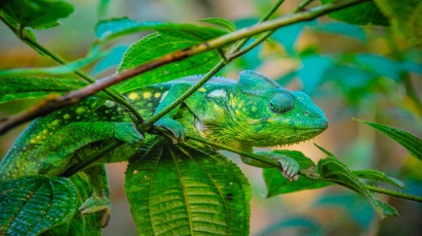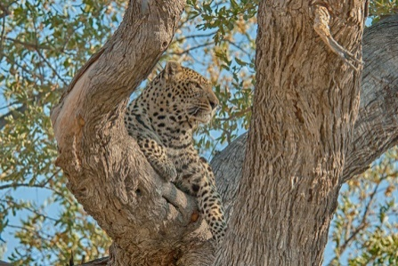Camouflage

Wild animal Domestic animal

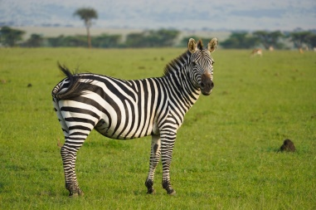

Carnivore Herbivore Omnivore

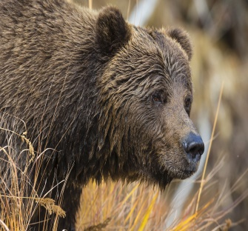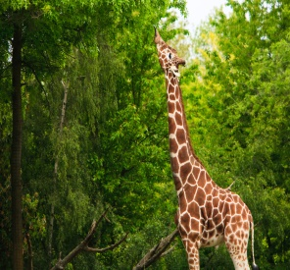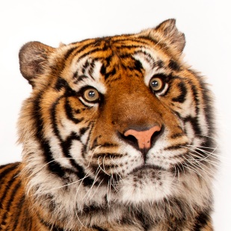

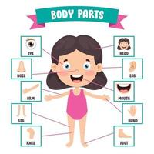Some body parts are the

same and some are

different.

Key Words

Adaptation

Carnivore

Continent

Domestic animal

Habitat

Herbivore

Omnivore

Pet

Predator

Prey

Wild animal