St Gabriel’s Home Learning Agreement 2021-2022
Rationale for this agreement:
Research carried out by the EEF on homework in secondary schools evidences…
“…the impact of homework, on average, is five months' additional progress. However, beneath this average there is a wide variation in potential impact, suggesting that how homework is set is likely to be very important… Homework has been extensively researched. There is a relatively consistent picture that pupils in schools which give more homework perform better… Some studies indicate that there may be an optimum amount of homework of between one and two hours per school day (slightly longer for older pupils), with effects diminishing as the time that students spend on homework increases.”

The setting of homework in secondary schools is shown to be the fourth most impactful method of teaching and learning when implemented to a high standard.
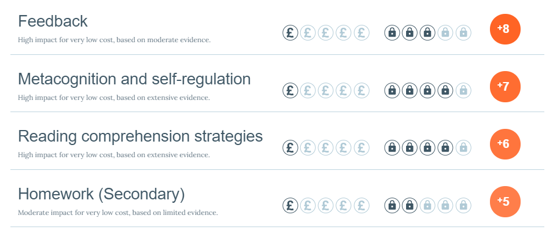
KS3 Home Learning Timetable:
Subject | Frequency | Y7 | Y8 | Y9
English | Weekly | Up to 30 mins | Up to 30 mins | Up to 30 mins
Maths | Weekly | Up to 30 mins | Up to 30 mins | Up to 30 mins
Science | Weekly | Up to 30 mins | Up to 30 mins | Up to 30 mins
R.E. | Weekly | Up to 30 mins | Up to 30 mins | Up to 30 mins
P.E. | Fortnightly | Up to 15 mins | Up to 15 mins | Up to 15 mins
Spanish/French | Weekly | Up to 30 mins | Up to 30 mins | Up to 30 mins
History | Fortnightly | Up to 30 mins | Up to 30 mins | Up to 30 mins
Geography | Fortnightly | Up to 30 mins | Up to 30 mins | Up to 30 mins
Computer Science | Every 4 weeks | Up to 30 mins | Up to 30 mins | Up to 30 mins
Music | Every 4 weeks | Up to 30 mins
Art | Every 4 weeks |  | Up to 30 mins | Up to 30 mins
TOTAL TIME PER WEEK: |  | 3 hours, 38 mins | 3 hours, 38 mins | 3 hours, 38 mins

KS4 Home Learning Timetable:
Subject | Frequency | Y10 | Y11
English | Weekly | Up to 1 hour | Up to 1 hour
Maths | Weekly | Up to 1 hour | Up to 1 hour
Combined Science | Weekly | 20 minutes per Science (1 hour) | 20 minutes per Science (1 hour)
Triple Science | Weekly | 30 minutes per Science (1.5 hours) | 30 minutes per Science (1.5 hours)
R.E. | Weekly | Up to 1 hour | Up to 1 hour
GCSE P.E. | Weekly practical | 1 hour (Enrichment) | 1 hour (Enrichment)
 | Weekly theory | Up to 30 mins | Up to 30 mins
Spanish/French | Weekly | Up to 1 hour | Up to 1 hour
History | Weekly | Up to 1 hour | Up to 1 hour
Geography | Weekly | Up to 1 hour | Up to 1 hour
Computer Science | Weekly | Up to 1 hour | Up to 1 hour
Music | Weekly practical | Up to 1 hour | Up to 1 hour
 | Weekly theory | Up to 30 mins | Up to 30 mins
Art | Weekly | Up to 1 hour | Up to 1 hour
Drama | Weekly practical | Up to 1 hour | Up to 1 hour
 | Weekly theory | Up to 30 mins | Up to 30 mins
Psychology | Weekly | Up to 1 hour
Food Technology | Weekly practical | Up to 1 hour | Up to 1 hour
 | Weekly theory | Up to 30 mins | Up to 30 mins
Design & Technology | Weekly | Up to 1 hour | Up to 1 hour
Photography | Weekly | Up to 1 hour
Media Studies | Weekly | Up to 1 hour | Up to 1 hour
iMedia | Weekly |  | Up to 1 hour
Voc Sports Studies | Weekly theory | Up to 30 mins | Up to 30 mins
Functional Skills | N/A
Key Skills (ASDAN) | N/A

Differentiation and Inclusion:
As with classwork, home learning must also be differentiated for students to ensure all can access/complete the tasks and all are suitably challenged. We know that students grasp content and skills at different rates and students have differing levels of abilities in different subject areas. The resources and support students have available to them at home vary widely. We must be mindful that whilst students can contact teachers via SMHW for support, they do not have direct access to subject specialists to help them with these independent learning opportunities. Therefore, instructions must be very clear and unambiguous.
One recommended strategy for differentiating home learning is to provide ‘Yellow’ and ‘Blue’ versions similarly to how we do in class. Yellow tasks should be accessible for all, but still maintain high expectations. Blue tasks should be designed to challenge more able students.
It is also appropriate to set students completely different tasks depending on their differing needs. For example, teachers may choose to set more pre-learning and retrieval tasks for students with learning difficulties, and more challenge tasks for high-ability students.
Home learning tasks may also be differentiated according to students’ interests as opposed to their ability. They may be given different options of producing and/or submitting the work to teachers.
Teachers should pre-empt barriers to students completing home learning and ensure strategies are implemented to remove these proactively. For example, if the home learning requires access to a virtual learning platform, a printed version / alternative task will need to be made available for students without access to IT at home.
Agreed Home Learning Tasks:
Teachers are expected to set a range of home learning tasks to give students a varied and engaging independent learning experience. Home learning should not always take the form of online learning or always require students to complete examination questions.
The following tasks have been agreed as suitable for home learning:
- GCSE Pod: Watch/listen to podcasts and complete accompanying activities (e.g. quizzes).
- Activities on Maths Watch / Vocab Express / Active Learn / Seneca Learning / Focus on Sound.
- Assignments, quizzes and spelling tests on Show My Homework.
- Topic projects with mini-deadlines to support students in managing their time.
- Creation of revision materials (e.g. flash cards) and knowledge organisers.
- Use of revision guides; reading and activities.
- Prescribed reading with follow-up tasks (e.g. comprehension, preparation for class discussion/debate).
- Spelling tests in all subjects for every topic (revision for home learning).
- Unit review preparation tasks.
- Long-term retrieval tasks.
- Examination style questions (KS4 only).
- Extended writing opportunities in a variety of genres (e.g. letters, poetry, persuasive writing, emotive writing).
- Interviewing people at home as part of research into a topic.
- Researching topics using pre-determined information sources (e.g. articles and web links).
- Practicing practical skills (e.g. cooking, musical performance, composition, skills linked to P.E. and drama)
- Completing listening exercises (e.g. Music, French and Spanish).
- Preparation for solo or group presentations and performances.
- Competition entries (school-based competitions or national/international competitions).
Setting Home Learning:
We must consider setting home learning when lesson planning. Time should be given to discuss the requirements of the tasks and for students to record the instructions in their passports. Students should have the opportunity to ask questions and seek clarity. You may need to shorten another part of the lesson to allow for this. Please use your professional judgement.
Please be mindful that setting home learning at the end of the lesson can lead this to be rushed, and may suggest that it is less important than the classwork tasks. It is preferable for home learning to be set after the Do Now task, or after the Progress Check for these reasons.
Assessment Expectations:
Teachers must consider how and when home learning will be assessed in advance of setting work. Whilst the teacher must check that all students have submitted the home learning on time to the expected standard to issue rewards and sanctions accordingly, it is not sufficient to only check that home learning has been completed without any further follow-up action. This approach does not promote high standards and suggests the task was not sufficiently important, thus undermining the value and purpose of home learning.
The following assessment methods are acceptable, should be selected based on the nature of the home learning task and a range should be used:
- Teacher assessment: Teachers mark the home learning task as part of the 1 in 4 feedback cycle. This can be done as whole class feedback or individual blue box marking.
- Peer assessment: Teachers model how to do this effectively and provide clear success criteria. This can be done as a Do Now task during the lesson when home learning is due.
- Self assessment: Teachers must model how to do this effectively and provide clear success criteria. This can be done as a Do Now task during the lesson when home learning is due.
- Presentation: A number of students are selected to present their work during lessons (e.g. during resilience time). This can be done through strategic or random selection as deemed appropriate.
- Discussion: Students share their learning from the home learning task during a structured class discussion. This is particularly suitable for research-based home learning activities.
- Computer assessment: Computer-based home learning tasks may be assessed automatically (e.g. SMHW quizzes) or teachers can send feedback to students via SMHW comments.
Home Learning Related Rewards / Sanctions:
- Mission points for ‘success’ will be given to students who submit home learning tasks on time to the expected high standard at the time of teachers checking the work.
- Teachers will sign passports using the QoE sanction code ‘H’ when home learning is either not submitted or not completed to the expected standard (unless a note from a parent/carer is produced to provide an explanation). Students will only be given one opportunity to submit home learning; teachers will not chase it. It will not be acceptable for students to bring it in the following day or next lesson.
- Teachers are expected to keep a record of submission of home learning for the sake of communication with parents/carers and monitoring of repeat offenders. This can be done using an electronic document or their teacher’s planner should they choose to purchase one.
Support:
A home learning club is available from 3.05-4.00pm for students with SEND in each year group one day per week with the Curriculum Support Team. Departments may also offer home learning clubs on their designated extra-curricular evening each week subject to staffing.
Communication:
Relevant details of this home learning agreement will be shared with all students, parents/carers and staff in September 2021. An overview will also be available on our school website.
Home learning resources and tasks will be shared with students and parents/carers via Show My Homework. There are functions to set spelling tests and quizzes directly. There is also the option to set differentiated tasks. All other home learning should be set under the heading of ‘assignments’. However, optional additional support or challenge tasks can be set as ‘Flexible tasks’.
For students in KS3, teachers will also provide a hardcopy overview of home learning tasks at the beginning of each topic, which will be stuck in students’ exercise books for easy reference. This may be on the back of ‘Look to the Light’ sheets or a separate sheet depending on each department’s preference (all teachers within a department must follow that department’s agreed approach). This will ensure consistency, as all teachers will set the same tasks for all classes.
For students in KS4, teachers will provide a hardcopy of the home learning tasks or ensure students have recorded home learning instructions correctly in the space provided in their passports at the time of the work being set to allow greater flexibility for teachers to respond to the strengths and needs of their classes and individual students. The consistency and success of this will be routinely quality assured by Middle Leaders.
July 2021

