Uniform Academic Year 2022 / 23

The school takes pride in the appearance and conduct of its pupils. The school’s reputation in this area is of importance to individual pupils both during school life and later when seeking employment. Therefore:

- School uniform is to be worn by all pupils and all adults are asked to ensure that the pupils comply with the accepted uniform standards through the Positive Discipline Policy and noted in the Pupil Passport.
- Please refer to the Pupil Passport for information regarding sanctions given to breaches of the uniform standards.
- Please ensure that learning is not disrupted by breaches in the uniform expectations.
- The headteacher reserves the right to prohibit unsuitable fashion/styles in dress and personal appearance which is contrary to the reasonable uniform policy summarised in this document.
- Any disputes arising from uniform or personal appearance queries/concerns will be decided upon by the Head.

Boys (obligatory)

- Navy Blazer with school embroidered logo
- Plain white shirt (tucked in)
- Year Group Tie
- Black tailored trousers (no tight fitting, fashion trousers, or jean or chino style)
- Plain black or grey socks – other colours are not allowed
- Plain black school shoes – see below
- Optional: Navy plain v-neck jumper - no zips, logos or motif
- An apron must be worn for all Design & Technology subjects

Girls (obligatory)

- Navy Blazer with school embroidered logo
- Year Group Tie if wearing a closed neck white shirt
- White closed shirt with Year Group tie (tucked in)
- White open neck shirt to be worn with pinafore only. Not allowed with trousers
- Navy Pinafore with logo over knee (must be knee length)
- Black tailored trousers (no tight fitting, fashion trousers, or jean style with buckles) must be to the top of the school shoe
- Plain white or navy blue socks below the knee or black opaque tights. No ‘over-knee’ socks/stockings.
- Plain black school shoes – see below.
- Optional: Navy plain v-neck jumper – no zips, logos or motifs.
- An apron must be worn for all Design & Technology subjects.

Shoes

Shoes must be plain black only. No logos, stripes, canvas or boots of any type

Acceptable footwear:

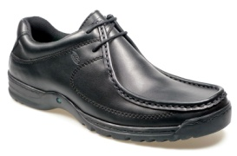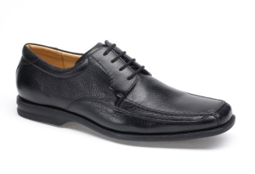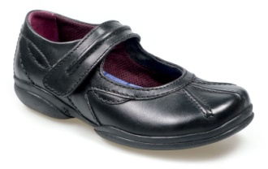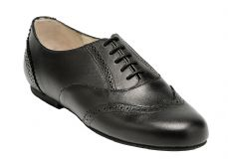Unacceptable footwear:
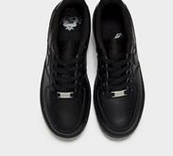
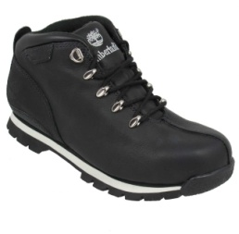
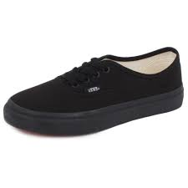
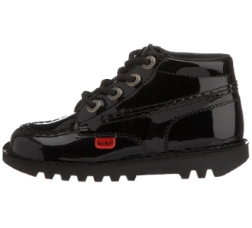

General Appearance

Jewellery and make-up

Not allowed:

- Jewellery including earrings and taped over earrings
- Make up and nail varnish
- Piercings or stretchers
- Fake sun-tan
- Badges of any description other than those distributed by school
- Fake nails or nail polish

Allowed:

- A wrist watch
- Badges issued by school for wear on the lapel of blazer (council, peer-mentor, etc)

Hair styles

Hair styles should be neat and tidy and of a natural hair colour. Hair should not be shorter than a
‘number 3’ without lines or fashionable designs.

Colour should be natural – no extremes of colour, length or style

Hijab head wear
Should your daughter choose to wear a hijab, it must be of a plain design, without any colour trim,
in navy blue or black

Outdoor coats

Outdoor coats should be warm and waterproof preferably in navy blue, black, or a dark colour

Coats should not be worn inside the building but may be worn outside at break, lunchtimes

The wearing of hoodies, track suit tops or other fashion wear is not allowed

Other information and equipment

Weatherproof bag for books and other equipment – no fashion handbags

Stationery

Pen, pencil, ruler, some coloured pencils, rubber, pencil case and a scientific calculator

Pupils may have uniform and equipment checks each morning as part of their ‘Standards Card’

Any pupil arriving at school without the appropriate equipment or uniform will be placed into the removal room until equipment is brought from home.

If there is any doubt regarding acceptable uniform, or if there are any temporary problems of availability, parents should contact school as soon as possible.

Physical Education and Sports Kit

Girls | Boys
Indoor Kit  Navy-sky-white girls cut sports polo shirt  Navy-sky-white skort (combined skirt/shorts)  (Navy-sky-white shorts if preferred)  Navy blue football/hockey socks only  Outdoor Kit  As above, but pupils can also wear:  Navy-sky-white hooded sweatshirt with school logo  Or plain navy hooded sweatshirt (with no zips, logos or motifs)  SWEATSHIRTS ARE OPTIONAL  Navy-sky-blue joggers or Plain navy blue full-length joggers (no zips, logos or motifs)  Or  Navy-sky-blue leggings with school logo or Plain thick black/navy leggings. (No logos or motifs) Skort must be worn over black leggings.  Pupils may also wear a blue or black base layer for arms or legs.  JOGGERS/LEGGINGS/BASELAYERS  ARE OPTIONAL  – for use in cold weather  Shin pads  Footwear  Indoor: Trainers/astro-turf boots  Outdoor: Astro-turf boots/football boots  When representing school:  White sports socks may be worn if appropriate. | Indoor Kit  Navy-sky-white sports polo shirt  Navy-sky-white shorts  Navy blue football socks only  Outdoor Kit  As above, but pupils can also wear:  Navy/sky/white hooded sweatshirt with school logo  Or plain navy hooded sweatshirt (no zips, logos or motifs)  SWEATSHIRTS ARE OPTIONAL  Navy-sky-blue joggers or Plain navy blue full-length joggers (no zips, logos or motifs)  Pupils may also wear a blue or black base layer for arms or legs.  JOGGERS/BASELAYERS  ARE OPTIONAL  – for use in cold weather  Shin pads  Gum shields  Footwear  Indoor: Trainers/astro-turf boots  Outdoor: Football boots  When representing school:  White sports socks may be worn if appropriate.
Boots or leisure shoes/pumps/canvas material, i.e., Converse/Vans are NOT allowed to be worn and trainers must be fully supportive

All items are part of the Falcon Gameswear range and are embroidered with the school motif.

PE Excusal Policy
The Physical Education Curriculum delivered at St Gabriel’s encourages pupils to participate in a variety of roles, such as performer, official, coach and leader. Each of these roles gives pupils the opportunity to develop life skills such as teamwork, confidence, leadership, self-esteem and a determination to work to the best of their ability. Therefore, it is Departmental Policy that every pupil must always have their full, correct PE kit for every lesson, even if they are not able to practically take part. Their class teacher will then assign them a role in line with the National Curriculum for PE, which will enable the pupil to be fully engaged in the lesson. This way, they can still demonstrate progress in the lesson without impact on any illness or injury.

Obviously, there are occasions when an injury or illness is long-term and it is not possible or appropriate for a pupil to be based in Physical Education. We will make alternative provision for such cases and this will be decided through discussion with the Head of Physical Education.

Uniform Suppliers

Monkhouses Schoolwear Murrays Family Clothing
86 The Rock 26 Bridge Street
Bury BL9 0PJ 0161 764 4320 Ramsbottom BL0 9AQ 01706 281812

PTs School Wear PTs School Wear
Bury Market Hall 7 New Road
14 Market Parade Radcliffe
Bury BL4 0QE 0161 761 1365 Manchester M26 1LS 0161 723 0991

Please check opening hours as they may alter in less busy periods.

