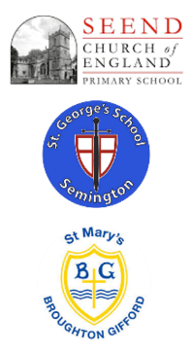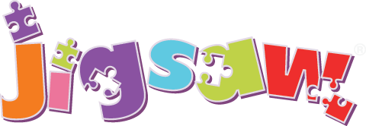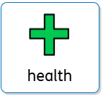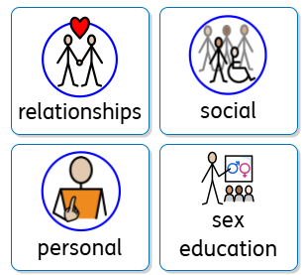

PSHEE at ‘The Three Schools’

**Curriculum Impact**

The implementation of this curriculum, ensures that when all children leave our school, they:

* will be able to recognise their own worth, work well with others and become increasingly responsible for their own learning.
* will know ways to stay safe and healthy
* will understand and respect each other’s common humanity, diversity and differences so that they can go on to form the effective, fulfilling relationships that are an essential part of life and learning.

**Curriculum Intent**

PSHE and values education is at the heart of our school ethos and learning and forms part of our curriculum. Our aim is to provide all children with the knowledge, understanding, attitudes, values and skills they need in order to prepare them for life.

As a Christian school, through worships and our curriculum our children learn about core Christian values including our core values of respect, generosity, wisdom and kindness.

Through PSHE lessons, pupils will be encouraged to take part in a wide range of activities and experiences across and beyond the curriculum, contributing fully to the life of our school and their communities. PSHE lessons also aim to play an important part in safeguarding our children.

**Curriculum Implementation**

We use the Jigsaw scheme of work which was updated to meet the DfE statutory guidance for Health, Relationships and Sex education.

The Jigsaw scheme of work follows the key themes of: Autumn 1: Being Me in My World

Autumn 2: Celebrating Difference Spring 1: Dreams and Goals Spring 2: Healthy Me

Summer 1: Relationships Summer 2: Changing Me

**Assessment**

Teachers will assess learning during each lesson to build up accurate judgements of children’s assessment. They will also record the progress of each child termly and use this to inform and adapt future planning. In three key units summative assessment is used to strengthen teachers understanding of the children’s attainment.